ABI Wildlife Consultancy



Biodiversity Audit on behalf of Edinburgh Napier University

Report for May 2011

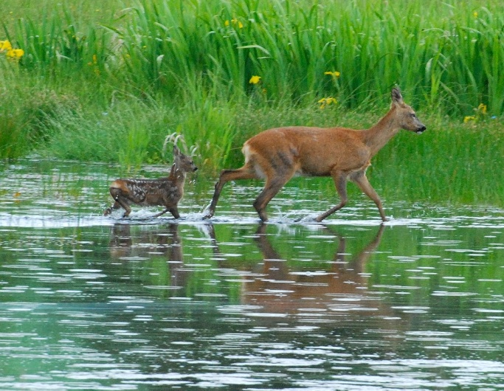

Roe Deer are secretive particularly where they share habitat with humans

Survey Work

The detailed plant list that was made up in August 2010 has been improved upon. Several new plants have been added to the list though this is still ongoing until the end of the survey in July. As one would expect with the detailed survey last August that there are several species that would have flowered and gone before then and this season’s survey is topping up these missing months. The bird survey also continues where we now have the core of breeding birds where some have not long arrived to breed from far off exotic places, and other more ‘local’ birds have settled down to breed while some have their first broods out of the nest.

The next survey to be carried out will be looking for bats which are now around but I prefer a nice evening for this when there are lots of invertebrates flying and the weather is warmer. The habitat potential around all the campuses is reasonably good where many trees have lots of cavities and there is also scope for some buildings to support bat populations. To date we have recorded Pipistrelle 45kHz and 55kHz in Craighouse which are probably the only two species we will record.

A sparrowhawk has nested in one of the campuses high in a tree where it gives a sharp alarm call as people go past near the tree. These birds are exceptional and skilled hunters and few prey species escape their grasp. Their body design allows them to weave very quickly through trunks and branches of trees when in pursuit of prey. They tend to prey on smaller birds but I have seen them take pigeons.

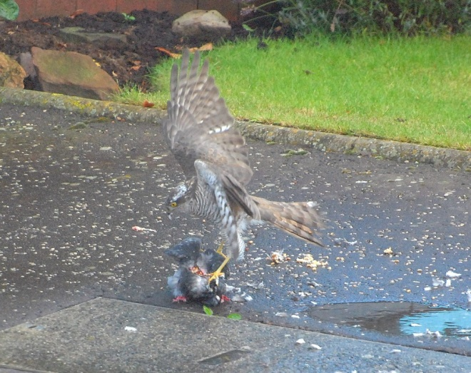

Sparrowhawk taking a pigeon in front of my house

One interesting observation made by Ian Walls, member of staff with the gardening team, was when he came face to face with a roe deer in Craighouse. Roe deer will lie low by day and feed mainly at night though in other circumstances will feed 24 hours a day. They are easily disturbed in populated areas and if disturbed they will often move away to find a less disturbed spot to lie-up. With lots of people and dogs around Craighouse it is very hard for these animals to find a place to lie-up safely during the daytime. At this time of year this female roe could be looking for a quiet area to give birth to either twins or a single kid (May-June time) and hopefully she will not be disturbed by people and dogs.

Craighouse

Numbers refer to the amount of different species

Habitat Type Birds Mammals

N Wood 13 2

S Wood 11 2

Parkland 13 1

Buildings 4 0

Craiglockhart

Numbers refer to the amount of different species

Habitat Type Birds Mammals

Semi-improved Grassland 5 1

Buildings 2 1

Parkland 13 0

Merchiston

Numbers refer to the amount of different species

Habitat Type Birds Mammals

Buildings 3 0

Abbie Patterson

Ecological Consultant