ABI Wildlife Consultancy



Biodiversity Audit on behalf of Edinburgh Napier University

Report for June 2011

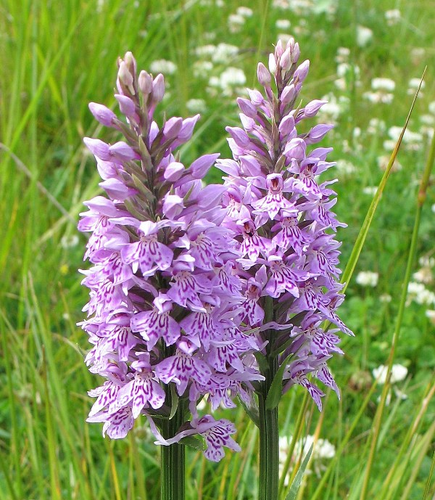

Common Spotted Orchid *Dactylorhiza fuchsii*

Survey Work

Survey work is now coming to an end with only July left to complete one year’s survey of flora, birds, bats, grey squirrel and other mammals, invertebrates, lichens and fungi. This will give a good synopsis of flora and fauna within the Edinburgh Napier University campuses. This information may also act as a baseline for further more in-depth analyses for students to pursue as part of their studies? There is a lot of data to write up and this information will be useful for Edinburgh Napier University when making decisions on any future developments.

A few more species have been added to the list and some are still waiting to be identified by the entomology department National Museums Scotland. All curators are currently busy setting up displays for the grand opening of Chambers Street museum in July. Other invertebrates have been found which will also require identification found in lichen and mosses but this is now unlikely to take place given the timescale involved?

It was interesting to see common spotted orchid recorded last August in Craiglockhart. This record was sent to the recorder for the Lothian’s for interest and has reported that this year has been a very good year for them. I also found one growing beside our wildlife pond in the garden for the first time. The bat survey is still ongoing where Craighouse has to be completed along with Merchiston. Bats have been found within the parkland habitat in both Craiglockhart and Craighouse though I am examining each phase 1 habitat type within the campuses. Also good news is that the roe deer seen last month is still around and has not been frightened away. There were no signs of any kids with her though she will hide them while she feeds nearby and could easily be overlooked.

The bird survey this month did not produce any new species but within parkland habitat in Craiglockhart produced the most seen at any time over the survey period with 16 species. I have to thank the gardening team for this as they were cutting the grass which attracts the birds to feed on exposed ground insects and swifts and swallows fly over these areas catching all the airborne insects in a feast. Roe deer signs were evident within the semi-improved grassland at Craiglockhart where a doe has been scent marking its territory by thrashing a tree (see image) and in Craighouse a black rabbit was recorded. I am not clear on black rabbits but would assume that this is a genetic variation? If you know the scientific answer to this then pleas email me [abiwildlifeconsultancy@o2.co.uk](mailto:abiwildlifeconsultancy@o2.co.uk)

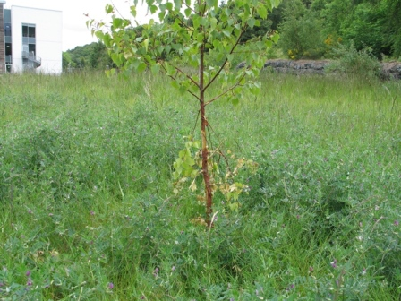

Damage to lower tree - Roe deer scent marking its territory

Craighouse

Numbers refer to the amount of different species

Habitat Type Birds Mammals

N Wood 12 1

S Wood 9 1

Parkland 12 2

Buildings 5 0

Craiglockhart

Numbers refer to the amount of different species

Habitat Type Birds Mammals

Semi-improved Grassland 3 2

Buildings 2 0

Parkland 16 1

Merchiston

Numbers refer to the amount of different species

Habitat Type Birds Mammals

Buildings 3 1

Abbie Patterson

Ecological Consultant