ABI Wildlife Consultancy



Biodiversity Audit on behalf of Edinburgh Napier University

Report for September 2010

Survey work.

Main focus this month has been on fungi where the survey will run through until the end of November. This will involve two visits per month (6 visits in total) for each campus: one survey taking place in the first half of the month and the other in the later half of the month. This will maximise the amount of species recorded given that most fungi appear briefly and decay rapidly. Bird survey is ongoing recording what is seen or heard within each habitat type. Mammals are recorded mostly by signs due to the high level of disturbance from dog walkers, joggers etc., which occur from before dawn at this time of year. However, signs are reliable and badger activity has been recorded along with field vole. I have begun analysing the invertebrate samples which will be ongoing throughout the winter. To-date I have almost completed one sample taken from *Grassland/Poor semi improved Phase 1 Habitat code B6 S1.*  One unidentifiable species will be forwarded to Dr K Bland at the Edinburgh Entomological Club for identification.

Interesting species

A plant found at the end of August, *Spergularia marina* (Lesser Sea Spurrey) was sent to the Lothian’s botanical recorder and is described as an ‘interesting find’ given that its habitat is normally in a saltmarsh and rarely found inland. One mushroom of interest has been found at Craighouse *Hygrocybe psittacina* (Parrot Waxcap).

Pest Species

Scale insect *sp* was found at Merchiston and should be highlighted given the damage it can cause to trees. They have infested two species of mature trees – sycamore and lime.

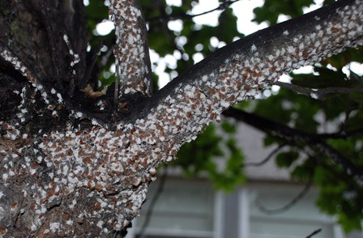Scale Insect

Craighouse

Numbers refer to the amount of different species

Habitat Type Birds Mammals Fungi

N Wood 9 5 6

S Wood 9 6 12

Amenity Grass 14 5 4

Buildings 12 7 0

As autumn sets in bird numbers have increased as species are now foraging for food over a wider area. Two species of bat, Pipistrelle 45 and 55 have been recorded feeding around the buildings. The south woodland has richer fungal fauna than any other habitat. This habitat has more decaying vegetation along with dead wood compared to the north woodland which has very little understory and large areas of bare soil.

Craiglockhart

Numbers refer to the amount of different species

Habitat Type Birds Mammals Fungi

Grassland 8 3 0

Amenity Grass 6 4 6

Buildings 5 2 0

Woodland 5 3 6

No fungi recorded around the buildings or grassland. Several interesting species were found in the amenity grassland with a good display of Fairy Inkcap *Coprinus disseminatus* around an old tree stump. Butterflies were still on the wing with a Peacock and Green-veined White seen. Interestingly, a tick *sp* (*Acari*) was found within the invertebrate sample – perhaps from a Roe Deer but could have come in by several hosts?

Merchiston

Numbers refer to the amount of different species

Habitat Type Birds Mammals Fungi

Buildings 4 0 1

Only one fungi species was found *Boletus porosporus*. Scale insect *sp* was found in two mature trees where they can cause damage.

A. Patterson

Ecological Consultant