ABI Wildlife Consultancy



Biodiversity Audit on behalf of Edinburgh Napier University

Report for February 2011

Survey Work

At this time of the season we are in a quiet period where we see very little happening, though this is not to say that nothing is actually happening, in reality there is a lot going on but mostly out of sight beneath the ground. Some early shoots are coming through and indeed snow drops along with crocus are already in bloom. I will soon be recording early plant life through to summer which will take me to a conclusion in July. The Lothian recorder for fungi was interested to hear of Waxcap fungi found on three campuses. GPS locations have been sent to him along with details of sites. I have an appointment with the Curator of Insects with the National Museum of Scotland to help identify a few minute parasitic insects from Craighouse campus.

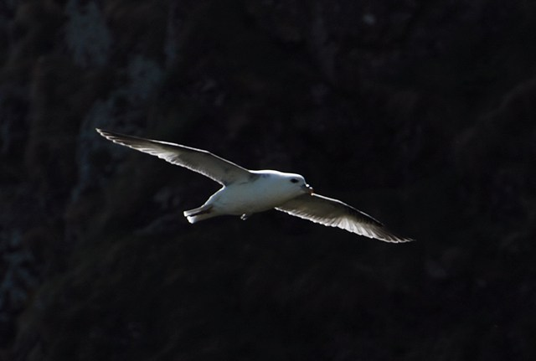

*Fulmar Petrel ©Abbie Patterson*

Bird monitoring continues with not much out of the ordinary happening. One interesting sighting has been a fulmar flying over Craiglockhart campus. This interesting and pelagic bird, and a member of the albatross family, goes out to sea in September/October and does not return until February looking to settle back on land in time for the breeding season. Though it is a little unusual to see this bird inland, they do sometimes nest on inland cliffs. However, they normally nest on the coast where they need the wind’s help to lift off and usually throw themselves off cliffs to achieve this. They have an interesting defence mechanism where it can project sticky, smelly oil from its stomach with alarming accuracy and I have recorded them taking down peregrine falcon on the west coast of Scotland by oiling the flight feathers.

Some wintering birds are still around e.g., fieldfare and redwing, but now that the weather has improved some have moved from the campuses back to agricultural areas where the feeding is better and safety in numbers. Waxwings have been tantalizingly close to Craighouse and Craiglockhart this winter but were never recorded within the campuses but nearby within gardens in the Greenbank area. An overlap will soon occur where winter birds will gather and leave us and will be replaced by migrants from the south and our summer visitors. Birds such as great-spotted woodpecker have already begun drumming on the trees in the past few days and birdsong is getting more territorial.

*Images from left to right: Waxwing and Fieldfare*

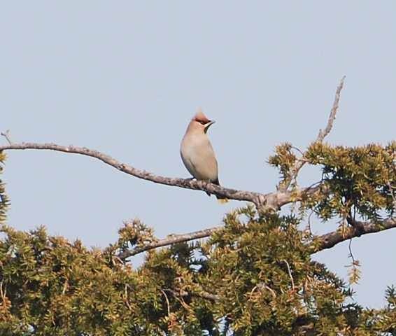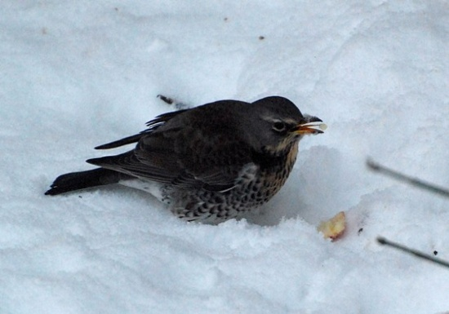

Craighouse

Numbers refer to the amount of different species

Habitat Type Birds Mammals

N Wood 12 1

S Wood 12 1

Parkland 11 1

Buildings 1 0

Craiglockhart

Numbers refer to the amount of different species

Habitat Type Birds Mammals

Grassland 4 0

Amenity Grass 5 0

Buildings 1 0

Woodland 13 1

Merchiston

Numbers refer to the amount of different species

Habitat Type Birds Mammals

Buildings 2 0

Abbie Patterson

Ecological Consultant