ABI Wildlife Consultancy



Biodiversity Audit on behalf of Edinburgh Napier University

Report for March 2011

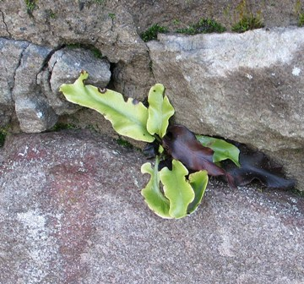 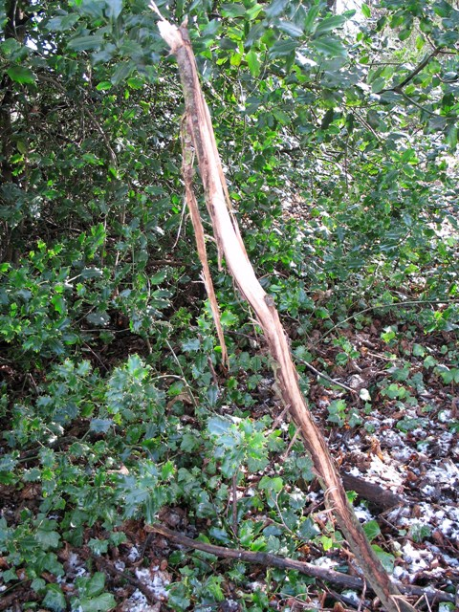

Hart’s Tongue Fern Fraying bark - Roe Deer damage

Survey Work

A new discovery at Craighouse was Hart’s Tongue Fern growing on an old wall where it was missed during last year’s survey due to thick brambles. There is a tendency for this species to become more scarce the further north and east (Inverness northwards) and they are fairly abundant within the Lothian’s. Apparently a ‘hart’ was an old name for deer and the shape of the plant resembles a deer’s tongue hence its common name. Roe deer damage was found in the south wood at Craighouse where they scent their territory by rubbing their antlers and facial rubbing to release scent on a small tree. This damage would have probably occurred last year and no other fresh evidence was found such as hairs and droppings at the site though it is still early in the season. However, this does confirm that there are roe deer living within or near the area of Craighouse.

A lichen survey began in March looking at walls, buildings, trees and other structures to identify species. It is a slow operation as lichens are not the easiest species to identify. Samples are taken from the field and examined under a microscope to help identify species. Only Merchiston and part of Craiglockhart have been completed to-date. What is interesting is that all lichens examined so far have the same microscopic invertebrate fauna grazing on them. Some I cannot identify as yet but there is one type of Collembola (springtail) species that seems common to all lichens. Invertebrates that could not be identified from the ‘sweep netting’ survey carried out last August are now with the curator of insects at the National Museums Collection Centre though it may be some time before we have an answer.

Birds are now singing territories, some are building nests and Great-spotted Woodpecker was ‘drumming’ on a tree in Craighouse. The first of the summer migrants are arriving with Chiffchaff singing just outwith the university campus. Some early plants are coming through such as Coltsfoot and Shepherds Purse and in a few weeks time we should see a lot more plants blooming. Small Tortoiseshell butterfly is on the wing in my garden this week along with male frogs and calling from my pond – is spring here?

Craighouse

Numbers refer to the amount of different species

Habitat Type Birds Mammals

N Wood 13 0

S Wood 10 1

Parkland 10 1

Buildings 1 0

Craiglockhart

Numbers refer to the amount of different species

Habitat Type Birds Mammals

Semi-improved Grassland 4 0

Buildings 1 1

Parkland 10 0

Merchiston

Numbers refer to the amount of different species

Habitat Type Birds Mammals

Buildings 2 0

Abbie Patterson

Ecological Consultant