PART 1

[Role Title]

 | 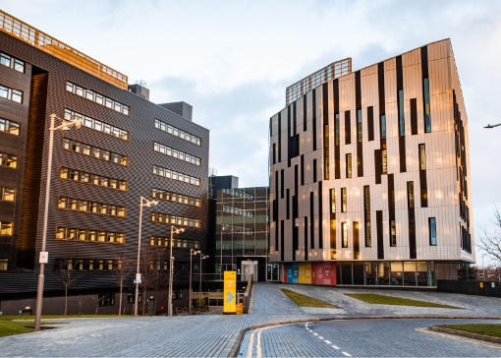 | 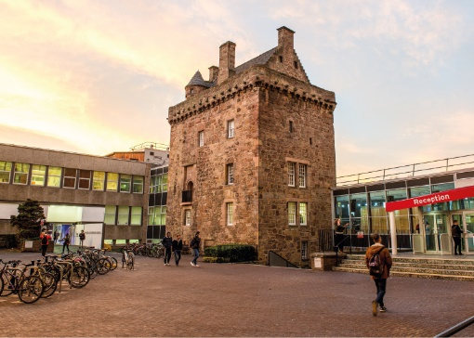

ROLE DESCRIPTION
GRADE  Grade [X]  LOCATION  [Provide campus location: Sighthill, Merchiston, Craiglockhart Edinburgh]  LINE MANAGER  [Line Manager Role Title] |  | ROLE SUMMARY  [1-3 paragraphs about the role]  Line Management Responsibility for:  This role does not have any line management responsibilities currently OR This role has line management responsibilities for [insert role titles / no. of line reports here].

MAIN DUTIES AND RESPONSIBILITIES
- X
- X
- X
- X
- X
- X
- X
- X
- Role model the University’s values & behaviours;
- Be responsible for ensuring that the information and records processed (received, created, used, stored, destroyed) on behalf of the University are managed in compliance with ALL applicable legislation, codes and policies e.g. Data Protection, Information Security and Records Management.

PERSON SPECIFICATION
 | ESSENTIAL | DESIRABLE

Education / Qualifications
- X
- X
- X

Skills / Experience
- X
- X
- X
- X
- X
- X
- X
- X
- X
- X
- X
- X
- X
- X

PART 2 - If the role has not been evaluated or is significantly different from the previous role, parts 1 and 2 of the role description form should be completed/updated. Please refer to the Role Description Guidance for Managers to support you completing this section. (Part 2 will be used for role evaluation purposes only).

ROLE Activities & ReQUIREMENTS
Communication
Teamwork and Motivation
Liaison and networking
Service delivery
Decision making
Planning and organising resources
Initiative and problem solving
Analysis and research
Sensory and physical demands
Work environment
Pastoral care and welfare
Team development
Teaching and learning support
Knowledge and experience
Any other significant activities not included above or any other information you want to highlight?

