EDINBURGH NAPIER UNIVERSITY

Temporary Agency Worker Policy and Procedure

- Background

1.1 The Agency Workers Regulations 2010 (AWR) came into force on 1st October 2011. The aim of these Regulations is to ensure the protection of temporary agency workers by applying the principle of equal treatment. The Regulations do not, however, entitle temporary agency workers to full equality and do not impose an employment status between temporary agency workers and the University.

1.2 The rights and statutory protections that temporarys already have under existing regulations remain unchanged, for example: paid leave (Working Time Regulations, 1998); National Minimum Wage (National Minimum Wage); rights under Health and Safety Law; and rights not to be discriminated against (Equality Act, 2010).

1.3 As an outcome of the introduction of The Agency Workers Regulations 2010, there is a requirement that the University records for all temporary agency workers are held centrally within Human Resources, to ensure that the rights detailed in the Regulations are complied with.

2. Scope

2.1 Who is covered by the Regulations?

- Temporary Work Agency (TWA)
- Temporary Agency Workers
- The University (hirer)

2.2 Areas outside the scope of the Regulations include: managed service contracts, the genuinely self-employed, individuals on secondment and the introduction of workers to employers for direct or permanent employment.

2.3 Temporary agency workers employed on a permanent basis with a TWA and who receive pay in-between assignments are not covered by the AWR. They will be employed in-line with the terms and conditions of the TWA.

3. Definitions

3.1 A Temporary Work Agency (TWA)

An employment business which supplies workers to the University for temporary work.

A TWA:
- Supplies individuals to work temporarily for and under the supervision and direction of the University.
- Pays for, receives or forwards payment for the work these individuals complete at the University.

3.2 A Temporary Agency Worker

Workers with a contract of employment or contract to perform work with a TWA, who as part of that contract are assigned to the University on a temporary basis, to complete work under the supervision and direction of the University.

4. Rights Under the Regulations

4.1 With the Introduction of The AWR, temporary agency workers are entitled to enhanced employment rights, some of these rights commence from Day 1 of a temporary agency workers assignment at the University and other rights begin following the completion of a 12 week qualifying period

(NB the qualifying period is not retrospective and for temporary agency workers already in post, the 12 week qualifying period only began to accrue on 1 October 2011).

4.2 Day 1 Entitlements

From the first day of employment temporary agency workers are entitled to be treated no less favourably than a comparable employee at the University (unless less favourable treatment is objectively justified) in relation to access to collective facilities and amenities as well as to information on job vacancies.

4.3 Collective Facilities Include:

- Canteen or other similar Facilities
- Food and Drinks Machines
- Toilet / Shower Facilities
- Baby Changing Facilities
- Prayer Room / Quiet Room

4.4 Job Vacancies:

All temporary agency workers have the right to be given the same opportunity as a comparable employee to try and find permanent employment at the University, therefore, the opportunity to apply for both internal and external University vacancies. The temporary agency worker should be advised by their University contact of this right and be shown where and how to access current vacancy information on Day 1 of their assignment at the University (i.e. they should be provided with the links to the University’s internal and external vacancy pages).

This right will not apply in the context of a genuine headcount freeze on recruitment in order to avoid redundancy situations.

4.5 Entitlements after 12 weeks:

Following a 12 week qualifying period, temporary agency workers are entitled to the same basic working and employment conditions that they would have been entitled to, for doing the same job, had they been recruited directly by the University.

4.6 Additional Rights after 12 weeks

- Pay: Basic / Overtime / Shift Allowance / Flexible Allowance
- Duration of Working Time / Rest Periods / Rest Breaks (in-line with the Working Time Directive).
- Annual Leave (entitled to the University’s enhanced personal holiday and fixed leave comparable to someone directly employed by the University in the same staff category)
- Paid time off for antenatal appointments and the right to alternative work or pay if the temporary agency worker is unable to continue with an assignment at the University during Pregnancy for Health & Safety reasons.
- Other payments if the temporary agency worker satisfies certain eligibility criteria (i.e. annual pay increments based on length of service).

Entitlements do not include areas such as: occupational sick pay; occupational maternity or paternity pay; pensions; contractual notice pay; andr redundancy pay.

4.7 Calculating the 12 week Qualifying Period

Particular rules apply to the calculation of the 12 week qualifying period which create situations where continuity can be broken, suspended and occasions when it will accrue despite an temporary agency workers absence. Please refer to the Working Clock diagram in Appendix A.

4.8 What counts towards the 12 week qualifying period?

- Any week where an temporary agency worker works with the University, whether in whole or part, counts as a calendar week for the purposes of the 12 week qualifying period (i.e. a temporary agency worker may only work 4 hours per week, however, will still be entitled to equal treatment after 12 calendar weeks).
- Termporary agency workers can build-up weeks towards the qualifying period through a series of different assignments through the same or different TWA’s provided that he or she is working for the University in “the same role”, i.e. a temporary agency worker can undertake 2 assignments in 2 separate departments at the University, and this could count towards their 12 week qualifying period if the main duties of the roles are similar.

4.9 How is continuity broken (the clock re-sets)?

- Continuity is broken and a temporary agency worker has to commence their 12 week qualifying period again when:
- The agency worker remains at the University, however, commence a new, substantively different role.
- There is a break of more than 6 weeks between the assignments that the agency worker undertakes at the University.

4.10 Situations where continuity will not be broken but weeks will not count (the clock is paused):

- A break for any reason that is not more than 6 weeks.
- A break of up to 28 weeks due to sickness or injury.
- A break of up to 6 weeks to take annual leave which the agency worker has accrued and is, therefore, entitled to.
- A break of up to 28 weeks to allow the agency worker to perform jury service.
- A break caused by a planned shut-down of the University (for instance Christmas Break).
- A break caused by Industrial Action at the University.

4.11 Situations where continuity will accrue for the originally intended duration of the assignment or the likely duration of the assignment, whichever is longer, despite a temporary agency workers absence from the University (clock continues ticking despite absence)

- A break is due to Pregnancy, Childbirth or Maternity and which take place either during pregnancy and for up to 26 weeks after childbirth.
- The agency worker is taking Maternity, Adoption or Paternity Leave.

5. Equal Treatment

5.1 After the 12 week qualifying period if a temporary agency worker has a concern that they are being treated less favourably in terms of their rights under the Regulations, they are entitled to raise their concerns in writing with both the University and / or TWA and request details of how their pay and conditions have been determined.

5.2 Comparators

It is beneficial for the University to identify a comparator for each agency worker to ensure that the agency worker receives equitable rights for both the Day 1 and 12 Week rights detailed in the Regulations. A suitable comparator is an individual who at the time of the agency workers assignment is, working under the direction of the University and engaged in the same or broadly similar work (this also takes into consideration where relevant whether they have a similar level of qualifications or skills).

6. Edinburgh Napier University’s Process

6.1 Agency Worker Usage

(a) Agency workers should only be used in exceptional circumstances to cover short-term temporary assignments, for instance: temporary cover due to sickness absence, holidays, during seasonal peaks or to assist with short-term specialist projects (i.e. specialist consultants sourced and paid through a third party). Agency worker assignments should not normally exceed 12 weeks.

(b) If a need is identified for a temporary agency worker, the Line Manager must contact HR to discuss their requirements (the business case) and to notify HR of their intention to use a TWA. HR will discuss whether this is the best option available for the departments needs and advise the Line Manager about: suitable agencies, pay rates, fees, contracts and agency worker rights.

(c) For staffing needs over 12 weeks individuals should normally be recruited on a fixed-term contract basis, through the University’s Recruitment & Selection process (a Staffing Authorisation Form should be approved, advert placed, selection process completed).

(d) In exceptional circumstances where a temporary agency workers assignment is extended past a 12 week period (i.e. an extended sickness absence situation), it is essential that the Line Manager liaises with HR and the TWA to ensure that the 12 week rights detailed in the Regulations, are adhered to, especially in relation to pay and annual leave entitlements. It is important that following the 12 week qualifying period, the agency workers terms and conditions are directly linked to the role that they are completing and mirror the terms and conditions of a comparator within the department, where a comparator exists.

6.2 Notification

(a) Human Resources require to be notified of all agency workers. This includes, all agency workers currently working at the University and all new agency workers before they commence their assignment at the University.

(b) Human Resources need to know key information about a temporary agency workers assignment in order to ensure the correct recording of the duration of a temporary agency workers qualifying period to ensure that the University complies with the new Regulations in regards to agency worker rights.

(c) The relevant University contact needs to complete a Temporary Agency Worker Notification Form for each agency worker assignment and forward it to their designated HR Adviser to record centrally.

6.3 The University’s TWA’s

(a) Following a national procurement exercise undertaken by APUC (Advanced Procurement for Universities and Colleges) the University’s contracted supplier for all temporary staffing needs can be found here. As part of this agreement low mark up percentage charges have been negotiated along with low finder’s fees (if a temporary agency worker is subsequently successful in obtaining a University position).

(b) . There is a legal requirement for the University to contact our preferred suppliers in the first instance for any agency worker needs that fall within these categories, before contacting any other TWA’s.

(d) If the role falls out with the preffered suppliers staffing categories, it is recommended that thse suppliers are contacted initially to ascertain whether they can source an appropriate agency worker. However, if they are unable to source a candidate, the University has the opportunity to utilise the Scottish Procurement Staffing Contract, which enables the use of a number of other agencies including agencies that specialise in IT Staff and Interim Managers, which HR can advise on.

(e) The University must not utilise Agencies outwith the APUC and Scottish Procurement Contracts. You must contact HR to discuss a suitable Agency for your need.

6.4 Paying Agency Workers

(a) Payments for work completed by agency workers are made directly to the TWA, are paid by the relevant department credit card and processed by Finance.
(b) Agency workers are paid an hourly rate, which should be discussed with HR. The TWA will include additional costs per hour to allow for: payment for holiday entitlement, deductions for National Insurance and a percentage charge for the TWA’s services.

(c) Day 1 - Pay
Day 1 rates include: an agreed basic hourly rate, hourly payment for statutory holiday entitlement (based on 28 days per year), a percentage to allow for deductions for National Insurance and a percentage charge for the TWA’s services.

The agency worker Hourly Rate Calculator – DAY 1, can be used to calculate a temporary agency workers total hourly rate for budgeting purposes.
If a temporary agency worker is successful in securing a University position, this may be subject to an Agency Finder’s Fee, which can vary.

(d) 12 Week - Pay
The hourly rate a temporary agency worker receives following the 12 week qualifying period must relate directly to the relevant University Salary Scales and should equate to the bottom salary point of the relevant grade (the grade should relate directly to the role that the agency worker is completing at the University, providing a comparator where possible).

(e) The agency worker will also be entitled to receive an hourly holiday allowance payment based on the University’s enhanced Annual leave entitlements (including fixed holidays), which must mirror the entitlements of the relevant staff category. Agency workers will also be entitled to payment for other pay entitlements that directly relate to the role that they are completing for instance, overtime / shift allowance / flexible allowance.

(f) It is important that the TWA is made aware of any enhanced entitlements following the 12 week qualifying period, to ensure that the agency worker’s hourly rate increases to incorporate these.

(g) The agency worker Hourly Rate Calculator – 12 Week, can be used to calculate a temporary agency workers total hourly rate for budgeting purposes.

If a temporary agency worker is successful in securing a University position following the 12 week qualifying period this may be subject to an Agency Finder’s Fee.

(h) Agency Worker Access to University Staff Resources
Dependant on the length and nature of a temporary agency workers assignment, they may require access to University staff resources. If the agency worker requires access to University resources (building access - outside standard University opening hours, sports centre - if a member, email account, library borrowing, access to on-line resources, printing & photocopying) they can be provided with a Staff ID number and an Associate Staff Card.

(i) In order to progress this, the relevant Line Manager will need to follow the process detailed in the University’s Associate Staff Process Guidelines, including completing The Associate Staff Notification Form.

(j) Agency workers who do not require access to University staff resources as they are on site on a short-term basis must sign in at reception where they will be issued with a Visitor Card.

(k) Line Manager Responsibilities
The role of the Line Manager / University Contact is crucial when gaining the services of a temporary agency worker. There are a number of processes that the Line Manager must ensure they follow. It is important that Line Managers communicate effectively with the relevant TWA and HR to ensure compliance with the Regulations, especially for assignments that exceed the 12 week qualifying period. Information in relation to pay and holiday entitlements need to be supplied between the University and the TWA to ensure that robust systems are in place to correctly manage agency workers and ensure that their rights are respected and catered for.

(l) The Line Manager / University Contact must:-
- Ensure that all avenues have been explored before considering a temporary agency worker (i.e. distributing the work-load amongst existing staff members, fixed-term contract)
- Contact HR to discuss the Business Case for seeking a temporary agency worker.
- Discuss suitable rates / agencies / contracts / terms and conditions with HR.
- Complete a Temporary Agency Worker Notification Form and email this to the relevant HR Adviser each time a temporary agency worker commences an assignment.
- If the agency worker requires access to University Staff Resources ensure that the Associate Staff Notification Form is completed to enable this.
- On Day 1 of the agency workers assignment ensure that all Day 1 rights are enabled. This includes making the agency worker aware of their right to apply for internal and external University vacancies and providing them with information about where to find information on current vacancies (i.e. providing them with the links to the University’s Internal and External Vacancy sites).
- Ensure that all agency workers are made aware of and have read the University’s Health and Safety Requirements on Day 1 of their assignment by providing them with the link.
- Ensure that all agency workers complete an Oath of Confidentiality Form on Day 1 of their assignment. This form is to be retained by the employing area for a period of 6 years from the date on which the agency workers assignment ceases in-line with the University’s retention schedule.

A concise Line Manager Checklist - Agency Workers is available on the HR Intranet Site.

APPENDIX A

AWR Working Clock
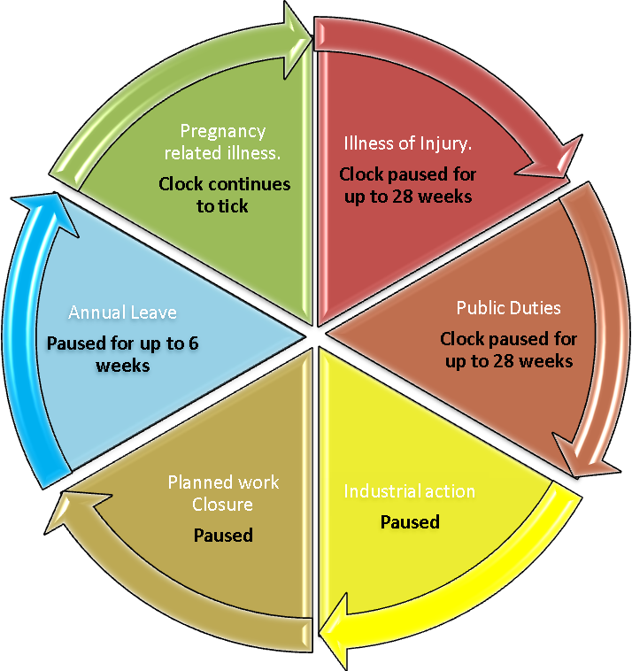
Pause Types | Action on qualification of clock
Pregnancy related illness | Clock continues to tick
Illness of injury | Paused (for up to 28 weeks)
Public Duties (e.g. Jury Service) | Paused (for up to 28 weeks)
Industrial Action | Paused
Planned work place closure | Paused
Annual leave | Paused for up to 6 weeks

