Consultant
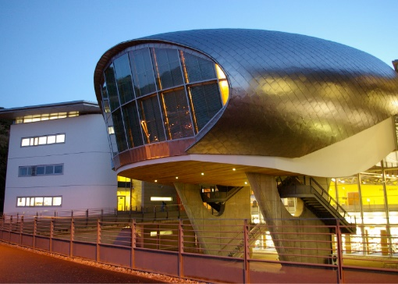 | 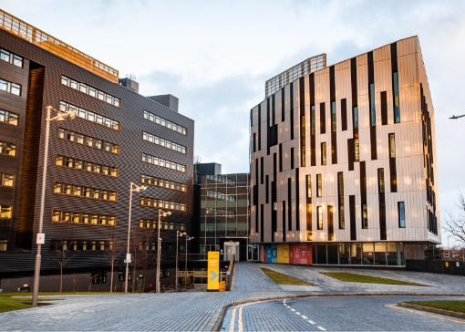 | 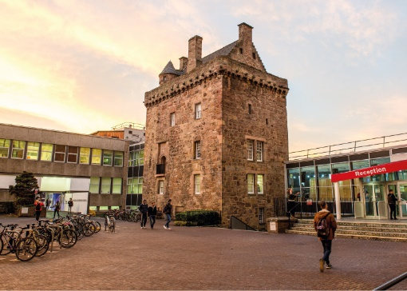

ROLE DESCRIPTION
GRADE  Grade 5  LOCATION  [Provide campus location: Sighthill, Merchiston, Craiglockhart Edinburgh]  LINE MANAGER  [Line Manager Role Title] |  | ROLE SUMMARY  [1-3 paragraphs about the role]  Line Management Responsibility for:  This role does not have any line management responsibilities currently.

MAIN DUTIES AND RESPONSIBILITIES

Teaching and Learning Support
- Required to produce learning material for seminars.

Research and Scholarship
- Contribute to other’s proposals for securing research contracts.
- Conduct individual and collaborative research projects.
- Continually update knowledge and understanding in field or specialism.
- Review and synthesise the outcomes of research studies.
- Translate knowledge of advances in the subject area into consultancy activity.

Communication
- Deal with routine communication using a range of media.
- Communicate complex information, orally, in writing and / or electronically.
- Communicate material of a specialist or highly technical nature within forum specific to the subject.
- Review technical reports for governmental and major industrial / commercial clients.

Liaison and networking
- Liaise with colleagues and students.
- Build internal contacts and participate in internal networks for the exchange of information and to form relationships for future collaboration.
- Participate in design team meetings for larger scale projects.
- Join external networks to share information and identify potential sources of funds.

Managing people
- Provide guidance as required to support staff and any students who may be assisting with the consultancy.
- Manage personal and own-project consultancy, research and administrative activities, with guidance if required.
- Co-ordinate work of Level 1 Associate Consultants as and when required.

Teamwork
- Work with colleagues on joint projects, coordinating as required
- Delegate work to Level 1 Associate Consultants, monitor its achievement and provide feedback as required.

Pastoral care
- Show consideration to others.

Initiative, problem-solving and decision-making
- Use new research techniques and methods.
- Use initiative and creativity to identify areas for consultancy and develop new marketing methods.
- Provide advice and input to the decision making of clients regarding design aspects of large projects.
- Use creativity to analyse and interpret research data and draw conclusions on the outcomes.
- Make independent decisions on site testing locations.
- Contribute to collaborative decision making with colleagues in areas of consultancy.

Planning and managing resources
- Plan and manage own research activity in collaboration with others.

Sensory, physical and emotional demands
- Sensory and physical demands will vary from relatively light to a high level depending on the discipline and the type of work
- Carry out tasks that require the learning of certain skills.
- Balance with help the competing pressures of research consulting practice and administrative demands and deadlines.

Work environment
- Is required to be aware of the risks in the work environment and their potential impact on their own work and that of others.
- May be required to undertake work in potentially hazardous sites.

Expertise
- Engage in continuous professional development.
- Understand equal opportunity issues as they may impact on areas of research content.
- Shall be a Full Corporate Member of relevant professional body.

PERSON SPECIFICATION
 | ESSENTIAL | DESIRABLE

Education / Qualifications
- X
- X
- X

Skills / Experience
- X
- X
- X
- X
- X
- X
- X
- X
- X
- X
- X
- X
- X
- X

