Research Assistant

 | 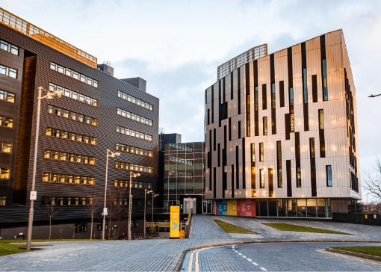 | 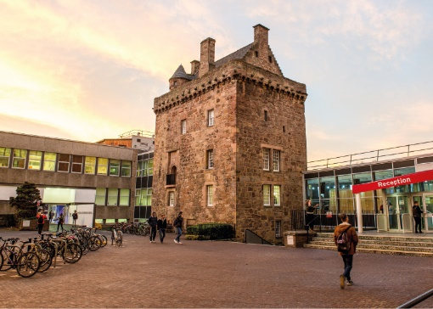

ROLE DESCRIPTION
GRADE  Grade 4  LOCATION  [Provide campus location: Sighthill, Merchiston, Craiglockhart Edinburgh]  LINE MANAGER  [Line Manager Role Title] |  | ROLE SUMMARY  [1-3 paragraphs about the role]  Line Management Responsibility for:  This role does not have any line management responsibilities currently.

MAIN DUTIES AND RESPONSIBILITIES

Teaching and Learning Support
- Could be expected to assist in the supervision of undergraduate student projects.
- Could be expected to contribute to introductory courses at undergraduate level, for example on the use of research methods and equipment.

Research and Scholarship
- Undertake basic research for example by preparing, setting up, conducting and recording the outcome of experiments and field work, the development of questionnaires and conducting surveys.
- Support the development of undergraduate project proposals
- Conduct literature and database searches.
- Write up results as project report
- Continue to update knowledge and develop skills.

Communication
- Write up results of own research, as part of a guided process
- Contribute to the production of research reports and publications.
- Present information on research progress and outcomes to bodies supervising research, e.g. steering groups.
- Prepare papers for steering groups and other bodies.

Liaison and networking
- Liaise with research colleagues and support staff on routine matters.
- Make internal and external contacts to develop knowledge and understanding and form relationships for future collaboration.

Managing people
- Provide guidance as required to support staff and any students who may be assisting with the research.

Teamwork
- Actively participate as a member of a research team.
- Attend and contribute to relevant meetings.

Pastoral care
- Show consideration to others.

Initiative, problem-solving and decision-making
- Make use of standard research techniques and methods.
- Deal with problems which may affect the achievement of research objectives and deadlines
- Contribute to decisions affecting the work of the team.
- Analyse and interpret the results of own research and generate original ideas based on outcomes.

Planning and managing resources
- Plan own day-to-day research activity within the framework of the agreed project.
- Co-ordinate own work with that of others to avoid conflict or duplication of effort.
- Contribute to the planning of research projects.

Sensory, physical and emotional demands
- Sensory and physical demands will vary from relatively light to a high level depending on the discipline and the type of work
- Carry out tasks that require the learning of certain skills.

Work environment
- Is required to be aware of the risks in the work environment.

Expertise
- Possess sufficient breadth or depth of specialist knowledge in the discipline (for example with an undergraduate or Master’s degree) and be developing further skills in and knowledge of research methods and techniques.

PERSON SPECIFICATION
 | ESSENTIAL | DESIRABLE

Education / Qualifications
- X
- X
- X

Skills / Experience
- X
- X
- X
- X
- X
- X
- X
- X
- X
- X
- X
- X
- X
- X

