Senior Manager End of Year Review

System Process Guidance

Contents
Introduction 2
Team Member (Reviewee): Completing your EOY Ratings & Comments 3
Manager (Reviewer): Completing the EOY Ratings & Comments for your Team Member 8
Manager (Reviewer): Completing the Calibrated Review Form for your Team Member 15

VERSION HISTORY

Version | Date | Change Summary
1.0 | May 2023 | N/A

Introduction
This guide will will instruct you in the process of completing the Senior Manager End of Year Review form on HR Connect, both as a team member (reviewee) and a manager (reviewer).
The first section of the form ‘Senior Manager End of Year Review Form’ will be open from 01/06 through to 30/06 for completion and submission of relevant sections by both the team member (reviewee) and their manager (reviewer).
The second section of the form ‘Final Calibrated End of Year Review’ will be open from 01/09 for completion and submission by the manager (reviewer) once the final calibrated rating has been communicated by the calibration committee. Please do not record anything in this form until you have received the final calibrated rating and informed your team member.

When inputting data into the review form/s, like any web-based system the page will eventually time out. Therefore, it is recommended that you either regularly save the form throughout the process to avoid loss of work or type up the information in a word document and copy and paste into the form when you are ready to submit.

Team Member (Reviewee): Completing your EOY Ratings & Comments
From the 1st of June the ‘Senior Manager End of Year Review Form’ will be available for completion in HR Connect.
Please note that this section needs to be completed and submitted first before the manager can complete and submit their part of the form.
Log into HR Connect Employee Self Service and click on ‘Performance’.

Within the ‘Review lifecycles’ section, click on ‘Senior Manager End of Year Review Form’
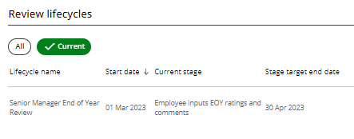

Click on ‘Generate’.
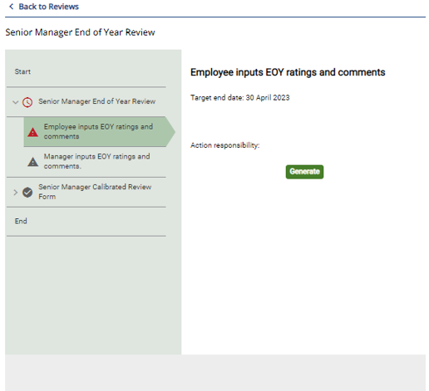

Ensure that you read through the summary page. Click on ‘Start’ to access and complete the form.
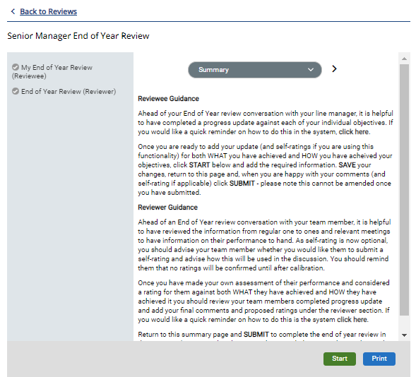

Ensure that you read through the guidance within the page.
Links to further guidance have also been provided.

Outline a summary to evidence your review reflections on WHAT you have achieved. This is a required field and cannot be left blank. It is recommended to type this up in word beforehand and copy over into the correct section of the form for ease of completion.

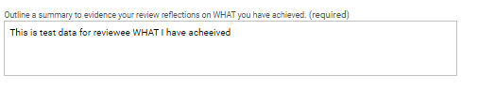

From the drop-down list, select a WHAT rating. This is a required field for completion and cannot be left blank. However, if you do not wish to give yourself a self-rating please select, ‘Prefer not to answer’.

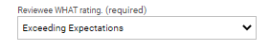

Outline a summary to evidence your review reflections on HOW you have performed. This is a required field and cannot be left blank. It is recommended to type this up in word beforehand and copy over into the correct section of the form for ease of completion.

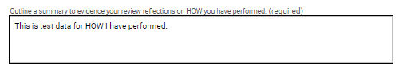

From the drop-down list, select a HOW rating. This is a required field for completion and cannot be left blank. However, if you do not wish to give yourself a self-rating please select, ‘Prefer not to answer’.

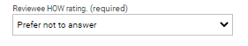

Please ensure that you read through the ‘Calibration Acknowledgement’ section. The form will not be able to be submitted to your line manager until the ‘Confirmed’ check box has been ticked.

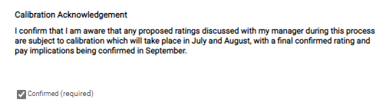

Please ensure that you read through the ‘Submitting your End of Year Review’ section. The form will not be able to be submitted to your line manager until the ‘Confirmed’ check box has been ticked.

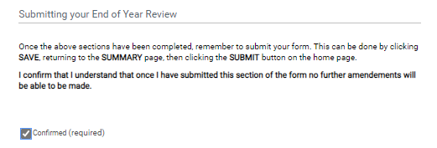

To submit the form, click on ‘Save’. You will be notified that you have saved your section of the form.

Click on ‘Summary’ to return to the summary page.

Once you are back on the form summary page click on ‘Submit’ and ‘Ok’. Please note that once you have submitted the form you will not be able to make any changes to your ratings and comments, therefore it is important ensure that you are happy with your ratings and comments before submission and that they have been saved correctly within the form.

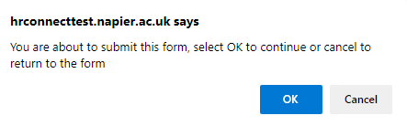

You will be notified that your section of the form has been submitted.

Once you have submitted your manager will receive an email informing them of this.

Manager (Reviewer): Completing the EOY Ratings & Comments for your Team Member
Once your team member has submitted their section of the form, your will receive an email notifying you of this. Please note that you will not be able to access the form until they have submitted their section.
Log into People Manager, click on ‘My Team’.
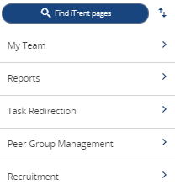

Select the team member from the left-hand side of the screen.
Click on ‘My Contribution’ and ‘My Contribution Forms’ and select the correct review and form for the current review period from the left-hand side of the screen.
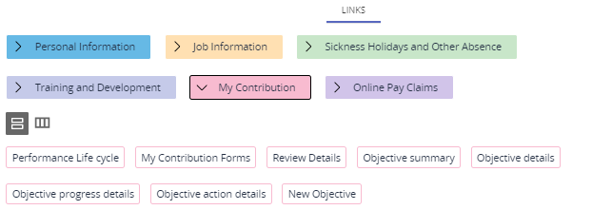

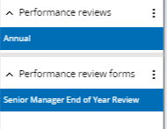

Read through the ‘Reviewer Guidance’ section and click on ‘End of Year Review (Reviewer).
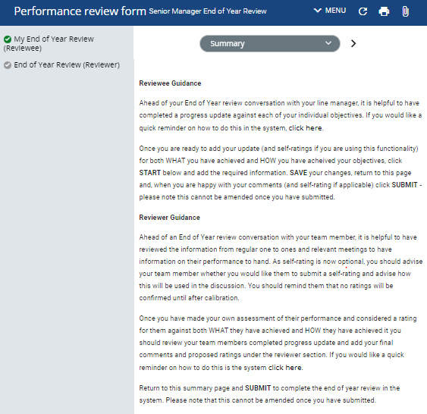

Please ensure that you read through the guidance on this page. Links to further guidance are also provided.

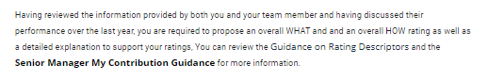

So that you can easily see what your team member has inputted, you can see this on the left-hand side of the page (greyed out).

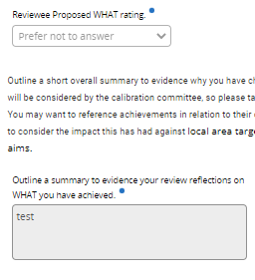

Read through the guidance within the page.
Input the WHAT rating. This is a required field and cannot be left blank.

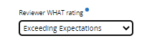

Outline a summary to evidence why you have chosen the WHAT rating This is a required field and cannot be left blank. It is recommended to type this up in word beforehand and copy over into the correct section of the form for ease of completion.

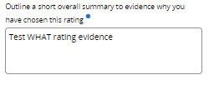

Input the HOW rating. This is a required field and cannot be left blank

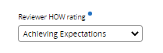

Outline a summary to evidence why you have chosen the HOW rating This is a required field and cannot be left blank. It is recommended to type this up in word beforehand and copy over into the correct section of the form for ease of completion.

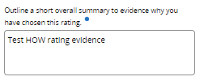

Input the overall proposed end of year rating. This is a required field and cannot be left blank.
You can also input any additional information which you would like the calibration committee to be aware of (this is an optional field).

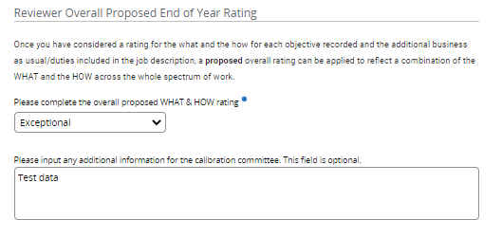

Please ensure that you read through the ‘Calibration Acknowledgement’ section. The form will not be able to be submitted until the ‘Confirmed’ check box has been ticked.

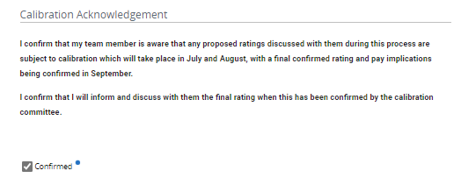

Please ensure that you read through the ‘Submitting the End of Year Review’ section. The form will not be able to be submitted to your line manager until the ‘Confirmed’ check box has been ticked.

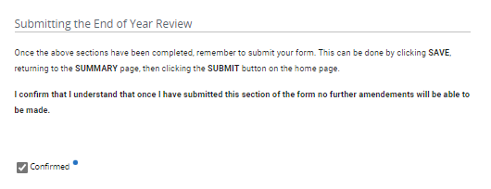

To save and submit the form, click on ‘Save’. You will be notified that you have saved your section of the form.

Click on ‘Summary’ to return to the summary page.

Once you are back on the form summary page, click on ‘Submit’ and ‘Ok’. Please note that once you have submitted the form you will not be able to make any changes to your ratings and comments, therefore it is important to ensure that you are happy with them before submission and that they have been saved correctly within the form.

You will be notified that your section of the form has been submitted and that it is now complete and cannot be modified. Your team member will receive an email informing them that it has been completed.

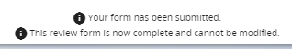

Manager (Reviewer): Completing the Calibrated Review Form for your Team Member

In September, the calibration committee will notify you of your team members final calibrated rating. Once you receive this, please ensure that you inform and discuss this with them before recording the final calibrated rating in HR Connect. When you are ready to record the final rating, please follow the instructions below.
Log into People Manager, click on ‘My Team’.

Select the team member from the left-hand side of the screen.
Click on ‘My Contribution’, ‘Performance Lifecycle’ and select the ‘Senior Manager End of Year Review’ lifecycle from the left-hand-side of the screen.

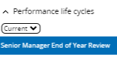

Click on ‘Generate’.
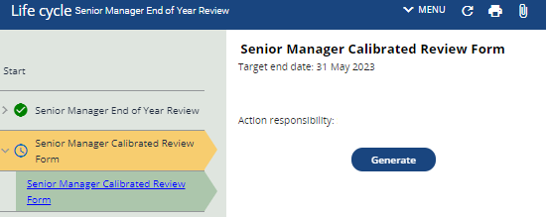

Read through the ‘Reviewer Guidance’. section and click on ‘Start’.
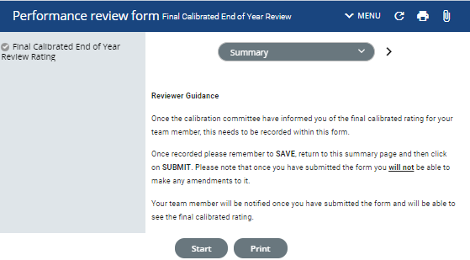

Input the Final Calibrated Rating as confirmed by the calibration committee.
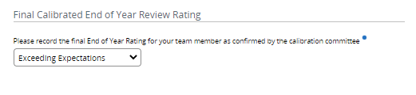

Please ensure that you read through the ‘Final Calibration Acknowledgement’ section. The form will not be able to be submitted until the ‘Confirmed’ check box has been ticked.
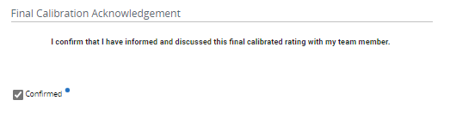

Please ensure that you read through the ‘Final Submission’ section. The form will not be able to be submitted until the ‘Confirmed’ check box has been ticked.
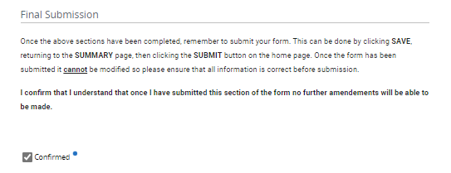

To save and submit the form, click on ‘Save’. You will be notified that you have saved your section of the form.

Click on ‘Summary’ to return to the summary page.

Once you are back on the form summary page, click on ‘Submit’ and ‘Ok’. Please note that once you have submitted the form you will not be able to make any changes to the final rating, therefore it is important to ensure that this has been recorded correctly before submission.

Once submitted, your team member will receive an email informing them of this. They will be able to view their final rating on HR Connect.

