Homeworking during COVID-19 – updated August 2020
Guidance for Employees

Purpose

As we move to a more prolonged period of homeworking, we have updated the temporary guidance that was developed to support employees working remotely during the pandemic. It is intended only to be used during this period and replaces the previous guidance. We recognise that due to individual circumstances, some employees may not be able to adhere to all of the advice.

The COVID-19 pandemic has presented us all with different challenges, not least within our working lives. Everyone has experienced a change to their normal working arrangements and for some people, this has taken more adjustment than others. Even those who are accustomed to working from home, may find these times particularly challenging. It is important that we all create good habits and strong boundaries. We recognise that many colleagues may be feeling anxious about the lack of certainty during this time and wish to provide them with support to maintain their health and wellbeing during this time.

Table of Contents | - Working arrangements ….…………………………………………………………………………………….. p.01  - Health and safety ………………………………………………………………………………..……………... p.03  - Your wellbeing …………………………..……………………………………………………………..…………. p.04  - Suggested ways of working………..……………………………………………………………..…………. p.06  - Confidentiality and security …………………………………………………….………..…………………. p.06  - My Contribution and development ……………………………………………………..…..…………… p.07  - Support ……………………………………………………………………………………………..…..…………… p.08  - Appendix – Health & Safety Homeworking Checklist

Working Arrangements

- During these difficult times, it is important that everyone continues to show flexibility and is sensitive to each other’s personal situations. Your manager should be aware of the extent that you are able to carry out your normal duties at home. If there has been a change in work priorities, or if it is impractical for some of your normal duties to be carried out at home, it may be appropriate for you to continue to focus on slightly different tasks which are still related to your role and capabilities but are more appropriate for your particular circumstances. It is expected that normal activity planning will continue for academic staff, however there may be occasions where certain types of work may need to be reprioritised. It should be expected that both managers and employees approach reprioritising work in a flexible manner.

- If you are responsible for caring for dependants, your manager should be aware of the practicalities surrounding this and what you are realistically able to do. We realise that for many employees, school and nursery closures will mean splitting work time and care duties every day and that it might not be easy to work a regular pattern. We recognise that this will be challenging, particularly for those with sole responsibility for children or other dependents, or who have very young children to look after.

- We appreciate the efforts people are going to in order to continue to fulfil their role while balancing other responsibilities and we are keen to take a pragmatic approach and facilitate alternative working arrangements that support this. This may mean that, with the agreement of your manager, you are working a different pattern, such as condensed/longer/shorter days, working in the evening, working during the weekend etc., if this would be helpful for you and it is practical for the role that you carry out. This may help you to share caring commitments with others in your household. This will be dependent upon individual circumstances and may not be possible in all cases. If you have any concerns about your working arrangements during this period, please raise these with your manager or the HR team.

- If you are unable to work at all due to caring responsibilities or due to the nature of your role, we ask that you use any outstanding periods of flexi-leave and toil in the first instance, and then use annual leave up to a maximum of 10 days to cover the period that you cannot work. After the 10 days has been used, your particular situation will be discussed between your manager and HR to determine the best solution.

- We appreciate that some people would welcome additional flexibility to enable them to balance work and home life more effectively and we are keen to try to facilitate this as much as possible. We have therefore introduced the option for staff to request to take a period of unpaid leave or temporarily reduce their working hours. If you would like to pursue either of this options, you should discuss this with your manager.

- You are responsible for normal costs associated with your place of residence, for example heating, lighting and broadband and any home insurance to cover loss or damage to personal property whilst undertaking work duties. You can obtain a tax rebate for costs associated with working from home via HMRC. If you have any concerns about the costs that you are incurring, you should raise this with your manager or the HR team.

- Working from home may affect the provisions of your home and contents insurance policy, although it should not affect the premium. It may also affect mortgage provisions. You are therefore advised to inform your insurer/mortgage lender/landlord that you are working from home.

Health and safety

- The University is responsible for the health and safety of all employees, including those working from home. You also have a responsibility to take reasonable care of your own health and safety. During the coronavirus pandemic, it is not possible to carry out usual health and safety risk assessments at employee’s homes, however it is important to follow the steps below to complete your own basic assessment at home.

- As this arrangement is on a temporary basis, it is generally fine to use your own furniture (chair, table) if it meets basic requirements for comfort and correct posture. If it is possible to set aside an area in your house as your office space/desk space, this can be helpful. Also, make sure that you have adequate lighting, remove trailing leads and don’t use the floor or high shelves for storage.

- If your current home working situation is not suitable, please discuss what items you may need to purchase and why you need them. Examples might include a desk or a chair. If your manager agrees you may purchase items up to a maximum limit of £250 plus reasonable delivery costs. All purchases must be pre-approved and claimed through the normal expenses procedure with items receipted. If you have specific disabilities this limit may be extended further to ensure you have suitable equipment. Such requests should be discussed with HR.

- The diagram below shows an ideal workstation set up. We appreciate that it may not be possible to replicate this entirely but wherever possible, you should take this into consideration when setting up your workstation.
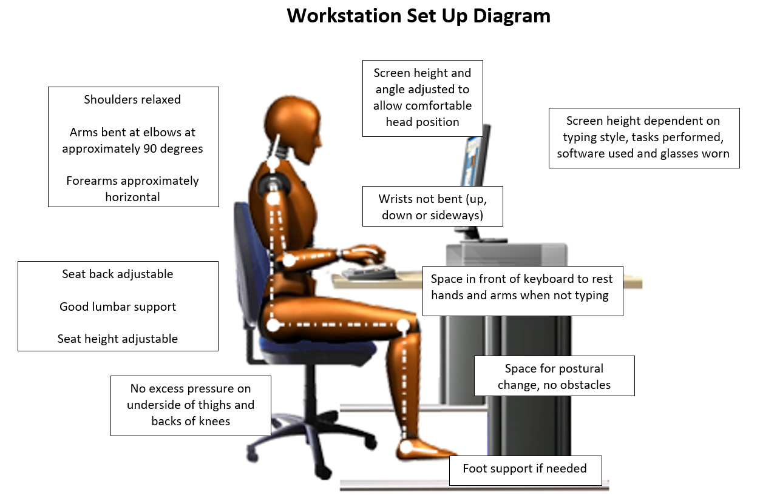

- You may not have your full setup at home, so if required please consider adaptations such as a small box as a footrest, try to use a firm chair and cushions to adjust height and a rolled towel/cushion to provide lumber support and books to raise screen/monitor height.

- Please read the University's guidance on DSE and it is important that you should complete the Health and Safety homeworking e-Learning module and a simple homeworking checklist to help you set up a safe workstation in your home. Further information is available from the Health & Safety Executive (HSE).

- Health and Safety homeworking e-Learning module

- The Health and Safety Homeworking checklist is contained in the appendix

- You should use this information to identify any health and safety concerns or barriers that may impact your ability to work safely from home and you should raise these with your manager so that appropriate advice or support can be provided.

- If it would help you to obtain key items of your office furniture or equipment from campus, you can arrange access by booking a slot via the Building Access app in Microsoft Teams, using this step-by-step guide. Microsoft Teams is available to all Edinburgh Napier colleagues via a web browser, or through the app which can be downloaded free-of-charge.

- If necessary, assistance may also be provided to help relocate these items to your home environment.

- If you require additional essential equipment, you can order this by following the process detailed within the IT Procurement intranet page. Due to increased demand and a worldwide shortage of components, there may be a delay in obtaining and allocating equipment. Information Services are doing all they can to secure and deliver equipment as quickly as possible. If you are unable to work due to lack of equipment, please discuss this with your manager.

- If you have a disability or medical condition that requires adjustments to be made to enable you to work at home safely, occupational advice may be sought and wherever possible reasonable adjustments will be made. You should discuss this with your manager.

Your wellbeing

- If you experience a change in your health, please inform your manager as you would do normally. If you develop symptoms of COVID-19, you should follow the latest NHS advice.

- One of the most difficult things to manage when working remotely is your time. Where you can establish a normal workday routine – be clear when your working day begins and ends and take regular breaks to refresh. Ideally, you should take a 2-3 minute micro break every 20 minutes where you get up and stretch, a 5 minute proper break every hour and a normal lunch break. When work is over, be sure to switch off and put your work away to avoid burnout.

- Cultivate healthy habits such as taking exercise and fresh air every day. Try to incorporate desk exercises into your daily routine and try to avoid awkward, static postures by regularly changing position. Phone meetings whilst walking can be a great way to get those steps in whilst still working, even if it is just around your home or garden.
- We understand that some colleagues may find it difficult to adapt to working in an environment with limited social contact, while others may find it harder to manage their time or separate work from home life. If you are experiencing difficulties, please discuss these with your manager. We appreciate the challenges of juggling childcare and work. We understand that this situation may raise issues of isolation if you live on your own, or if you share your home with others.

- Your manager will regularly check-in with you to ensure that you are managing your work-life balance effectively and will arrange virtual team meetings. Participating in ‘virtual’ coffee mornings, tea breaks and social events can help people feel connected and reduce feelings of isolation. If you have any ideas for social interactions during this period, please discuss these with your manager.

- It is likely that some people will be experiencing higher levels of stress and anxiety during this period. It is during times like these, that we need to stay informed, but also ensure we value our own wellbeing and mental health. The University's Health and Wellbeing pages contain a range of information, advice and support. The following resources provide free support for managing mental health:

Workplace Options | Confidential and independent resource to help employees balance their work, family and personal lives.
Big White Wall | 24/7 peer-to-peer and professional support from clinicians.
Mindfulness sessions | Online live sessions that consist of 35-40 minute mindfulness practice followed by some reflections and discussion.
Mental Health Foundation | Advice about looking after your mental health during the COVID-19 outbreak.
MIND | Practical advice about taking care of mental health and wellbeing during the COVID-19 outbreak.
NHS and HSE Stress Control classes | Live-streamed free stress classes specific to support you through COVID-19 and which can also be accessed via You Tube.
World Health Organisation | The WHO has launched a health at home challenge on social media with suggestions on staying healthy while at home, including working at home
Headspace | An new app package has been created called “Weathering the Storm”

Suggested ways of working

- Ensure that you are clear about what is expected of you and are comfortable that the required outcomes are reasonable given your individual circumstances. Keep your manager updated on progress as you normally would.

- When working remotely it can help to write a list of what you need to achieve each day. Sharing your calendar with your colleagues can be helpful so that they know when you are available, or offline.

- People work much better when they are focused on one thing, so try to minimise distraction and move the phone out of the way to let you concentrate. Aim to get the big thing completed early in the morning.

- You are encouraged to use free virtual means of communication wherever possible, e.g. WebEx, Microsoft Teams or Skype for Business. If you need any support to use online systems you should discuss this with your manager. Detailed Information Service guidance is available to support everyone who is working from home. IS have developed a new MS Teams Portal which offers specific guidance on MS Teams.

- Try to embrace video calling – being present and seeing each other is an important part of keeping connected. Don’t hide away or do other work during the meeting.

- Some employees may require both audio and visual connection in a meeting in order to connect properly. Managers have been asked to be mindful of this when hosting meetings to ensure that no one is disadvantaged. If it would help you to have both mediums in use during team meetings, please let your manager know.

- Many people tend to over communicate when they are working from work. Try not to overcompensate because you are feeling anxious about ‘being seen’ or want people to know what you are doing. Focus on achievements, rather than activity. You know if you are on task and being productive – keep yourself in check.

Confidentiality and security

- It is essential that University systems and data continue to be protected from cyber security threats during this period. Some of the usual University security measures don’t apply from home, so it is important that you are even more careful and vigilant during this period.

- You should complete the Information Security e-Learning module to refresh your understanding of the risks and what you can do to protect the University, and yourself, by minimising the likelihood and impact of information security incidents.

- Be wary of the threat posed by malicious or scam emails that may be received, purportedly relating to COVID-19, during this period.

- You should follow the usual security procedures when working from home. You should not allow other members of your household to use University equipment, you should lock your screen and put paperwork in a safe location, out of view and reach of other household occupants.

- Ensure that you understand your obligations in relation to the University's Data Protection Code of Practice - Security of Personal Data and take appropriate measures to protect personal data.

- If you are using a personal device for work you should ensure that you do everything possible to keep it secure and comply with the data protection regulations. Please read this advice about keeping safe online to prevent compromising the security of the University’s data.

- If you have confidential papers which you no longer require, please retain them securely and bring them back to the University to place in a confidential waste console at the first available opportunity. Only shred confidential waste at home if it is absolutely necessary and if your shredder shreds to a high enough security standard (cross cut DIN level P-4 minimum, no ‘tape’ style shredders). Further information about disposing of confidential documents whilst working from home can be found here.

My Contribution and your development

- It’s important you take the time to reflect on this academic year and discuss your successes, challenges and any support that you need moving forward. Your manager should schedule a virtual end of year conversation with you and you can complete your self-assessment in the normal way on the current review form on HR Connect.

- You may wish to consider the following when you prepare for your end of year conversation.

- Reflect on your objectives and how they have changed. What challenges did you face? How did you work around these challenges? How did that affect you achieving your objectives? Consider what objectives became no longer relevant.
- Identify what new priorities you needed to focus on due to COVID-19.
- Think about your successes. As a result of the pandemic, many of us have achieved great things. We’ve had to adapt, work in different ways and had to accelerate our learning, through learning new tools, systems, or processes.

- You can start planning your 2020/21 objectives with your manager using the offline template on the My Contribution intranet site. You’ll then be able to copy and paste these into the new system when it goes live.

- My Contribution intranet pages and online training sessions are available to support this process, further details are available on the online staff development events page.

- The prolonged homeworking period may offer you the opportunity to further develop your skills and commit to completing training. Learning and development can contribute to positive wellbeing, build resilience and help you adapt to these changing times. An extensive online training provision is available for employees to access during this time.

Support

Human Resources Team | humanresources@napier.ac.uk
Health and Safety Team | safetyoffice@napier.ac.uk
Trade Unions (EIS & UNISON) | If you are a member of a trade union, you can obtain support from your representative
Learning and Development Team | To discuss virtual courses, you should contact learninganddevelopment@napier.ac.uk for further information.

Health and Safety – Homeworking Checklist

DISPLAY SCREEN EQUIPMENT (DSE) | Yes | No | Further information
Have you completed the online Essential Skillz homeworking module? |  |  | If no, you should complete the Homeworking module as soon as possible. (Refer to guidance attached on accessing Essential Skillz)
Where a laptop has been provided, do you have a separate mouse and keyboard and a docking station? |  |  | Use in line with guidance on use of computer and other handheld devices.
Are you aware of the importance of taking regular breaks from computer-based work? |  |  | Further guidance on DSE can be found on the Health and Safety website
FIRE | Yes | No | Further information
Is your work area free from excessive combustibles? |  |  | Combustibles are anything which can burn easily and quickly i.e. lots of paper, cardboard, flammable aerosols.
Do you regularly dispose of waste materials? |  |  | Do not allow waste material to accumulate in your work area.
Are your exit routes clear? |  |  | These should be free from obstruction.
Do you have an escape plan? |  |  | Know exactly what you would do in an emergency consider doing a household escape plan.  See http://firekills.direct.gov.uk
In the event that you have a medical condition/disability which could affect your ability to evacuate your home quickly in an emergency, have you ensured that your work area is on the ground floor level? |  |  | In the event that there are any concerns with regards to safe and quick evacuation, please contact the Health and Safety Team for more advice.
Do you have a smoke alarm fitted? |  |  | Smoke alarm should be fitted (preferably close to the work area) and tested regularly with the battery replaced as and when required.
ELECTRICAL EQUIPMENT | Yes | No | Further information
Are visual checks of electrical equipment undertaken to identify any obvious faults such as worn or damaged leads or plugs? |  |  | Check for cracks/loose casing, missing screws, breaks in the insulation etc. Take out of use if faults found - do not use unsafe equipment.
Is the equipment working as it was designed to? |  |  | Look for discolouration, signs of overheating on the cables or casing.
Where there is more than one appliance powered from a single electrical wall socket, is a properly fused multi socket available and used? |  |  | Small electrical appliances, e.g. fan heaters, irons, can use a lot of electricity and be a fire hazard and therefore should not be used with an adapter.
Are cables secure in all plugs? |  |  | The outer sheath must be secure in the plug grip.
SLIPS, TRIPS AND FALLS | Yes | No | Further information
Are your floor coverings sound and without defects which could cause you or others to trip over? |  |  | Slips and trips are the biggest cause of all workplace accidents and can easily be minimised by simple checks and remedies.
Are your walkways clear of tripping hazards,  E.g. trailing cables? |  |  | Move obstacles and re-route trailing cables as necessary.
MANUAL HANDLING | Yes | No | Further information
Does your work require any manual handling activities? |  |  | Set up your work area to avoid having to move equipment or furniture.  Also available in the Essential Skillz training library is manual handling training.
WORKING ENVIRONMENT | Yes | No | Further information
Are you able to provide a suitable work environment free from disturbance and/or disruptive noise? |  |  | Consideration should be given to family members in the home, pets, neighbours etc.
ACCIDENTS / FIRST AID | Yes | No | Further information
Do you know the procedure for reporting any accidents, or work-related illnesses? |  |  | If no, please refer to the Health and Safety website for guidance on accident reporting and/or the HR website for guidance on sickness absence.
Do you have suitable first aid materials available whilst working at home? |  |  | You will need to have basic first aid materials available i.e. a small first aid kit.
SECURITY | Yes | No
Can laptop, computer and confidential files be locked away when not in use? |  |  | For data protection and security purposes these should be secured when not in use.

Note: This checklist is for your information only, there is no requirement to forward it on to the H&S Team.

