UNIDESK FOR STUDENT SYSTEMS

These instructions have been compiled to provide an indicative walkthrough of functionality and call logging within the Student Systems area of UniDesk.

Essential Links:

UniDesk LIVE environment: UniDesk Home

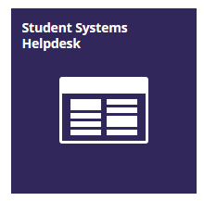
For quick access, it is recommended that when you are within the Student Systems UniDesk area, the link is saved to your Add to Favourites bar:

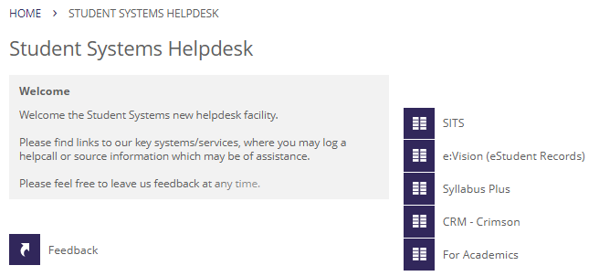

Please select (click) the service (or system) you require assistance with.

PAGE

For Academics 3

SITS 4

e:Vision (eStudent Records) 5

Syllabus Plus 6

CRM 7

All Users 8-9

For Academics:

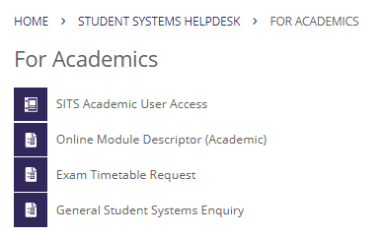

The options available may seem limited, for now. As our service progresses this may grow over time.

You may click on the service enquiry you require to make.

For SITS:

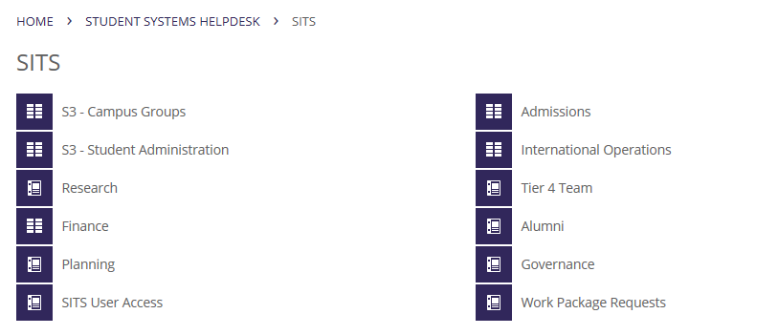

You may select your Team, eg. School Support Service (Campus Groups):

Select the activity you require assistance with:
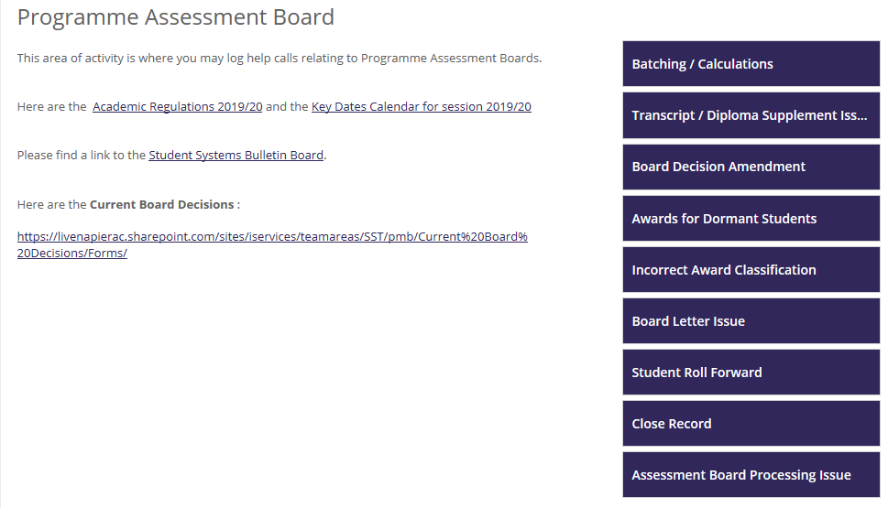

On occasions, when you require to log a call, you should be able to identify the relevant category of call within the area of business activity, eg. one of the options on the right.
For e:Vision (eStudent Records):
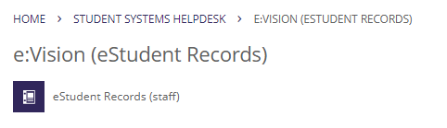

When you select this you will have limited option for call logging:

On occasions, when you require to log a call, you should be able to identify the relevant category of call within the area of business activity, eg. the option on the right.

The call logging options for eStudent Records (e:Vision) will be built upon, over time, when we can analyse and develop what is relevant for our customers.
For Syllbus Plus:
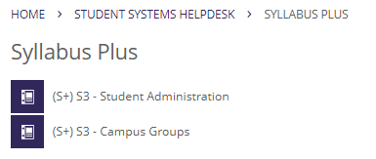
This area is predominantly for School Support Service:
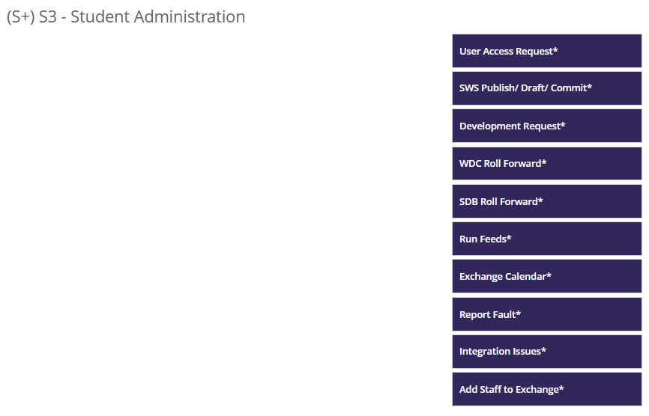
And:
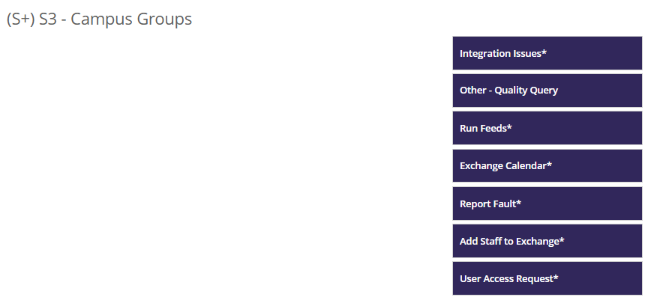
On occasions, when you require to log a call, you should be able to identify the relevant category of call within the area of business activity, eg. one of the options on the right.

For CRM – Crimson:
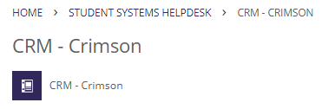

This area is predominantly for Student Recruitment:

On occasions, when you require to log a call, you should be able to identify the relevant category of call within the area of business activity, eg. one of the options on the right.

As shown above, another benefit for introducing UniDesk is to use this service as both an area in which helpcalls may be logged but also as a source of information. We are able to provide links to relevant, helpful information on the staff intranet and to our document guides (hosted on our SharePoint site).

A number of potential helpcalls can be mitigated by the provision of targeted information and solutions prior to call logging. Our aim is to target as much relevant information to our users to create confidence and empower self-serve.

For example, the blank space on the left of the page within the ‘activity’ areas is where we can insert useful information. This can include, detail about what the activity is, hyperlinks through to the Student Systems Bulletin Board, and links to online manuals/processes/training materials.

Additionally, the ‘forms’ which you complete and log for each helpcall are customisable. This can include:
- Fields of information can be mandatory *
- Outlining procedures, processes or areas of general knowledge
- Attachments can be placed inside the form for further explanation, diagrams, etc
- Keywords

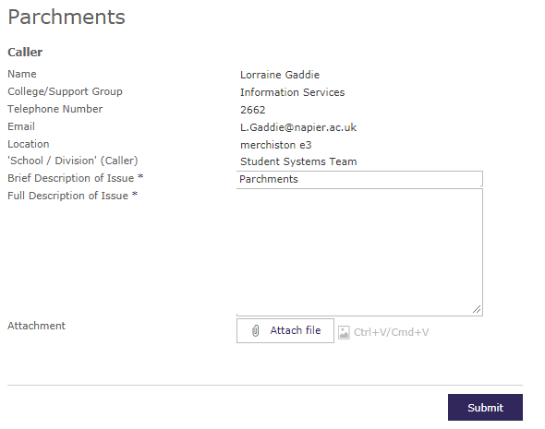

Please help us to help you.

UniDesk is fully customisable and it is where your input is essential and welcome, as a user of this service. Please let us know how are services are performing, whether by providing positive comments or constructive feedback, your feedback will be welcomed.

Please note, you can also manage, log and track any of your UniDesk helpcalls within the My requests tab, found on the UniDesk home screen, accessed at https://napier.unidesk.ac.uk/

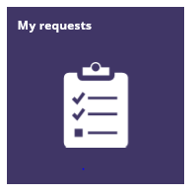

Thank you and please do not hesitate to provide any feedback to Student Systems Feedback

