Supporting Vulnerable Staff
Manager Guidance

The purpose of this guidance is to support you to assess staff who fall within the two groups more vulnerable to the effects of Covid-19 when planning for the return to campus. These groups are those at higher risk of severe illness from Covid-19 and those at extremely high risk of severe illness from Covid-19. Further information on these groups is available from NHS Scotland. This includes staff within the Black, Asian & Minority Ethnic group. This guidance explains the steps which need to be taken to minimise, as far as reasonably practicable, their exposure to Covid-19.

It is the responsibility of staff to inform you that they do or may fall within one of the two vulnerable groups. They are not required to disclose medical information, but should indicate whether they are in a more vulnerable group, in order that appropriate consideration can be given to any suitable and reasonable adjustments that are necessary to protect their health.

If, you become aware that a member of your team falls within the vulnerable category, you should follow the steps below in the flowchart to support the assessment of risk and inform decisions about any additional measures that should be put in place. It is important to make staff aware of the overarching University Covid-19 Return to Work Risk Assessment and any department/role based risk assessments and the actions and recommendation that have been implemented as a result of this as part of your discussion. Staff should complete the Covid-19 Staff Assessment form in the appendix and discuss this with you. The situation should be kept under regular review.

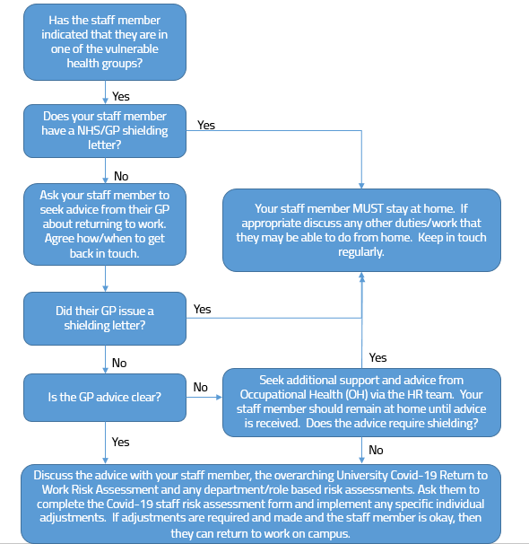

People at extremely high risk

Staff who have received a ‘shielding’ letter must remain at home. They should continue to work from home, wherever possible. If they cannot undertake their normal duties from home and they cannot be furloughed, you can ask them to undertake alternative duties or project work (within their skill set and grade) to complete at home.

People at higher risk

Staff who fall within the higher risk group, but who have not received a ‘shielding’ letter should be asked to contact their GP for advice on any additional specific measures which may need to be Implemented to protect their health. These may include changes to work activities, practices or working patterns.

Thereafter, you should discuss with them any additional specific measures and/or adjustments, advised by their GP, which need to be implemented to protect their health and enable them to safely return to campus, where it is reasonable and appropriate to do so.

You must seek advice from Occupational Health (OH) via the HR team in the following circumstances:

- The staff member is unable to discuss their concerns with you
- You and/or the staff member require additional advice regarding their vulnerability and health

If you are unable to make the necessary adjustments to enable the staff member to work on campus and they are unable to do their work from home, you can ask them to undertake alternative duties or project work (within their skill set and grade) to complete at home.

Staff who live with someone who is in a vulnerable group

Staff who live with someone who has been advised to shield should continue to work from home, where this is possible.

If they cannot work from home or their role is essential and they are required to return to campus, you should in the first instance discuss any concerns with them and revisit the relevant risk assessment and working practices for their area to ascertain whether it offers sufficient reassurance for them. You should consider any additional specific measures and/or adjustments, advised by the vulnerable person’s GP, where it is reasonable and appropriate to do so.

Staff who live with someone who is in the higher risk category (notably those who are over 70, are pregnant or have an underlying health condition) should continue to work from home, where this is possible.

If they cannot work from home or their role is essential and required on campus, they would be expected to attend work. However, you should discuss any concerns with them and should revisit the relevant risk assessment and working practices for their area to ascertain whether it offers sufficient reassurance for

them. You should consider any additional specific measures and/or adjustments, advised by the vulnerable person’s GP, where it is reasonable and appropriate to do so.

What can be done to remove or lessen the risk?

The Health and Safety team can advise on any other local reasonable adjustments in addition to the overarching University risk assessment and local school/services risk assessment. The actual measures will be dependent upon individual circumstances and specific GP advice, however the following types of adjustments may be considered:

- Changes to tasks, duties or other ways of working
- Amended working hours or patterns
- Working from an alternative campus

Prior to making a final decision, further advice should be sought from the Health and Safety Team, your HR Partner and Occupational Health, if necessary.

Covid-19 Staff Assessment Form

The purpose of this form is to establish whether you fall within one of the vulnerable health groups, whether you require to remain ‘shielded’ at home, or whether you can attend work on campus. If you can attend work on campus these questions will assist your manager in the consideration of any additional adjustments which may need to be discussed with you prior to your return to campus. Responses will be treated confidentially and sensitively. You do not need to provide details of any medical condition. Please note this form will be stored securely on your HR employee file.

Name: | School/Service:
Job Title: | Contact number:

- Have you received a ‘shielding’ letter and/or advice from your GP to remain shielded? Y/N
If you answered Y to this question, you must remain at home.

- Are you in the higher risk group but have not received an NHS or GP ‘shielding’ letter? Y/N

Higher risk group includes individuals who are:

- aged 70 or older (regardless of medical conditions)
- under 70 and instructed to get a flu jab as an adult each year on medical grounds
- pregnant
- Black, Asian or Minority Ethnic (BAME)

And those with:

- chronic (long-term) respiratory diseases, such as asthma, chronic obstructive pulmonary disease (COPD), emphysema or bronchitis
- chronic heart disease, such as heart failure
- chronic kidney disease
- chronic liver disease, such as hepatitis
- chronic neurological conditions, such as Parkinson's disease, motor neurone disease, multiple sclerosis (MS), a learning disability or cerebral palsy
- diabetes
- problems with their spleen, for example sickle cell disease
- a weakened immune system as the result of conditions such as HIV and AIDS, or medicines such as steroid tablets or chemotherapy
- a BMI of 40 or above who are seriously overweight

- Please confirm that you have discussed your health concerns with your GP Y/N
If you answered N to this question, please contact your GP for specific advice relating to your health

- Has your GP advised you of any specific adjustments/alterations which need to be considered Y/N
to enable your return to the workplace?

If you answered Y to this question, please state these adjustments/alterations

- You consider that you are able to return to work on campus Y/N

Employee Signature ………………………………………………………………………… Date ………………………….

Manager Signature ………………………………………………………………………….. Date ………………………….

Please confirm any agreed measures and/or adjustments that will be put in place

Review date:

If you answered N to this question, a referral to Occupational Health will be made.

