Rivers Suite Booking Form
Please note before completing this form that there is a £240 charge to use the Rivers Suite.
The Siegfried Room and Wilfred Room can no longer be booked as separate spaces.
This charge is for internal bookings only being paid for via a cost-code.
External bookings should be referred to the Conference Office on ext. 3711.

Please return this form via e-mail to conferences@napier.ac.uk

Name:
Department:
COST CODE (required):
Extension Number:
Email:

EVENT TITLE (required):
Date(s):
Timings (consider time needed to set-up etc.):
Number Attending:
Preferred Room Layout (see images below):

Additional Information / Special Requests:
____________________________________________________________________________________________________________________________________________________________________________________________________________________________________________________________________________

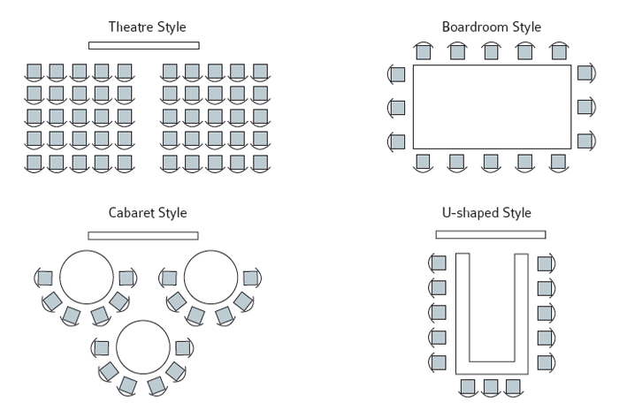
Maximum capacity 30 delegates
Maximum capacity 70 delegates
Maximum capacity 40 delegates
Maximum capacity 100 delegates

