ABI Wildlife Consultancy



Biodiversity Audit on behalf of Edinburgh Napier University

Report for October 2010

Survey work.

The focus for October has been the continuation of the fungi survey. It has been a very interesting month with several rare and unusual finds from deadly poisonous, hallucinogenic to much unexpected finds of *Ramaria* (Coral fungus) along with 5 species of *Hygrocybes* (Waxcaps). Bird life has also been interesting where there has now been a shift to winter visitors such as fieldfare and redwing from Scandinavia along with more local migration such as small flocks of long-tailed tits and goldfinch. It has also been a good month for meeting people who use the campuses to walk or other activity where they are interested in the work that I am currently carrying out on behalf of Edinburgh Napier. Some of these people are local to the area and involved in helpful tasks such as litter picks.

Craighouse

Numbers refer to the amount of different species

Habitat Type Birds Mammals Fungi

N Wood 12 2 4

S Wood 9 2 5

Amenity Grass 10 2 23

Buildings 2 0 0

The most interesting species found in Craighouse was coral fungi *Ramaria* (possibly *flava*). Listed as rare and very little understood and any information for this species is valuable. Apparently edible but has a laxative effect – not sure why anyone would want to eat it! Waxcaps *Hygrocybe conica* found on grass banks, interesting but not rare*.*

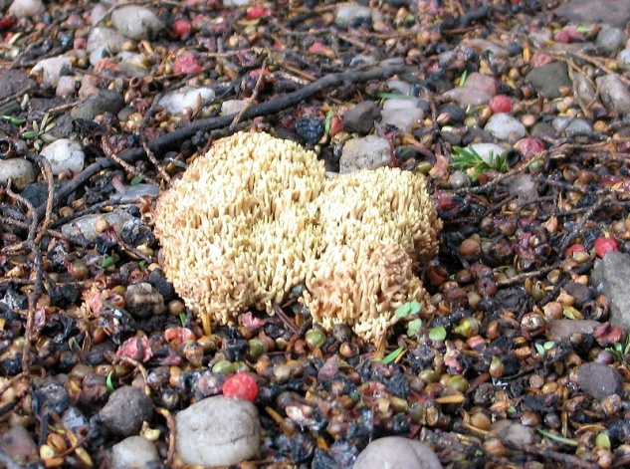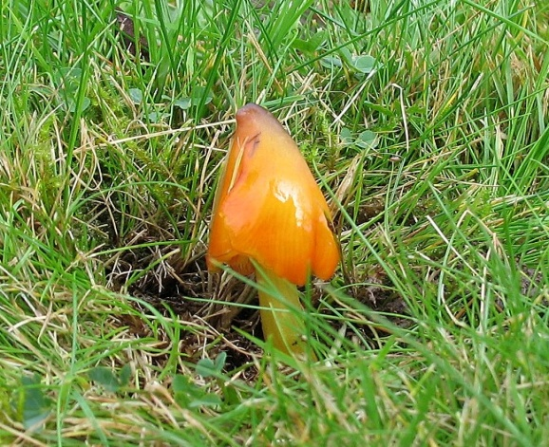

*Ramaria flava Hygrocybe conica*

Craiglockhart

Numbers refer to the amount of different species

Habitat Type Birds Mammals Fungi

Grassland 1 3 5

Amenity Grass 8 2 17

Buildings 2 0 0

Woodland 13 0 13

Several species of interest such as *Coprinus comatus* (common on grassland), *Leucopaxillus giganticus* and also *Paxillus involutus* which is deadly poisonous and found within two habitats associated with trees.

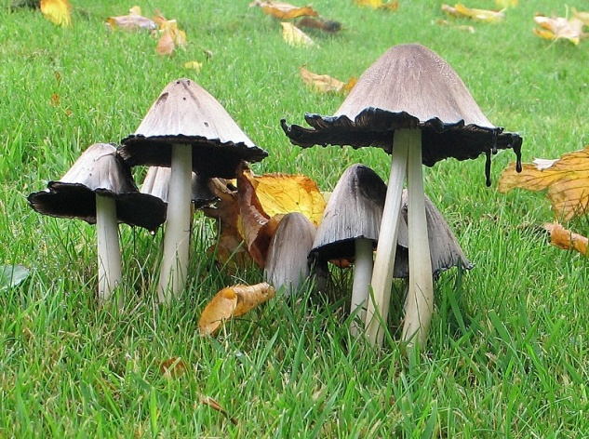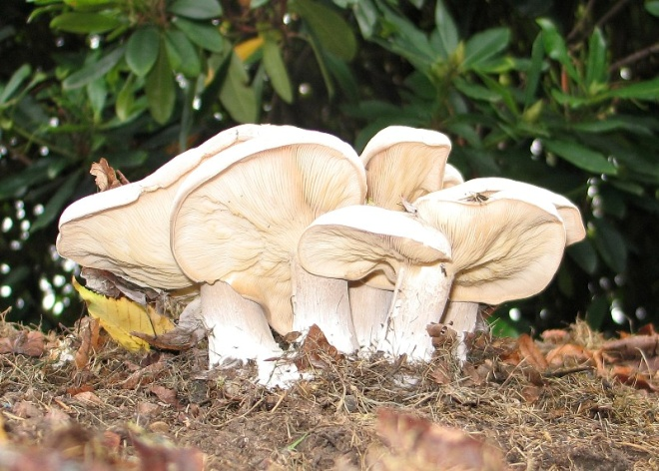

*Coprinus comatus Leucopaxillus giganticus*

Merchiston

Numbers refer to the amount of different species

Habitat Type Birds Mammals Fungi

Buildings 0 0 1

Disappointingly but not surprising only one fungi found at Merchiston which was waxcap *Hygrocybe virginea* which is not rare but still an interesting find.

Work planned for November will be a continuation of the fungi survey though it is perhaps getting a little past the time for finding new species. Bird survey will continue and if enough leaves have been blown off the trees a survey of all grey squirrel dreys will be conducted.

A. Patterson

Ecological Consultant