ABI Wildlife Consultancy



Biodiversity Audit on behalf of Edinburgh Napier University

Report for April 2011

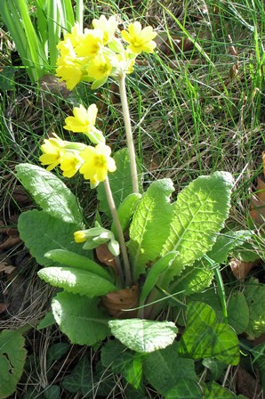

False Oxlip

Survey Work

The lichen survey has now been competed with samples taken from: buildings, trees and walls and other structures such as iron railings. Trees as a habitat hold more species than other structures and Craighouse had slightly more species than other campuses. Lichens can survive extreme environments from the Antarctic to deserts. Lichens survive best in temperatures ranging from - 20°C to + 70°C in which Scotland, particularly the Highlands fit well with this temperature range. Humidity is also important to allow lichens to dry out slowly and areas rich in lichen species can be found towards west Scotland. This species group are sensitive to air pollution, in particular sulphur dioxide (SO2) and as such are good biological indicators.

Summer migrants have now all arrived with swallows, chiffchaff, willow warbler singing territories within the campuses. Some early plants have now been added to the botanical list started last July such as wild garlic. The vice county botanical recorder for the Lothian’s met with me at Craighouse to examine a species of oxlip. Interestingly this species was false oxlip which is a cross between primrose and cowslip (both these species found within meters of each other), and though false oxlip is not considered a rare plant there are only three recorded in west Lothian, one in east Lothian and this record for Craiglockhart would be a first for the city of Edinburgh.

|  |  |
| --- | --- |
| **2km distribution of *Primula vulgaris x veris = P. x polyantha* in Edinburgh** | |
| gridGBv4_nbnims-245323480120 | |  |  | | --- | --- | | **2km square legend** | | |  |  | | 000000000_255051051 | Present in 2km squares | |

Location of False Oxlip in the Lothian’s

Craighouse

Numbers refer to the amount of different species

Habitat Type Birds Mammals

N Wood 14 1

S Wood 12 2

Parkland 13 3

Buildings 1 0

Craiglockhart

Numbers refer to the amount of different species

Habitat Type Birds Mammals Lichens

Semi-improved Grassland 3 0

Buildings 2 1

Parkland 11 0

Merchiston

Numbers refer to the amount of different species

Habitat Type Birds Mammals Lichens

Buildings 3 0

*(gate at the rear of campus was locked and this area was not examined)*

Abbie Patterson

Ecological Consultant