Environmental Sustainability Monthly Meeting - April Agenda

Ankit Duggal: President, Edinburgh Napier Students’ Association
Ben Standish: Campus Cycling Officer
Emilia Heiskanen: Edinburgh Napier Sustainable Society
Heloisa Fyfe: Vice President, Edinburgh Napier Students’ Association
Jamie Pearson: Environmental Sustainability Manager
Nicola Scrimgeour: Marketing and Communication Officer

Emilia
- Sustainability Society Update

Last meeting last week – no more for the academic year.
The society has had one focus group and will have another in May when exams are done. Focus groups to talk about sustainability/climate module. Some information to be used by the team who will be running the module.

Petra will be taking over as president of the society.

Emilia will do the divestment blurb – Nicola says most of the rest is ready to go out.

Emilia has been in touch with Callum before releasing the survey but decided to move forward separately.

We discussed the coffee conscience take-over of the coffee provision at ENU and talked about ideas related to meat-free meals (e.g. removing beef).

Ben
- Quick Update – Training, Dr Bike, Bicycle Care and Repair Kit (working title),

Cycle Ride Leader Training taking place on 6th May. 2 women/2 men, 3 students/1 staff. It will create a network of Cycling Champions to help with future led rides.

Dr Bike session on 29th April cancelled but have secure more funding for next year – there will be between 3-5 sessions worth of funding.

I am pulling together 6 ‘Care and Repair Kits’ one for each campus and accommodation site. These will have QR codes attached to items linking to ‘how to’ videos. This should be in place by the summer

- bicycle options focus group:
A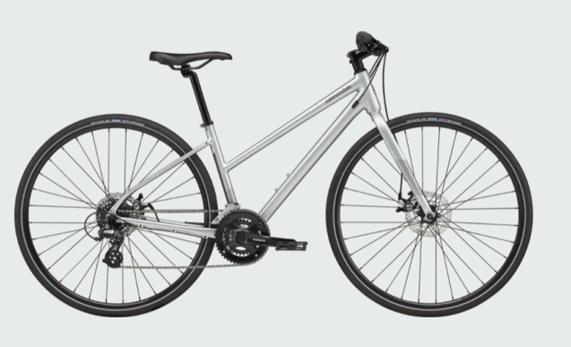
- Lightweight 11kg
- 14 gears (2x7)
- Mudguards to be added
- No integrated lights
- No chain case

B
- Heavier at 18kg
- 7 gears
- Integrated mudguards, panier rack, chain case and lights (dynamo)
- Upright riding position

Emilia has a Revolution MTB and it is heavy buy fit for purpose. She does like the upright riding position – good for the canal but perhaps not as good for the road riding.
Nicola suggested something that with a light integrated would be great.

Heloisa –
- Hedgehog Friendly Campus

“As part of the silver actions of the Hedgehog Friendly campus, we need to conduct a hedgehog survey on campus. Here's a video that explains it: https://www.youtube.com/watch?v=tw9yqWlE8pA

The idea is for us to do a survey at Merchiston and Craiglockhart at the same time.

Q for Jamie: do we need permission from the estates team to carry this out? Who do we talk to?

Yes – would need permission from Russell. Need to ask the HFC people – are the cameras etc. battery operated, or do they need to be plugged in?

Q for Emilia: Would the sustainable society like to be involved in helping us with this?”

Emilia would say yes but she would need to ask the new committee. But Emilia would imagine they would be happy to help with this. If it takes place this year she doesn’t know if there is anyone available to help but next academic year Emilia can ask Petra.

Jamie
Env. Strategy Group Meeting – the strategy first draft is there but has been delayed slightly. Gary is meeting with Andy today to answer some initial questions and then it will go to ULT. Jamie will share info as soon as he can and as widely as possible.

