Edinburgh Napier University
Environmental Management System Maps
ENU-EMS-047

University Campuses and Accommodation Sites
Scope: September 2014
Campus | Address | Internal Space (m²) | External Space (m²) | Total Space (m²) | Number of buildings | Site Map Ref | Site History Ref | Additional Maps Ref including notes (and description)
42 Colinton Road | Edinburgh, EH10 5BT | 803.78 | 4,227.66 | 5,031.44 | 1 | ENU-EMS-29 | ENU-EMS-49
Bainfield Social Space | Bainfield Drive, EH11 1BF | 1,156.79 | 0 | 1,156.79 | 0 | ENU-EMS-32  ENU-EMS-33 | ENU-EMS-52 | Occupies bottom floor of accommodation.
Bainfield Student Accommodation | Bainfield Drive, EH11 1BF | 22,000.00 | 8,522.41 | 29,754.49 | 4 | ENU-EMS-32  ENU-EMS-33 | ENU-EMS-52
Bankhead Workspace | 10 Bankhead Terrace, Edinburgh, EH11 4DY | 539.40 | 0 | 539.4 | 1 | ENU-EMS-30 | ENU-EMS-50
Craiglockhart Campus | 219 Colinton Road, Edinburgh, EH14 1DJ | 13,658.99 | 50,841.41 | 64,500.4 | 2 | ENU-EMS-31 | ENU-EMS-51
Merchiston Campus | 10 Colinton Road, Edinburgh, EH10 5DT | 26,161.28 | 5,624.80 | 31,786.08 | 1 | ENU-EMS-34 | ENU-EMS-53 | Trade Effluent Consent. Applied for but not required. ENU-EMS-60,61&62.
Morningside Church | 60 Morningside Road, Edinburgh, EH10 4DH | 613.22 | 594.14 | 1,207.36 | 1 | ENU-EMS-35 | ENU-EMS-54
Riego Street Student Accommodation | 1-15 Reigo Street, Edinburgh, EH3 9BL | 4,685.06 | 1,340.24 | 6,025.30 | 1 | ENU-EMS-36 | ENU-EMS-56
Screen Academy | 2A Merchiston Avenue, Edinburgh, EH10 4NU | 621.13 | 8.2 | 627.33 | 1 | ENU-EMS-37 | ENU-EMS-57
Sighthill Campus | 9 Sighthill Court, Edinburgh, EH11 4BN | 23,365.52 | 23,759.57 | 47,125.09 | 3 | ENU-EMS-38 | ENU-EMS-58

University Campuses and Accommodation Sites – Not included in scope
Campus | Address | Internal Space (m²) | External Space (m²) | Total Space (m²) | Reason for not Including Site
Baileyfield | Unit 10, Baileyfield Crescent, Edinburgh, EH15 1ET | 613.88 | 623.55 | 1,237.43 | Temporary lease.
Morrison Circus Student Accommodation | 6&7 Morrison Circus, Edinburgh, EH8 3DW | 1,786.09 | 0 | 1,786.09 | Lease ends 31/08/15.
South Gyle | 36&38 South Gyle Park, Edinburgh, EH12 9EW  ENU-EMS-74  ENU-EMS-59 | 3,326.12 | 0 | 3,326.12 | Building is owned by the University but leased.
West Bryson Student Accommodation | 7&9 West Bryson Road, Edinburgh, EH11 1EH | 2,649.70 | 1,262.22 | 3,911.22 | Lease ends 31/08/15.

New Buildings: Yet to be built
Campus | Address | Reason for not Including Site
Orwell Terrace Student Accommodation | Unknown  ENU-EMS-75, ENU-EMS-55 | New accommodation, currently at planning stage.

Historic University Buildings: Sold or no longer leased or owned
Campus | Address | Reason for not Including Site
42a Colinton Road | Edinburgh, EH10 5BT | University vacated the building in September 2014.
Craighouse Campus | 1 Craighouse Road, Edinburgh, EH9 1HT | Campus sold. Vacated May 2013.
Livingston | St. John’s Hospital, Livingston, EH54 6TR | University has moved out of the rented space.
Marchmont Campus | 61 Marchmont Road, Edinburgh, EH9 1HT | Campus sold. Vacated January 2013.
Melrose | Borders General Hospital, Melrose, TD6 9BS | University has moved out of the rented space.
West Tollcross and Fountainbridge Student Accommodation | 123 Fountainbridge / West Tollcross, Edinburgh, EH3 9QG | University vacated the buildings in June 2013.
Wrights Houses Student Accommodation | 28&34 Wrights Houses, Edinburgh, EH10 4HR | University vacated the buildings in June 2014.

Aim is to gain Platinum EcoCampus status and ISO14001 by the end of the 2014/15 academic year. The campuses and accommodation sites above will be open during that time.

Total Space

Total included in Environmental Management System (EMS) Scope: 188,521.60m².
Total not included in EMS Scope: 10,260.86m².

Total Percentage of accommodation and campus floor space included in EMS scope: 94.56%.

Map Key

Used In The Following Maps: ENU-EMS-29, 30, 31, 32, 34, 35, 36, 37 and 38

Symbol | Description | Example
A | Open Grate (non-descriptive)
B | Non-descript Metal Cover | 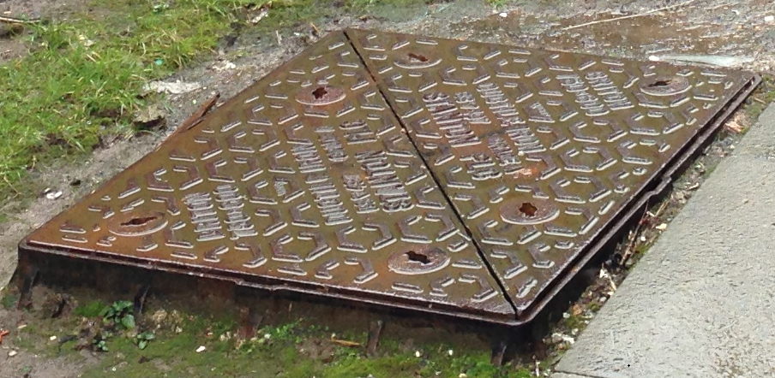
C | Metal Grate with SW emblazoned | 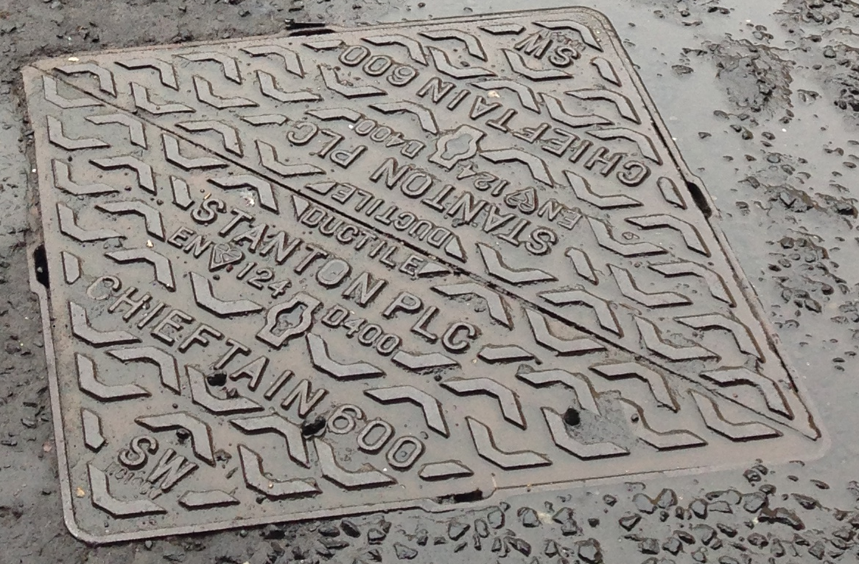
D | Metal Grate with FW emblazoned | 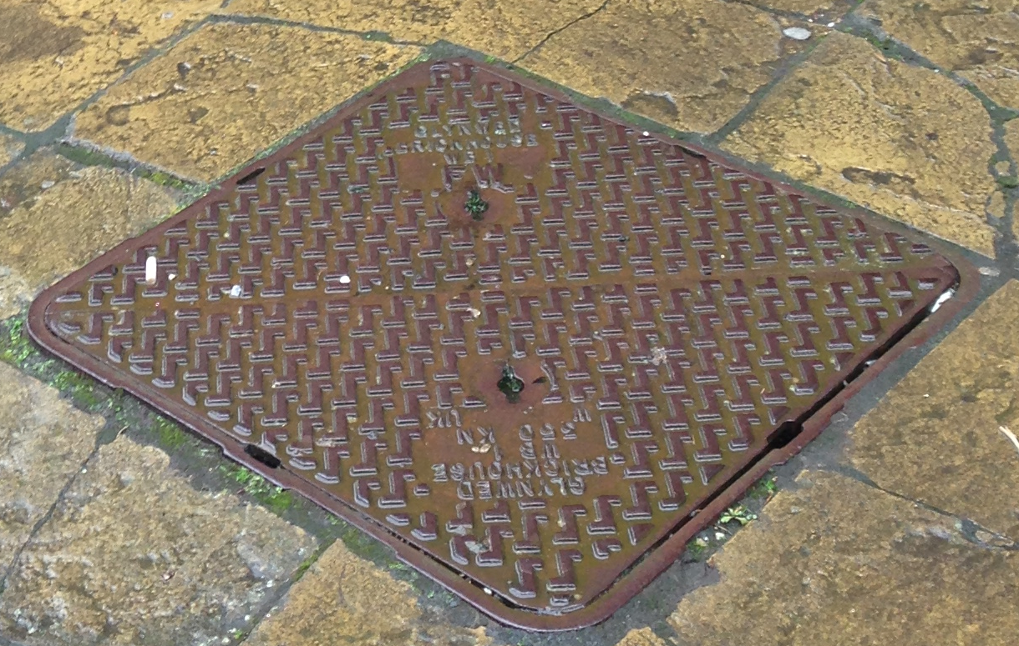
E | Metal Grate with W emblazoned | 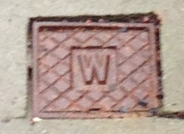
F | Grate Channel (non-descriptive) | 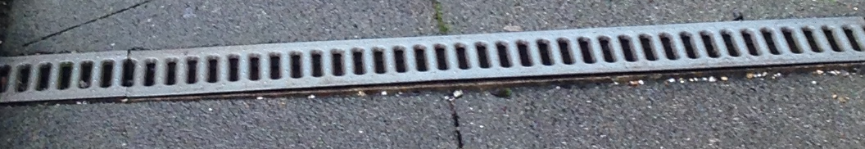
G | Fire Hydrant | 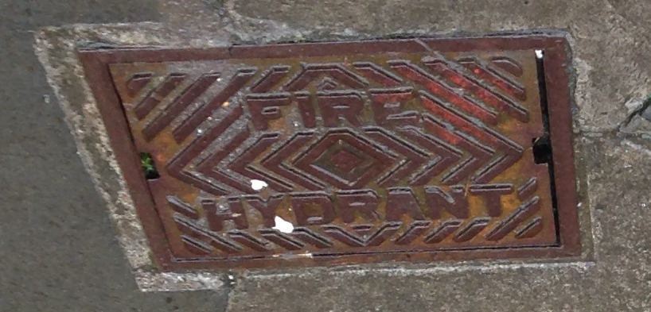
J | Rod Access Point | 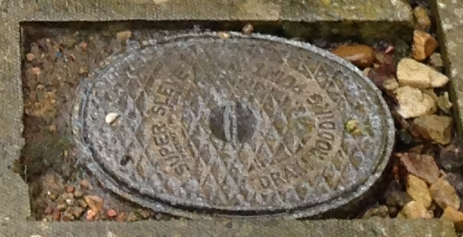
K | Gas Cover
Blue Circle | Waste Collection Point
Brown Triangle | Effluent/Water Out
Green Dot | Down-pipe for Roof Water
Grey Square | Heating Vent
Pink Cross | Water In
Purple Line | Campus Boundary
Red Dashed Line | Car Park Boundary
Yellow Star | Air Conditioning

Changes to the Document
Reason for Change | Date of Change
Removal of information pertaining to Hong Kong. The development will not go ahead. | 01/05/14
Refresh of scope, to update the variation in scope since May 2014. | 29/09/14

Notes:
EMS Manager. Jamie Pearson. Sustainability / Environmental Advisor. Property & Facilities Services.
EMS Senior Management. Members of the Principal’s Executive Group and the Environmental Sustainability Advisory Group. See EMS Implementation Team ENU-EMS-6a for Management and Communication Structure.

Author: Jamie Pearson, Sustainability / Environmental Advisor.
Approver: Grant Ferguson, Assistant Director, Property & Facilities.
Version One Created: 11/03/13
Version: Three
Date: 29/09/14

