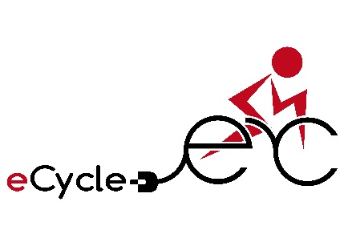

User Agreement and Registration Form
Edinburgh Napier University

All users of the eCycle scheme are required to complete and sign this form. A manual will be supplied during the induction which details the operation of the eCycle. This form only needs to be completed once. Please use block capitals.

PERSONAL DETAILS

Name:

Staff/Matriculation Number:

Department/School:

Home Address
(term-time for students):

Phone:

Email:

Emergency contact information
(Name/Phone number):

CYCLING EXPERIENCE

I confirm that I am a confident and competent cyclist (circle below as appropriate). If no, you will be required to attend a cycle training course before using an eCycle:

Yes No

If you answered yes to the question above, how often do you usually cycle (circle below as appropriate):

Infrequently (once per month) Occasionally (once bi-weekly) Often (weekly)

TERMS AND CONDITIONS

Please read the following terms. Your signature will signify you agree to the terms.
- I am a student or a member of staff at Edinburgh Napier University.
- I confirm that I have the necessary experience and competence to ride an eCycle safely and will ride in a matter within my competence.
- I will abide by the Highway Code https://www.gov.uk/rules-for-cyclists-59-to-82 and will follow good cycling practice http://think.direct.gov.uk/cycling.html
- I acknowledge that I am responsible for my own safety.
- I have attended an induction. I have read and accept the Risk Assessment for the use of an eCycle. I am aware of the user manual and film available at www.bit.ly/ENU-SO11
- I certify that, to the best of my knowledge, I do not have a medical condition which might have the effect of making it more likely that I be involved in an incident which could result in injury to myself or others e.g. other road users.
- I will take all reasonable precautions to prevent loss of the eCycle and accessories, including always using the D-lock and cable to fix the eCycle itself to an immovable object (ideally a cycle stand), and within secure cycle stores where available.
- If using the eCycle for personal commute or personal travel, I will ensure there is an appropriate and safe place at home to store the bike securely overnight.
- I will no allow other persons to use the eCycle or accessories when in my possession.
- I will consider required precautions, including wearing a high visibility vest and helmet.
- I will conduct an M-check on the cCycle and check all accessories before every use and journey, and report faults immediately to Property & Facilities Helpdesk 0131 455 5000.
- I will not use an eCycle or any accessories, including helmet, with a known fault. If I do I accept I am using them at my own risk.
- I will not carry out any work to the eCycle or accessories to rectify faults which appear during use. I will contact the Property & Facilities Helpdesk immediately 0131 455 5000.
- I undertake that the eCycle or associated equipment, including accessories will not be used improperly and that it will be returned to Edinburgh Napier University in the same condition as it was received (save for ordinary wear and tear) at the agreed location.
- I will report any theft immediately to the Property & Facilities Helpdesk at 0131 455 5000.
- I will assist the University with monitoring and evaluation of the eCycle scheme.

Edinburgh Napier University shall not be liable for any injury or loss whatsoever in relation to use or loan of an eCycle, except in relation to personal injury or death arising from the University’s negligence. Any injury or loss resulting from or arising in connection with the reckless, careless or improper use of an eCycle or equipment by a user shall be borne by such a user. Users have a duty to report any damage or faults to the eCycles or equipment immediately, so that they can be maintained in a roadworthy and usable condition.

I agree to the terms and conditions.

Signed: Date:

Application Accepted by Edinburgh Napier University.

Name (print): Signature: Date:

