Contents
Process overview 2
Part1 Overview 2
Part 3 overview 2
DFA sign off Overview 3
Roles 3
Requester Journey 4
Part 1 4
Saving your Submission 7
Part 3 Requester Journey 9
Part 3 approval 12
To approve part 3 12
Your Dashboard 14
Part 1 Approval 16
Part 3 Approval 17
DFA 18
Finance Business Partners (FBP) Journey 19
The FBP dashboard 20
Head of Procurement (HoP) Journey 23
Procurement Leads Journey 24
Part 3 Field Descriptions 24
Section 3b Field Descriptions 26
The Procurement Leads dashboard 31
Hardware Software Approvers Journey 33
DFA Journey 36
DFA Dashboard 38
Technical Appendix 40
Stage Codes 40
Source Codes 41

Process overview
Those applying for any procurement over £12.5k must complete a PRF in the online system. The form consists of 3 parts and several routing options that are defined by the information entered into the form. Everyone is required to complete part one of the form and, depending on the outcome, part 3 also.

Part1 Overview
When filling in part1 you will be required to indicate the intended use for your procurement request. If your request is for hardware or software it will be subject to approval by Information Services members pertaining to those areas. If your request has GDPR implications, you will be required to add some information about this and governance service will be notified and you can expect contact from them regarding your request. Your request will also be subject to approval by the Management Accountants and then the Head of Procurement (HoP) or one of the nominated delegates (HoP Delegates). Each of the approval routes can be rejected at any stage, if your request is rejected you will be notified with who rejected your request, when it was rejected and for what reason. If appropriate, you will have the opportunity to re-submit. Once part 1 has passed all approval routes, the HoP will decide if procurement is required. There are 3 possible outcomes:
- Approved and Procurement is required
- Your request is rejected by the HoP
- Approved and Procurement is not required
Procurement Required
If procurement is required, the HoP will assign a Procurement Lead to your request and they will contact you to arrange completion of part 3. You don’t have to fill in part 3 as the Procurement Lead will do this during said contact. You will have the opportunity to see what information the Procurement Lead is entering and upon completion you will be required to approve the additional information. This is then subject to a further HoP approval stage and, if approved, the request will them be subject to Delegated Financial Authority (DFA) sign off.
Your request is rejected by the HoP
If your request is rejected at Part 1, you will receive a reason for the rejection. Please take account of any recommendations and then resubmit your request.
Procurement is not required
If your request is approved and procurement is not required it will subject to a non influencible spend process which moves the request directly into Delegated Financial Authority (DFA) sign off.

Part 3 overview
If procurement is required, a Procurement Lead will be assigned to your request. They will arrange a time to go through part 3 with you and when complete you will be required to sign off the information in the form. The HoP will also be required to approve part 3 and is able to adjust the values on part 3 before committing your request to DFA.

DFA sign off Overview
Depending on the Total contract value, your request will be subject to DFA sign off. DFA4 sign off is the lowest level and all approved requests are subject to this process. DFA3, 2, 1 represent increments in the total contract value. DFA1 is the highest and requires 4 stages of sign off by 4 people. Then 3 and 2 respectively for DFA3 and DFA2. Your request can be rejected at any stage of DFA, if it is, you will be notified via an email containing who rejected your request, when it was rejected and why.

Roles
Role | Description
Requester | The person filling in Part1
HoP | Head of Procurement, System owner and responsible for several approval stages of the process.
Procurement Lead | Assigned when procurement is required. Assists in filling out Part 3 of the form. Main contact for your request if procurement is required.
Core funded Management Accountant (CFMA) | Responsible for assessing and approving Part 1 if core funded is selected.
Externally Funded Management Accountant (EFMA) | Responsible for assessing and approving Part 1 if Externally funded is selected.
Governance | Notified if your request has GDPR implications
Hardware | Responsible for assessing and approving requests for IT hardware
Software | Responsible for assessing and approving requests for IT software
DFA4 | Responsible for assessing and approving all requests that are approved at part1 or part3
DFA3 | Responsible for assessing and approving requests that are approved at part1 or part3 if the Total Value is over a defined threshold
DFA2 | Responsible for assessing and approving requests if the Total Value is over a defined threshold
DFA1 | Responsible for assessing and approving requests if the Total Value is over a defined threshold

Requester Journey

Part 1

You can start a new request either from your dashboard (see below) or by using the direct link:

https://bpm.napier.ac.uk/Runtime/Runtime/Form/myPRF1Dashboard
https://bpm.napier.ac.uk/Runtime/Runtime/Form/PRF1Main/

To start a new request from your dashboard click the “Create new” button in the “My Saved Requests” tab as shown.
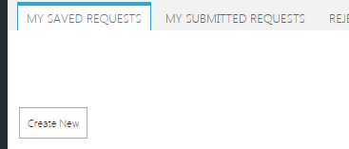
1a Requester
This section is filled automatically when the form loads, if any of the information in here is wrong please contact your HR representative.
1b Basic information
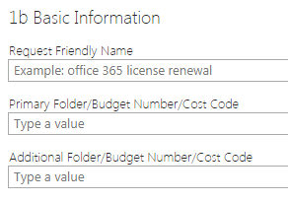
Request Friendly Name
Please enter a memorable name for your request, this is to make easier for you to identify your request.
Primary Folder/Budget Number/Cost Code (Mandatory)
Please enter the Cost Code or Budget Number or Primary Folder name that you wish to place your request against. This is the main Agresso folder the purchase will be charged to. Example: D803-00
Additional Folder/Budget Number/Cost code (Optional)
You can optionally enter an additional Cost Code or Budget Number or Folder name here. If there is a shared cost; the second Agresso folder can be added here. Example: D920-00
Funding Source
Select whether your request is core funded or tied to a project and has an external funding source. When selected please choose a Management Accountant from the appropriate dropdown. NB the drop down contents will change depending on chosen funding source.
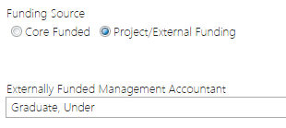
Externally Funded/Core Funded Management Accountant
Name of your School/Department’s Finance Business Partner/Management Accountant. Example: Emma Johnston
Total Contract Value Excl. VAT
The total cost of this purchase. If this is an ongoing cost, the value should be for the length of the contract (if defined) or over four years (if rolling contract) (This value is subject to change if procurement is required)
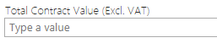
Rationale For Total Contract Value
Please supply an explanation for how the value you have entered in the Total Contract Value has been calculated. Please supply as much information as possible to help Procurement make a decision about your request.
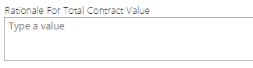
Brief Description and justification of Requirements
Please provide an explanation of why this purchase is necessary and what market research has been carried out.
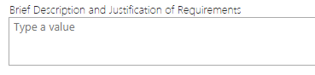
Desired Time frame
Provide a deadline for delivery or installation
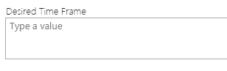
1c Data Protection
If your request involves a system that processes personal data you must inform governance services. Use the radio button to indicate if your request falls under the GDPR criteria. If you select Yes, an additional text area will appear. Enter as much information as possible. When submitted, Governance services will be notified and this information will be sent for assessment.
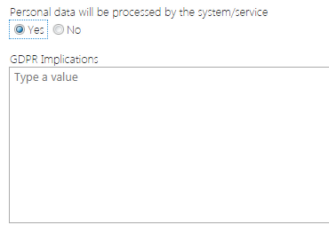
1d Broader Detail
If your purchase is for hardware select “yes” on the appropriate radio button. If you select yes your request will be routed to Infrastructure Leads in Information Services for approval.
If your purchase is for software, select “yes” on the appropriate radio button. If you select yes, your request will be sent to Software Leads in Information Services for approval.
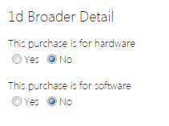
Declaration (Mandatory)
In order to progress your request you must indicate the information you have supplied is true and to the best of your knowledge. If you don’t check this box you cannot submit your request.
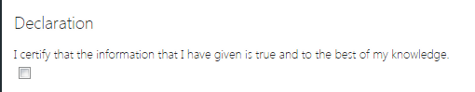

Saving your Submission
You can save your request and revisit it if you have more information to add at a later date, if you save your request you will directed to your dashboard and your saved request will appear in the “my saved requests”
To save your request click the “Save” button.
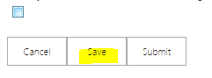
Submit
When you are ready you can submit your request for part one multi stage approval. Please note, you cannot change or alter any of the information in your form once it has been submitted, if you made a mistake or omitted any information on your from you can ask the Management Accountant or HoP to reject it where you will have the opportunity to adjust and re-submit.
To submit your request click the “Submit” button.
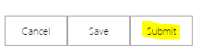
When you submit you will be directed to your dashboard and receive a notification via email similar to the one shown below:
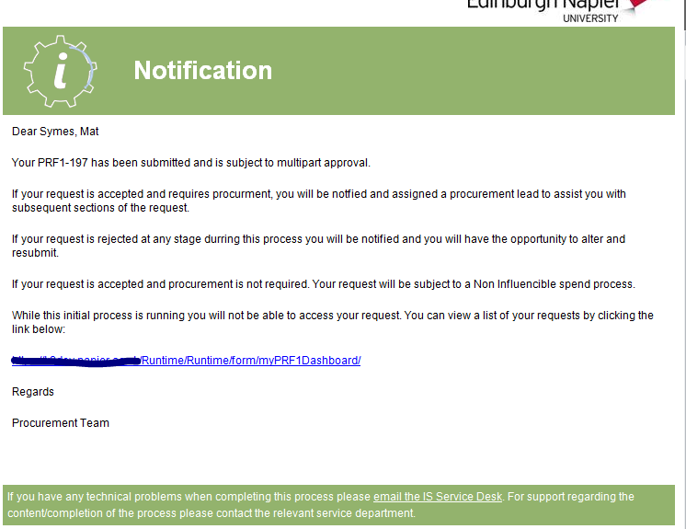

Your request will have moved from the “My Saved Requests” tab to the “My Submitted Requests” tab in your dashboard and you will be automatically routed to that tab when you click submit.
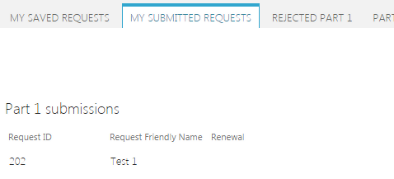
As stated earlier, you cannot change any of the information in the request once submitted. You can view a read only version of your request by double clicking the desired line in the “My Submitted Requests”

Part 3 Requester Journey
If your request is deemed applicable for procurement, the HoP will approve Part1 and assign a Procurement Lead. You will also receive an email similar to the one below:
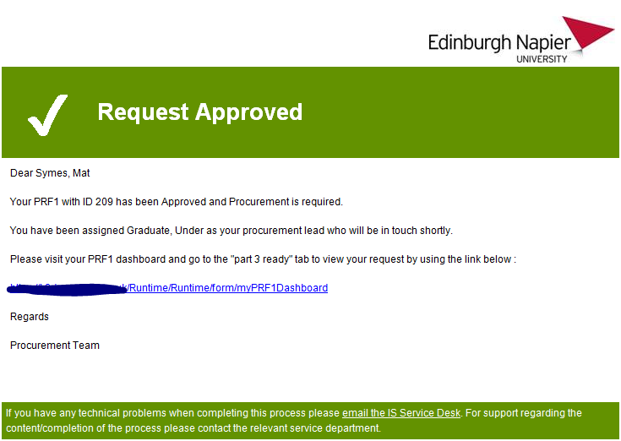
You also note that your request has moved in your dashboard from “Part 1 HoP approval” to “Part 3 ready”.
Part 3 of the form is different in so much as, apart from quotes, the Requester does not have any editable areas of part 3. This is because the Procurement Lead assigned to your request will fill this in with you. The Procurement Lead has control over part 3, once contacted, the Procurement Lead will start to fill in part 3. If you are talking with the Procurement Lead during this time you can follow what they are doing by double clicking the request in the “part 3 ready” tab on your dashboard. This will open a version of part3 you can a) Add quotes to and b) refresh. Refreshing will reveal any of the changes the Procurement Lead had made to the form.
Note: changes can only be observed after the Procurement Lead has clicked “save” at their end.
Although Part 3 is filled in by the Procurement Lead, it is good to be able to assist them by understanding the elements in part 3. Below is a table of all the fields in part 3, a description for each and an example value of what might enter into those fields:

Field | Explanation | Example
Is this request linked with a research project? | Does this purchase link to funding for a research project? | Yes
Is this a Goods, Services or Works requirement? | What type of thing are you buying – is it an actual product or a service to be delivered or construction works to be carried out? | Goods
Type of requirement? | Is this purchase a one off or will it be ongoing over a number of years? | One off
Type of requirement? | Is this the first time the University has purchased this or is it a replacement? | New
Have you explored alternative options to purchasing new? | Have you researched whether there could be a second hand purchase, loan or collaboration instead of a new purchase? | Yes
If yes, which options have you considered? | Consider the options given or add your own | Buy/borrow from another School/ department
Are any of the options feasible as an alternative to purchasing new? | Would any option potentially negate your requirement to purchase new? | Yes
Please give rationale for above answer | Explain why the option is feasible or why not | Another School only requires this equipment on a part time basis so we can borrow it when needed
Current supply arrangements in place (if applicable) | Do you already have a contract or informal arrangement with a company for this good, service, works? | Yes
Is there a contract in place? | Is there a formal signed contract e.g. has the Uni and the company signed an agreement ? | Yes
Current spend on existing arrangements/ contract | How much do you currently spend? | £50,000 per annum
Have you had any discussions with potential suppliers regarding this requirement? | Have you discussed the upcoming purchase with the current or other suppliers? | Yes
State name of supplier(s) | Give names of companies
Is there a Conflict of Interest with this supplier/any of these suppliers? | Is there any reason why the choice of supplier could be seen as subjective? | Yes
Have you had a demo or trial with this supplier/any of these suppliers? | Have you visited or had suppliers on campus to showcase their product? | Yes
Have you received quotes? Please upload any quotes received in the view below this section | Have you already researched the market price through obtaining supplier quotes? | Yes
Do you have a preferred supplier? | Is there one supplier you would prefer for this purchase for any reason? | Yes

Financial Breakdown
This section shows the breakdown of costs for the total length of the proposed contract. The Procurement Lead will go through these costs with you and adjust accordingly. Note: the total contract value entered in part 1 may not reflect the same value after these adjustments and so the value in the breakdown is then used as the total contract value going forward. Financial breakdown is split into years and expenditure types; capital or revenue.

Part 3 approval
In order for a measure to be recorded, you are required to sign off part 3. The measures have been put in place to help procurement identify bottlenecks in the overall process. Your approval of part 3 provides a record of your agreement with what the Procurement Lead has done with you and a time stamp to measure performance. Once part 3 has been completed with the Procurement Lead, the Procurement Lead will submit those changes for part 3 approval. Part 3 approval consists of a 2 stage sign off. The first stage is the Requester agreement stage, the second stage is by the HoP. The HoP can reject part 3 at any point. If the HoP approves part 3, the request will be subject to DFA sign off at 1 to 4 levels depending on the value entered as actual contract value in the financial breakdown in part 3. Once completed you will receive an email similar to the one below:
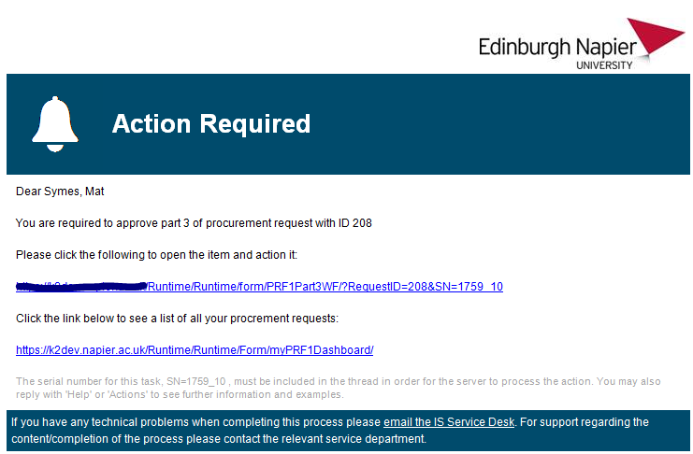

To approve part 3
- Click on the link in the email when received
- Scroll to the bottom of the form and use the check box to indicate your agreement
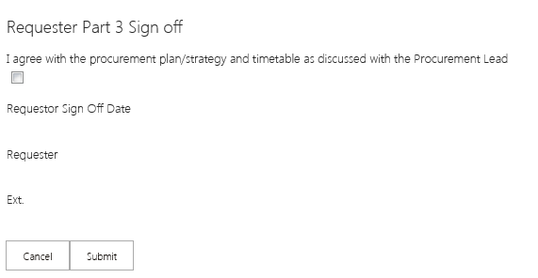
- Click submit*
*If you spot an error that would mean you would not normally agree, please contact the Procurement Lead immediately with the details. Sometimes the HoP can adjust this mistake for you without having to reject the request.

Your Dashboard
Your dashboard comprises of several tabs that indicate the journey your request is taking, as one stage completes, the request will disappear from one tab and move to the tab that matches the stage of the process.
Overview of tabs in your dashboard
My Saved Requests
This tab contains all the requests you have saved but not submitted. You can double click on the desired line in the view to reopen your request and continue to edit. You can either save again, cancel your changes or submit.
My Submitted Requests
This tab contains the view that contains all of your part 1 submitted requests. Depending on the information entered, this will sit here until all of the stages are approved or your request is rejected. While these approval stages are in progress you can view a read only version of your request by double clicking the appropriate line.
Rejected Part 1
If your request is rejected at any point in the approval process it will move to this tab. Here you can double click on the rejected request and if appropriate adjust it and resubmit. If you wish to resubmit, it is advisable to save your request straight away. This will move it back to the “My Saved Requests” tab and you can resubmit from there.
Part 3 Ready
The view in this tab shows all of your approved part 1 requests. Double clicking here will open a read only version of the part 3 form. The assigned Procurement Lead will go through this with you and you can click refresh on the part 3 form to see the data being entered by the Procurement Lead. You don’t have to fill out this section at all.
Part 3 Sign off Pending
The view in this tab shows all of your requests that require you to agree the changes your Procurement Lead made when you worked with the assigned Procurement Lead on part 3. Double clicking the desired row in the view will open a form with an invite to click the agree check box at the bottom. Once agreed the request will move to the Part 3 Waiting for HoP tab.
Part 3 waiting for HoP
This tab shows all of your requests that are sitting with HoP or their delegates for Part 3 sign off. You cannot change the information at this stage but you can see a read only version of your request by double clicking the desired row. You can also view the progress by clicking “view progress”

DFAs
This tab shows all of your requests that are in the DFA stages of the process. You can view a read only version of the request by double clicking the applicable row in the view. You can also view the progress of the request by clicking the View Progress link*. The view shows all the people assigned to review your request. If there is date next to the person’s name; this means that the request has been processed by that person and for DFA 3, 2 and 1 processes, it is now sitting with the next person in the chain. For a DFA 4 process, the request will either move to Rejected or Complete tabs after being process by the DFA assigned to level 4.
*A browser that supports Silverlight must be used
DFA Rejected
If any of your requests are rejected at DFA; these will show in the view in this tab. When the request is rejected at any DFA level, it must go back to the very start of the process. It is advisable to open the request from the DFA rejected tab and click “save” straight away. This will return the request to the “My saved requests” tab where you can work on it and re-submit if necessary.
Complete
Finally any completed and approved requests will show here, you can double click the applicable row in the view to see your completed request.
Viewing the progress of a request
Each request has 3 processes: part1, part 3 and DFA. You can view the progress of each request when your request is in an un-actionable state. At all other times the request is actionable, this means it’s sitting with you.
If your request is in an un-actionable state, (My Submitted Requests), (Part3 waiting for HoP) and (DFA) you can monitor its progress by clicking the “View progress” link in the appropriate row. When you click the link, provided you are in a browser with Silverlight installed, you will then see the process. All green boxes in the process means that stage of the process is complete.

Part 1 Approval
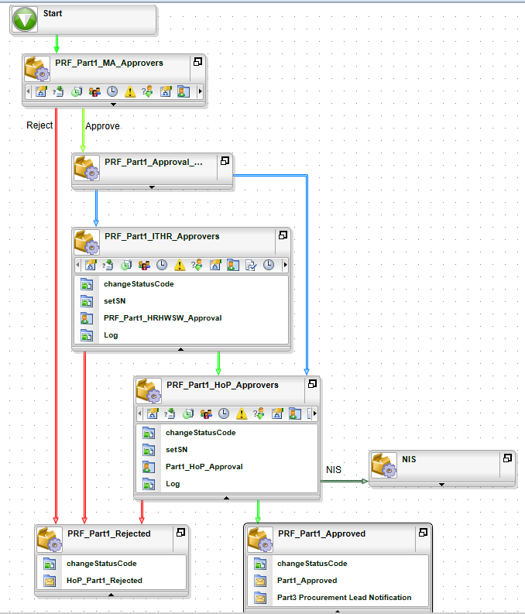

Part 3 Approval
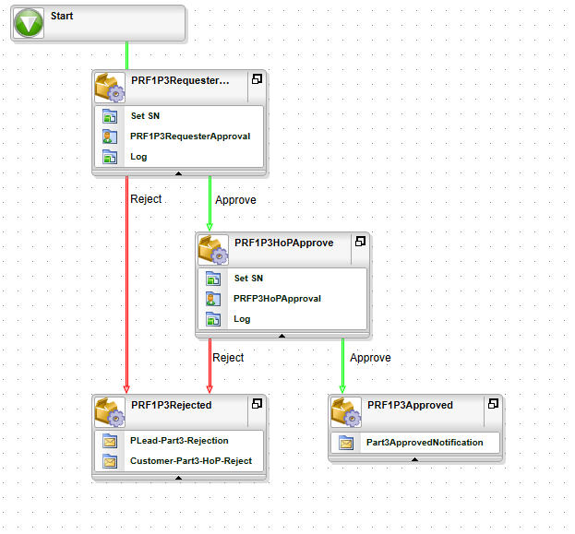

DFA
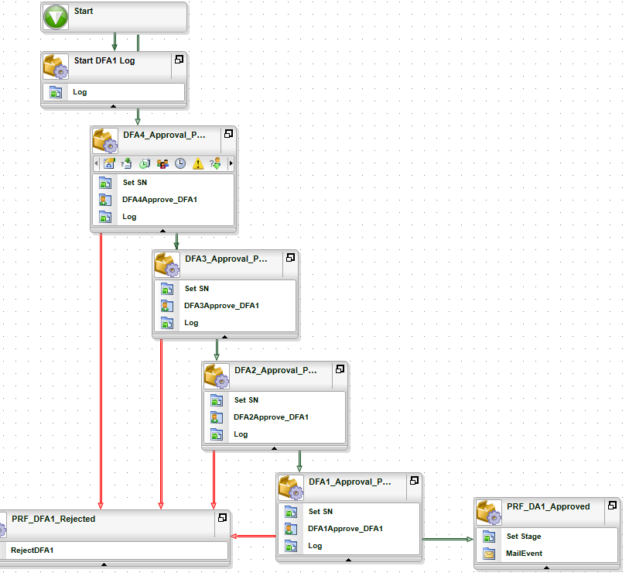

Finance Business Partners (FBP) Journey
Finance Business Partners are required to review and approve part 1 of the request. You can either process the request by clicking on the email notification that requires Finance Business Partner approval or use the FBP dashboard located at the link below:
https://bpm.napier.ac.uk/runtime/runtime/form/MADasboard
Email Notification example
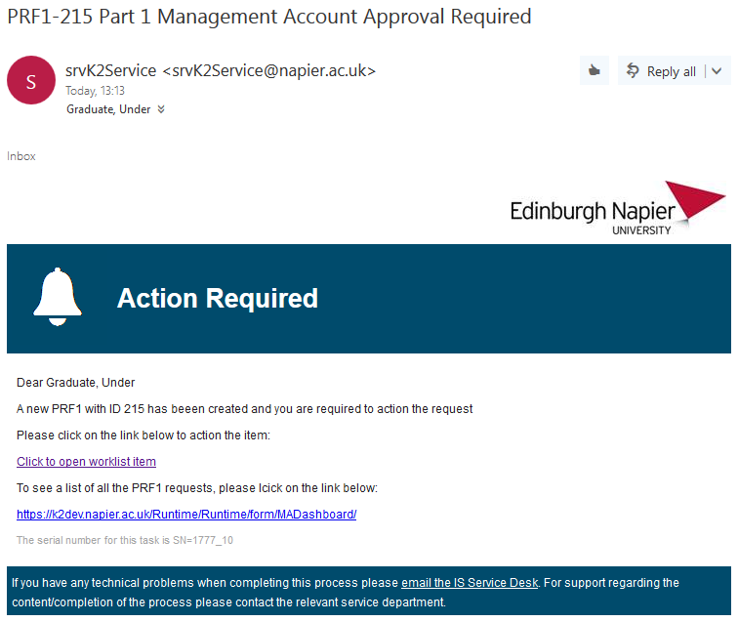

When clicking on the link in the email or double clicking the relevant row in the “Approval Pending” tab in the dashboard, you will be transported to the Part 1 workflow action form for FBPs.
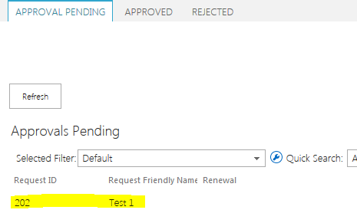
Use the drop down list in the “Approval Action” section at the bottom of the form to indicate your decision. Whichever option is selected, you will be required to enter a reason in the text area below the drop down list. If you don’t, you cannot progress the request. If a request is rejected, the reason will be captured in a log and sent to the original Requester. If the request is approved the data will be captured in the main data area and displayed to the HoP and the DFAs. If a request is rejected further down the process and the original Requester re-submits, you will be required to fill this out again in response to any adjustments the originator may make to part1.
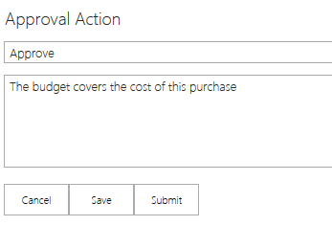
When ready, click the submit button and you will be redirected to the “Approved” tab on the MA dashboard.
The FBP dashboard*
The FBP dashboard is personalised meaning only the requests where you have been identified as the FBP will show. If the request is rejected further along the process and the FBP is changed as a result. You will no longer see the request in your dashboard. The FBP dashboard comprises of 3 tabs:
Approval Pending
These are all the requests that require action from you. Double clicking a row here will allow you to action the request.
Approved
These are the requests you have approved. You can double click here to see a copy of the approved request.
Rejected
There are all the requests you have rejected, if a request resubmitted, it will disappear from this view. Double clicking a row here will open a read only version of the request for review.
Selected Filters
Each view in your dashboard has search functionality to help you find a request see below:
Entering a value in the highlighted box will filter the request by any visible value in the view. “Request friendly name” or “Request ID” are two examples.
Unfiltered
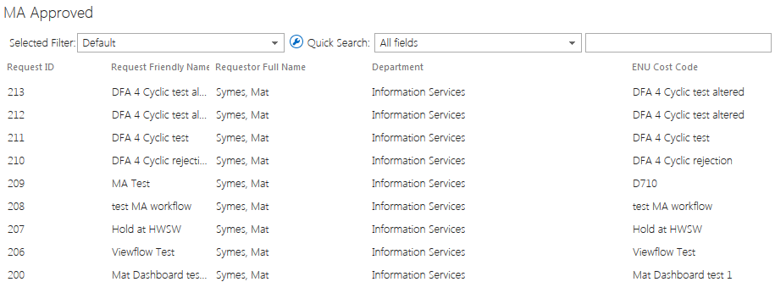
Filtered
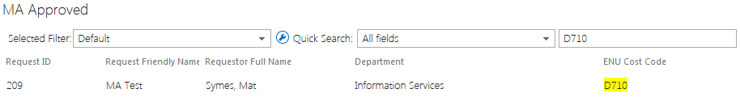You can also pin point searches by selecting a single field to search from the middle drop down see below:
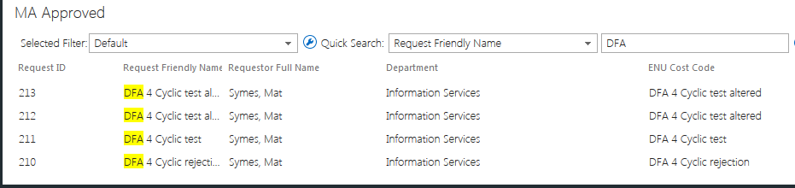
Note: If a request is rejected further down the line, it may be removed from the approved view until it is reprocessed.
*Note the URL of the FBP dashboard does not contain the acronym FBP, this is because the department was renamed during development and URLs cannot be changed on existing forms in hosting platform.

Head of Procurement (HoP) Journey
The Head of procurement is responsible for approving key stages of the process. This is irrespective of whether procurement is required or not. In addition, the HoP or their delegates are responsible for identifying those responsible for DFA sign off. HoP Delegates can also perform this function as part of a shared task similar to Hardware and Software authorisation.
Part one sign off
After the MA and after any HW or SW approvals the HoP or his delegates are required to assess and approve or reject part1. There are three options:
- No Procurement is required
- Procurement is required
- Straight rejection
If no procurement is required the HoP is required to provide a reason and if not a straight rejection, then assign the various DFA people for DFA approvals depending on the Total contract value.
If procurement is required, the HoP is required to assign a Procurement Lead to continue the application process with the original Requester.
If the contents of part 1 do not satisfy quality criteria the HoP will perform a straight rejection.
Other system responsibilities
The HoP is also the system owner and as such has control over system configurations:
- Procurement Process definitions*
- DFA Thresholds (Phase 2)
- Procurement Leads list
- HoP Delegates
- No Procurement required reasons*
- Purchase alternative reasons*
- Core funded management account lists
- Externally funded Management Accountant list
- DFA1 user set
- DFA2 user set
- DFA3 user set
- DFA4 user set
*To preserve historical data it is advised to append only to these lists

Procurement Leads Journey
As a Procurement Lead, you are responsible for completing the remaining parts of the form AKA part 3. If, at the end of part 1, the HoP or one of his delegates decide that procurement is required, they will assign a Procurement Lead. The Procurement Lead is notified via an email similar to the one below:
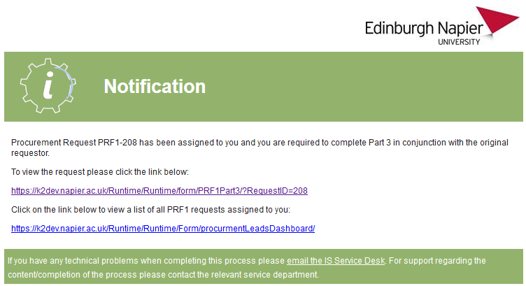
You can either action the request from the link in the email or use the personalised Procurement Lead dashboard. When opening a request, you will be automatically moved to the part 3 tab. Part 3 is designed to be filled in in conjunction with the original Requester. The original Requester gets a link to a version of the request that they can’t edit. Instead they can refresh the form and view what data has been entered into after each time the Procurement Lead’s version is saved. The only control the Requester can use is in the “Quotes” section where they can upload any quotes that support the defined procurement process. This is because it is usually the Requester that arranges and holds any quotes pertaining to the requested purchase and it helps prevent the request being rejected further up the chain.

Part 3 Field Descriptions
Field | Explanation | Example
Is this request linked with a research project? | Does this purchase link to funding for a research project? | Yes
Is this a Goods, Services or Works requirement? | What type of thing are you buying – is it an actual product or a service to be delivered or construction works to be carried out? | Goods
Type of requirement? | Is this purchase a one off or will it be ongoing over a number of years? | One off
Type of requirement? | Is this the first time the University has purchased this or is it a replacement? | New
Have you explored alternative options to purchasing new? | Have you researched whether there could be a second hand purchase, loan or collaboration instead of a new purchase? | Yes
If yes, which options have you considered? | Consider the options given or add your own | Buy/borrow from another School/ department
Are any of the options feasible as an alternative to purchasing new? | Would any option potentially negate your requirement to purchase new? | Yes
Please give rationale for above answer | Explain why the option is feasible or why not | Another School only requires this equipment on a part time basis so we can borrow it when needed
Current supply arrangements in place (if applicable) | Do you already have a contract or informal arrangement with a company for this good, service, works? | Yes
Is there a contract in place? | Is there a formal signed contract e.g. has the Uni and the company signed an agreement? | Yes
Current spend on existing arrangements/ contract | How much do you currently spend? | £50,000 per annum
Have you had any discussions with potential suppliers regarding this requirement? | Have you discussed the upcoming purchase with the current or other suppliers? | Yes
State name of supplier(s) | Give names of companies
Is there a Conflict of Interest with this supplier/any of these suppliers? | Is there any reason why the choice of supplier could be seen as subjective? | Yes
Have you had a demo or trial with this supplier/any of these suppliers? | Have you visited or had suppliers on campus to showcase their product? | Yes
Have you received quotes? Please upload any quotes received in the view below this section | Have you already researched the market price through obtaining supplier quotes? | Yes
Do you have a preferred supplier? | Is there one supplier you would prefer for this purchase for any reason? | Yes

Section 3b Field Descriptions
Field | Explanation | Example
Process | Procurement process determined by the requirement and the contract value | Further competition under existing framework
Stakeholder Group (UIG) | Who will be involved with defining the requirement and evaluating any tender bids? | Names of relevant individuals
Framework Agreement | A sector wide contract which offers a possible route to market with agreed pricing, terms and conditions and warranty | APUC Framework Agreement for Furniture
General Data Protection Regulations (GDPR) requirements | Will any personal data be processed in relation to this requirement which may put the University in a position of data processor or controller under the GDPR? This is particularly relevant for ICT/ software purchases.  Further information available here:  https://ico.org.uk/for-organisations/guide-to-the-general-data-protection-regulation-gdpr/ | Yes, software will integrate with Active Directory and process staff/student names, phone numbers and emails
Community Benefits | Does this requirement offer opportunities for targeted recruitment and training, including vocational qualifications, support for disadvantaged groups, small business and social enterprise development and community engagement or initiatives? If so, please give details.  Further info available here:  http://www.gov.scot/Resource/0049/00496919.pdf  https://www.gov.scot/publications/sustainable-procurement-guidance/ | Yes, we would like the successful supplier to offer summer placements to students as part of the contract
Fair Work Practices | Is it important that any potential suppliers offer fair working practices such as:  - offering employee training and skills development;  - paying the National Living Wage and ideally the Scotland Living Wage;  - not using zero hours contracts;  - encouraging trade union or other employee representation;  - taking steps to increase employee diversity;  This is particularly relevant for the purchase of services, and works but could be applicable in other procurements. This is recommended for contracts over £50k  Further info available here:  http://www.gov.scot/Resource/0048/00486741.pdf | Yes, this is relevant as the requirement is for a service over £50k
Equality Issues | Should potential suppliers for this requirement be assessed on considerations to enable the University to better perform the equality duty? These duties are to:  - eliminate unlawful discrimination, harassment and victimisation and other prohibited conduct  - advance equality of opportunity between people who share a relevant protected characteristic and those who do not  - foster good relations between people who share a protected characteristic and those who do not  Further info available here:  http://www.gov.scot/Topics/Government/Procurement/policy/corporate-responsibility/Sustainability/Equality  https://www.gov.scot/publications/sustainable-procurement-guidance/ | Yes, this is relevant as the requirement relates to HR software
TUPE | Service provision changes  This is when:  - a service provided in-house (e.g. cleaning, workplace catering) is awarded to a contractor  - a contract ends and is given to a new contractor  - a contract ends and the work is transferred in-house by the former customer  When Transfer of Undertakings (Protection of Employment) regulations (TUPE) applies:  - the employees’ jobs usually transfer over to the new company  - their employment terms and conditions transfer  - continuity of employment is maintained  Further info available here:  https://www.gov.uk/transfers-takeovers | No, this is for goods and not services
Sustainability opportunities (Circular Economy, Environmental, etc.) | Does this requirement offer relevant opportunities for any type of social, environmental or ethical benefits? For example in relation to:  ▪ Biosecurity;  ▪ Biodiversity;  ▪ Climate change;  ▪ carbon emissions reduction targets;  ▪ climate change adaptation;  ▪ acting sustainably;  ▪ Communities;  ▪ Employment;  ▪ skills and training;  ▪ small and medium sized enterprises (SMEs), third sector, social enterprises, supported businesses;  ▪ Fairly and ethically traded;  ▪ Working conditions and labour standards;  ▪ Conflict minerals;  ▪ Health and wellbeing;  ▪ Health and safety guidance;  ▪ Physical or mental health and wellbeing;  ▪ Heritage – protection and enhancement  If so, please give details.  Further info available here:  http://www.gov.scot/Topics/Government/Procurement/policy/corporate-responsibility | Yes, this requirement aims to increase renewable energy generation within the University estate with an associated carbon emission saving.
Modern Slavery Risks | Does this requirement pose any risks of human trafficking/ modern slavery within the supply chain? If so, please specify further including indicating what steps could be taken to mitigate these risks.  Further info available here:  https://beta.gov.scot/policies/human-trafficking/ | This risk is unlikely as the delivery of the required service involves the employment of highly skilled professionals
Life-cycle Costings | Is there an opportunity/benefit to using Lifecycle Costing to evaluate the purchase of this requirement?  Life-cycle costing covers part or all of the following costs over the life cycle of a product or service:  (a) costs produced by the organisation or other users, such as:  (i) costs relating to acquisition;  (ii) costs of use, such as consumption of energy and other resources;  (iii) maintenance costs;  (iv) end of life costs, such as collection and recycling costs; and  (b) costs attributed to environmental externalities linked to the product or service during its life cycle, provided their monetary value can be determined and verified. This may include the cost of emissions of greenhouse gases and of other pollutant emissions and other climate change mitigation costs | Yes, this would be worthwhile as the upfront costs for this requirement for LED lighting are high but the ongoing energy costs are lower than traditional lighting.
Other | Detail here any other additional points which should be taken into consideration in the purchase of this requirement?

The Procurement Leads dashboard
The Procurement Leads dashboard comprises of 4 tabs:
- My assigned requests
This tab shows all of the requests that have been assigned to you for completion of part 3 but have yet to be completed.
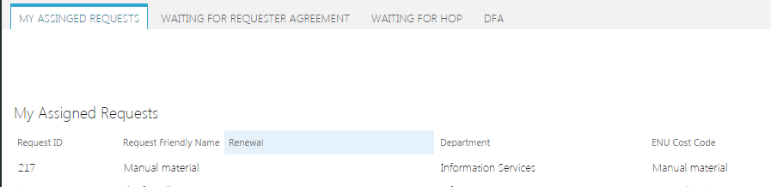
Double click an item row on this view and you will be transported to an editable version of the form containing part 3.
- Waiting for Requester agreement
This tab shows all of the completed part 3 requests that are waiting for the original Requester to agree.
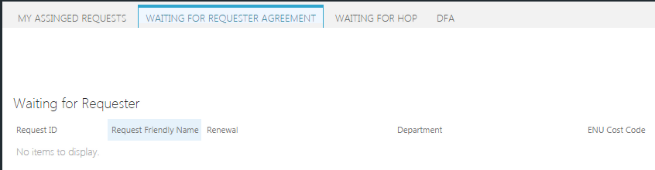
Double click an item row here and you will see a read only version of the request.
- Waiting for HoP
This tab shows all the part 3 completed requests that have been signed off by the original Requester and are waiting for the HoP to provide the final approval before DFA.
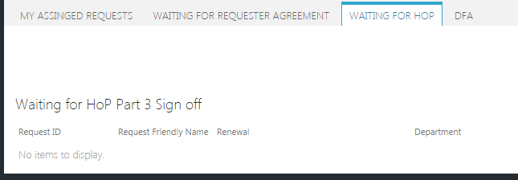
Double click an item row here and you will see a read only version of the request.
- DFA
This tabs shows all the items that are currently in DFA sign off
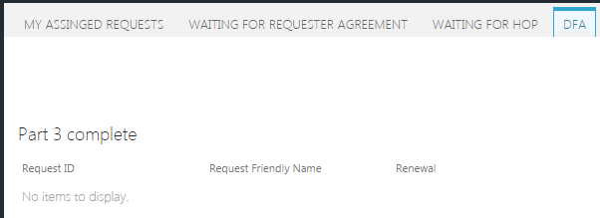

Hardware Software Approvers Journey
If a purchase is required for hardware or software or both; the Requester will indicate this in part one of the request form. If this is the case, a shared task will be issued to all those occupying that role. A shared task is one that is distributed to many users but only requires actioning by one. Once actioned, the task will no longer be available to the rest of the users. If a shared task is opened by one of the users and not actioned, the other cannot action the task until the person that opened it has released the task. This will be covered later.
If a purchase is required for hardware or software the users in that role will receive a notification similar to the one depicted below:
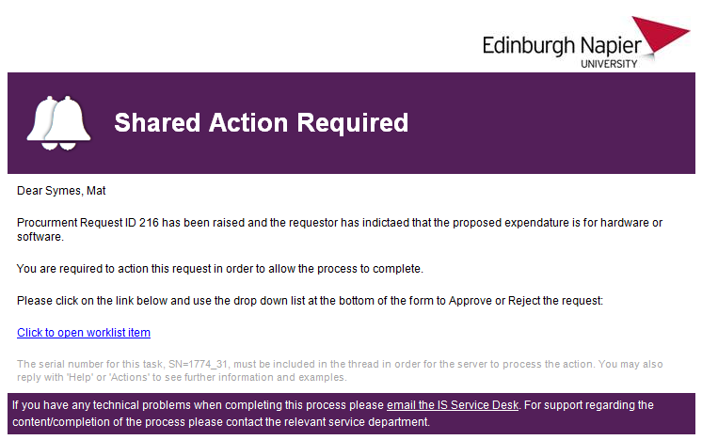
To process the request
- Click on the link in the email
- When the form opens, scroll to the bottom and use the drop down to indicate your decision. If you reject the request you must provide a reason in the text area provided.
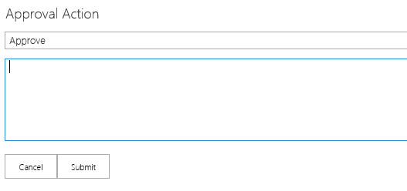

NB: If someone has already processed the request, an error will be displayed similar to one shown below:
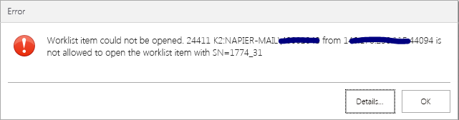
NB: If the request is rejected further up the line, you may be requested to re-approve or reject after adjustments.
Releasing a Task
If you open a worklist item and don’t action it; it will not be available to the other approvers in your role until you release it. A worklist item is open by clicking on the link in the email. If you close the form without actioning it or close the windows or you forget or you don’t intend to action the item after it is open, you must release it for others to action. Below are the instructions of how to release:
- Navigate to the following URL:
https://bpm.napier.ac.uk/runtime/runtime/form/myWorklist

- The form that opens shows all tasks that have assigned to you*
- Find the task that you want to release and click the > at the end of the row
- When you click the arrow a sub menu will open, click the open padlock symbol to release the task
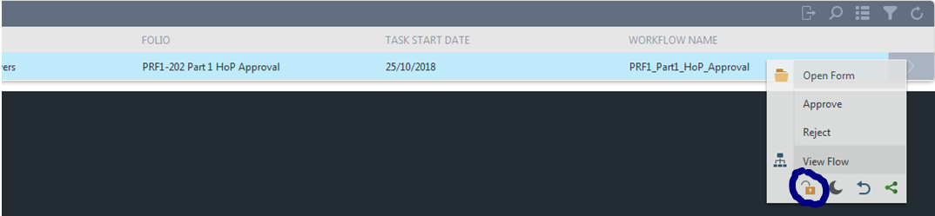
* This list shows all tasks assigned to you, if you are involved with other processes managed by the platform used to build the PRF system, you will see those tasks here as well.

DFA Journey
As a DFA you are responsible for sign off on all procurement and non influencable spend processes that qualify. There are four levels of DFA depending on the Total contract value of the proposed expenditure. You may be assigned to any of these four levels so it is important to remember that your dashboard may not look the same if you have been assigned to a different level of sign off for a particular purchase.
When signing off there are three options:
- Approve
- Reject
- Hold
If approve is selected and you are the final DFA sign off level, the process will complete and the Requester will be informed. If you are not the final level of sign off the next DFA level will receive the same options.
If Reject is selected the Requester will be informed and the process will revert back to the very beginning.
If Hold is selected the process will stay with you until Approve or Reject is selected.
To process a request
If you have been assigned as a DFA you will receive an email similar to the one below:
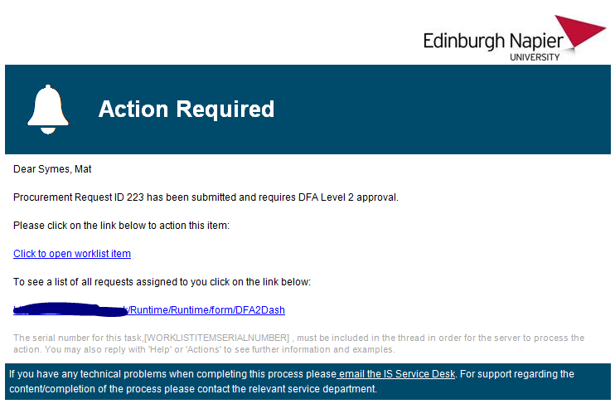

- Click on the “..open worklist item” link
- Inspect the request
- When ready to make decision, use the DFA approval section as shown below*
*If the request does not require procurement the approval section will be at the bottom of Part1. If procurement is required, the approval section will appear at the bottom of part 3.
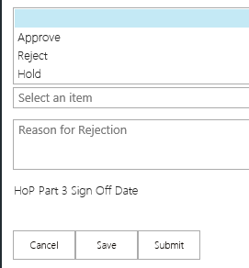
- Use the drop down to select your choice then click “Submit”
- Once you click submit you will be transported to the Dashboard appropriate for the DFA level you have been assigned to.

DFA Dashboard
There are 4 DFA dashboards, one for each DFA sign off level. As mentioned earlier, you may be assigned to any of these levels so keep in mind that the dashboards are personalised for each level so you will only see the requests to which you have been assigned and only the dashboard level for that particular request. In short, you may have access to more than one dashboard and these will look different. All DFA dashboards have 4 tabs:
- Approvals Pending – All requests actionable by you
- Completed approvals – All requests that have been actioned by you at this level
- Rejected Requests – All requests that you rejected at this DFA level*
- On Hold – All request you put on hold at this DFA level

* Rejected requests don’t stay in this view, if a request is rejected the Requester is informed, they can resubmit the request, when they open a rejected request and save it the status changes and the request will disappear from this view.
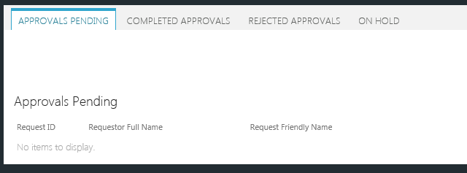

Technical Appendix

Stage Codes
1 | P1 Saved but not submitted
2 | P1 Waiting for MA approval
3 | P1 Waiting for Hardware/Software Approval
4 | P1 Waiting for HoP Approval
5 | Rejected at P1
6
7
8 | P1 Approved P3 Ready
9 | P3 Waiting for Requester approval
10 | P3 Waiting for HoP approval
11 | P3 Approved DFA ready
12 | Rejected at P3
13
14
15 | DFA4 Approval Pending
16 | DFA3 Approval Pending/DFA4 Approved
17 | DFA2 Approval Pending/DFA3 Approved
18 | DFA1 Approval Pending/DFA2 Approved
19 | On HOLD at DFA4
20 | On HOLD at DFA3
21 | On HOLD at DFA2
22 | On HOLD at DFA1
23 | Complete
24 | DFA4 Rejected
25 | DFA3 Rejected
26 | DFA2 Rejected
27 | DFA1 Rejected

Source Codes
Source code drive routing back to the appropriate location from the Master Read only form
Code | Action
1 | Go back to myPRFDashboard go to mySubmitted tab
2 | Go back to myPRFDashboard go to waiting for HoP tab
3 | Go back to myPRFDashboard go to DFAs tab
4 | Go back to PRF1Manager go to All Saved Requests tab
5 | Go back to PRF1Manager go to Part 1 rejected tab
6 | Go back to PRF1Manager go to Part 3 Requests tab
7 | Go back to PRF1Manager go to Part 3 Requester pending
8 | Go back to PRF1Manager go to DFAs tab
9 | Go back to PRF1Manager go to Part 1 MA pending
10 | Go back to PRF1Manager go to HWSW approvals
11 | Go back to PRF1Manager go to Complete tab
12 | Go back to myPRFDashboard go to Complete tab
13 | Go back to MA Dashboard and go to Complete tab
14 | Go back to MA Dashboard and go to Rejected tab
15 | Go back to Procurement Lead Dashboard and go to DFA tab
16 | Go back to Procurement Lead Dashboard and go to Waiting for HoP tab
17 | Go back to Procurement Lead Dashboard and go to Waiting for Requester tab
18 | Go back to myPRFDashboard go to rejected at part3
19 | Go Back to HWSW Dashboard after closing.

