ASSOCIATE LECTURER

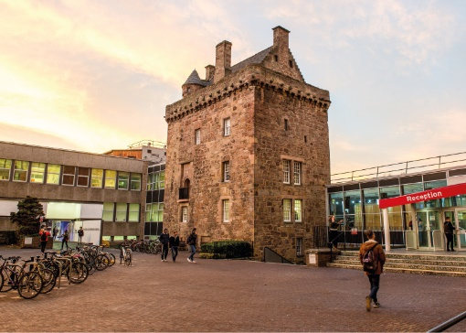

ROLE DESCRIPTION
GRADE  Grade 5  LOCATION  Sighthill, Craiglockhart or Merchiston, Edinburgh |  | ROLE SUMMARY  All new staff appointed to a Grade 5 Associate Lecturer post will deliver high quality, student centred teaching, underpinned by academic scholarship (research, pedagogy, knowledge exchange or professional practice).

MAIN DUTIES AND RESPONSIBILITIES
Academic staff are expected to carry out a range of duties and responsibilities taken from the following. Whilst it is not anticipated that all activities listed below will be covered by one person, it is expected that all individuals will make a balanced contribution to teaching and learning and research, and will demonstrate academic leadership.

Teaching and learning support
- Teach as a member of a teaching team in a developing capacity within an established programme of study, with the assistance of a mentor if required.
- Teach in a developing capacity in a variety of settings from small group tutorials to large lecturers.
- Transfer knowledge in the form of practical skills, methods and techniques.
- Identify learning needs of students and define appropriate learning objectives
- Ensure that content, methods of delivery and learning materials will meet the defined learning objectives.
- Develop own teaching materials, methods and approaches with guidance
- Develop the skills of applying appropriate approaches to teaching.
- Challenge thinking, foster debate and develop the ability of students to engage in critical discourse and rational thinking.
- Supervise the work of students, provide advice on study skills and help them with learning problems
- Select appropriate assessment instruments and criteria, assess the work and progress of students by reference to the criteria and provide constructive feedback to students.
- Seek ways of improving performance by reflecting on teaching design and delivery and obtaining and analysing feedback.

Research and scholarship
- Reflect on practice and the development of own teaching and learning skills.

COmmunication, liasion and networking
- Deal with routine communication using a range of media.
- Communicate complex information, orally, in writing and electronically.
- Preparing proposals and applications to external bodies, eg for funding accreditation purposes.
- Communicate material of a specialist or highly technical nature.
- Liaise with colleagues and students.
- Build internal contacts and participate in internal networks for the exchange of information and to form relationships for future collaboration.
- Join external networks to share information and ideas.

Academic leadership
- Agree responsibilities.
- Manage own teaching, scholarly and administrative activities, with guidance if required.
- Could be expected to supervise students’ projects, fieldwork and placements.
- Act as a mentor for students in capacity of personal tutor.

Teamwork and pastoral care
- Promote, contribute, and collaborate with academic colleagues on course development, curriculum changes, group meetings, internal committees and the development of research activity and teaching.
- Collaborate and coordinate teaching, research and projects.
- Responsible for dealing with student issues in accordance with University regulations.

Initiative, problem-solving and decision-making
- Develop initiative, creativity and judgement in applying appropriate approaches to teaching and learning support and scholarly activities.
- Respond to pedagogical and practical challenges.
- Share responsibility in deciding how to deliver modules and assess students.
- Contribute to collaborative decision making with colleagues on academic content, and on the assessment of students’ work.

Planning and managing resources
- Use teaching resources and facilities as appropriate.
- Plan and manage own teaching and tutorials as agreed with mentor.
- Be responsible for ensuring that the information and records processed (received, created, used, stored, destroyed) on behalf of the University are managed in compliance with all applicable legislation, codes and policies e.g. Data Protection, Information Security and Records Management.

sensory, physical and emotional demands
- Sensory and physical demands will vary from relatively light to a high level depending on the discipline and the type of work and will involve carrying out tasks that require the learning of certain skills.
- Balance with help the competing pressures of teaching scholarship and administrative demands and deadlines.

Work environment
- Is required to be aware of the risks in the work environment and their potential impact on their own work and that of others.

Expertise
- Possess sufficient breadth or depth of specialist knowledge in the discipline to work within established teaching programmes.
- Engage in continuous professional development.
- Able to engage the interest and enthusiasm of students and inspire them to learn.
- Develop familiarity with a variety of strategies to promote and assess learning.
- Understand equal opportunity issues as they may impact on academic content and issues relating to student need.

PERSON SPECIFICATION
Applicants are expected to present evidence of achievement against each of the specific criteria outlined below.

Refer to Criteria for Research, Enterprise, Learning & Teaching, Professional Practice for academic postings.

 | ESSENTIAL | DESIRABLE

Education/Qualification

- Higher degree in a relevant discipline.
- Undertaking a PhD or actively publishing research outputs.
- Ideally HEA membership or a strong willingness to achieve membership within 18 months of appointment

Experience
Evidenced achievement against the criteria for Esteem, Innovation, Contribution and Academic Leadership.

- Esteem - profile that demonstrates some national standing.
- Innovation and Impact - record of quality outputs in terms of originality, significance and rigour.
- Contribution - contribution to generation of external income. Engagement with relevant communities internally and potentially externally.
- Academic Leadership - providing leadership and support to colleagues within the University, for example as a Module Leader or Programme Leader of a small/medium size programme.

Skills/Personal Requirements

- Demonstration of the University’s agreed values and behaviours – Professional, Innovative, Inclusive and Ambitious.

