How to use the Vacancy Management System
The Vacancy Management System is an application that supports the recruitment administration process for externally advertised vacancies. Key points include:
- Job applications must be made via the online application form. An alternative format is only available for applicant’s with a disability.
- Candidate can create a user profile and complete their application over a series of sessions, and can view their application details at any time.
- All application information will be available to recruitment contacts and panel members online.
- Recruitment contacts will manage the status of each applicant and report/extract basic information in Excel format for mail merge etc.
- Equal opportunity information goes straight into a central database.
- Panel members can get access to applicant information at any stage through the recruitment process and use online until interview stage.
If you have any questions please speak to your HR Adviser or email vms@napier.ac.uk

User Roles
Recruitment Contacts
- Update candidate status throughout the recruitment and selection process.
- Compile application reports and extract candidate information and use this to create candidate communications or Recruitment and Selection templates e.g. a short-listing matrix.
- Add any applications not made online to the system.
HR Advisers
- Create vacancies on the system and assign a recruitment contact.
- Process new user requests. Request candidate information to be purged in line with retention schedule.
- Update recruitment contact name if necessary to cover holidays or sickness absence.
Panel Members
- View applications via the Vacancy Management System.
- Use the Excel version of short listing matrix.

Logging On
The link you need is https://applications2.napier.ac.uk/Jobvac/admin/AdminMyjob.aspx.

User set up
Panel members’ access to a particular vacancy is managed by the Recruitment Contact. They can choose users e.g. Panel members, from a list of existing employees. The Recruitment Contact will be responsible for letting panel members know when they are able to access applicant information.
System access is not available to external assessors although it will still be possible for them to receive applicant reports in electronic format.

Overview
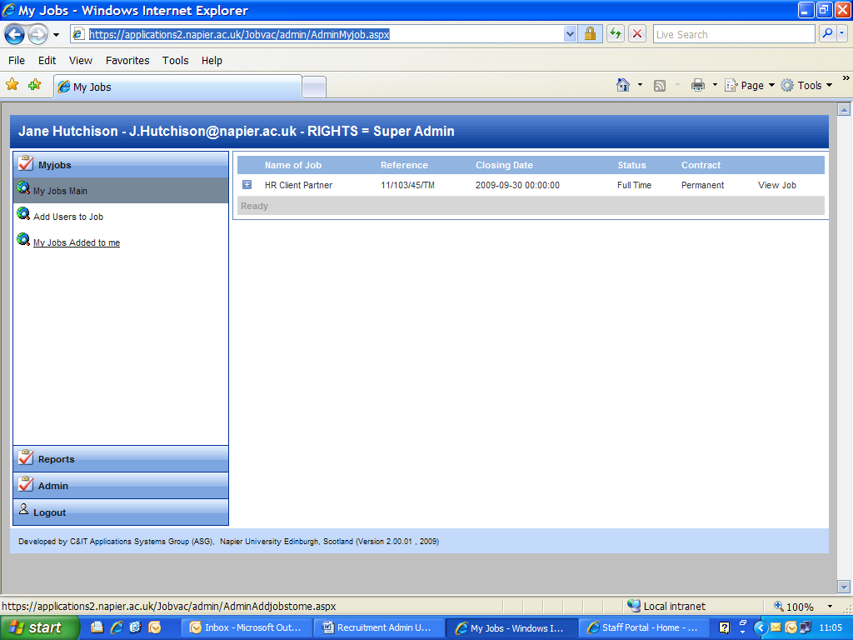
This is the main application view.

My Jobs Main This shows the list of all vacancies for which you are the recruitment contact. This section will be used mostly by recruitment contacts.
Add Users to Job This section enables the recruitment contact to give panel members a view of the applications for the role. This section will be used by recruitment contacts.
My Jobs Added to Me This section lists the vacancies for which you are a panel member. This section will primarily be used by Panel Members.
Tip: When you open the web page you will need to double click on the link you need e.g. My Jobs Added to Me to ensure you can view all current vacancy information. Or alternatively refresh the screen by hitting F5.

Setting Up Panel Members
After a vacancy has been created by the HR Adviser, they will advise the Recruitment Contact who must then give the panel members, when known, access to the job and its applications. Without this access they will not be able to view the applicant details online.
Step 1: Click on Add Users to Job. To view existing users click on the “+” sign next to the vacancy you are working on.
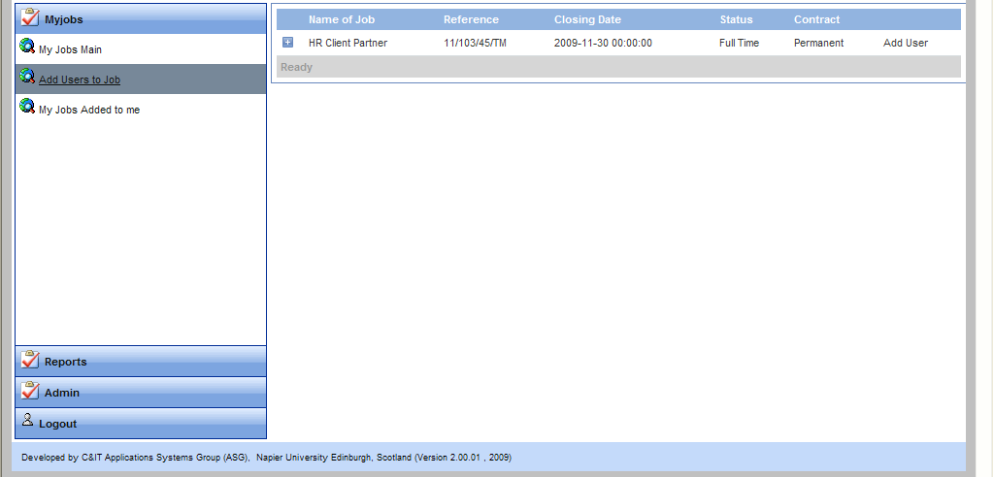
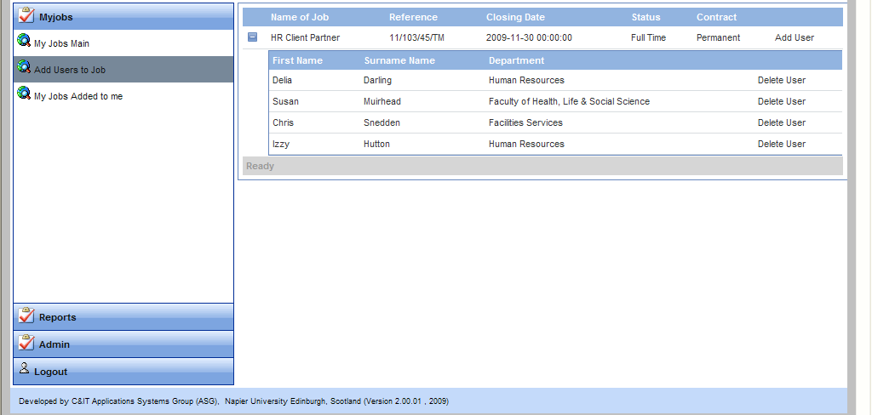
Step 2: From this view you can remove a panel member by clicking on Delete User. Or to add a new user, click on Add User.

Step 3: After clicking Add User you will view a list of Edinburgh Napier employees. If a panel member is external then you cannot give them live access to applications. However you can still use the system to email a report to them in pdf format showing applicant details.
You can search this list using one or a combination of fields. The search function is case sensitive so important you use the appropriate capital/lower case combination.
To search for the person, type your search criteria in the relevant box. In the example below I am searching for “Ron”
Click on the filter button next to it at which point you can set your filter criteria or not as the case may be. In most cases you would use Contains or StartsWith
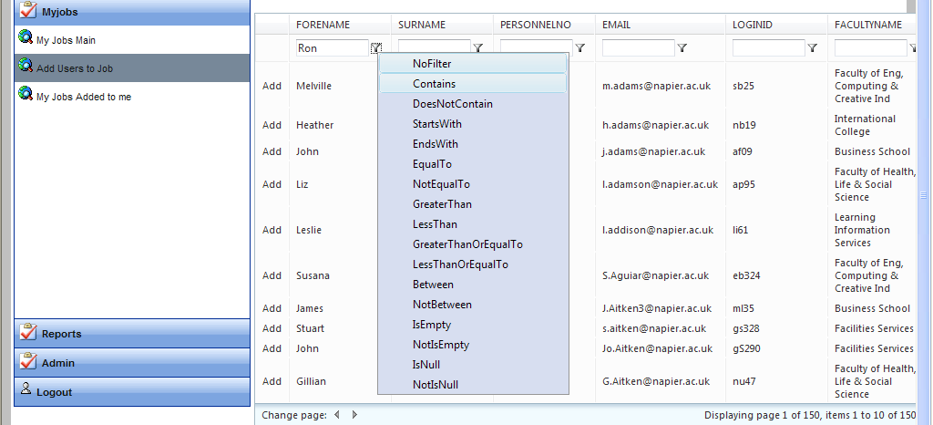
TIP: If you cannot find who you are looking for please check the case, change if necessary and search again. If the person you are looking for is not there please email VMS@napier.ac.uk for support.

When you can view the person you want in the list of employees click Add. Repeat this for each panel member.
There is no email notification sent as a result of adding or deleting users so you will need to confirm access for people. When confirming access to panel members send them a copy of the link to the system https://applications2.napier.ac.uk/Jobvac/admin/AdminMyjob.aspx and a link to the panel members “How Do I” notes http://staff.napier.ac.uk/services/hr/recruitmentandselection/Pages/RecruitmentSelection.aspx

Viewing An Individual Application
Each time an application is received you will receive an email notification. You may want to use the Rules options in Outlook to manage these messages. e.g. to move emails into a particular folder, delete automatically or forward onto a person/group of people/generic email address.
If you need instructions on how to create a rule search Outlook Help for ‘manage message by using rules’.
From the candidate list view click on Full Details
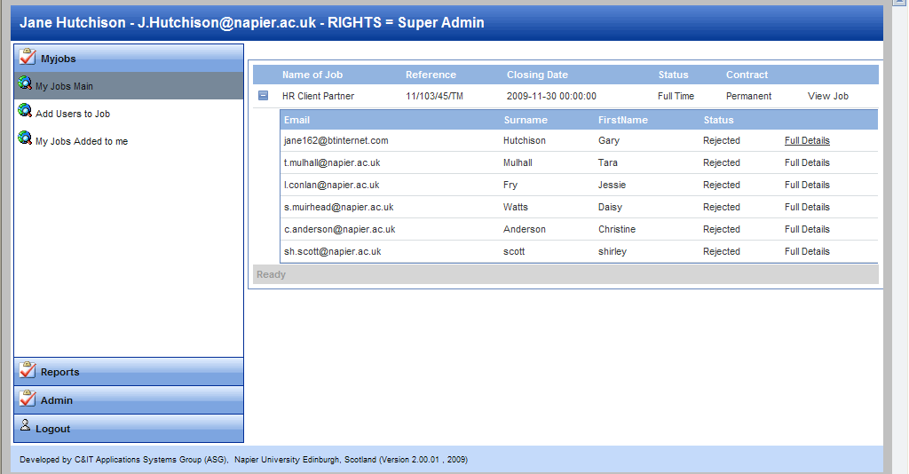
Every application defaults to Rejected. You will change the status for candidates who are successful at the short-listing stage and then again for these people post interview.
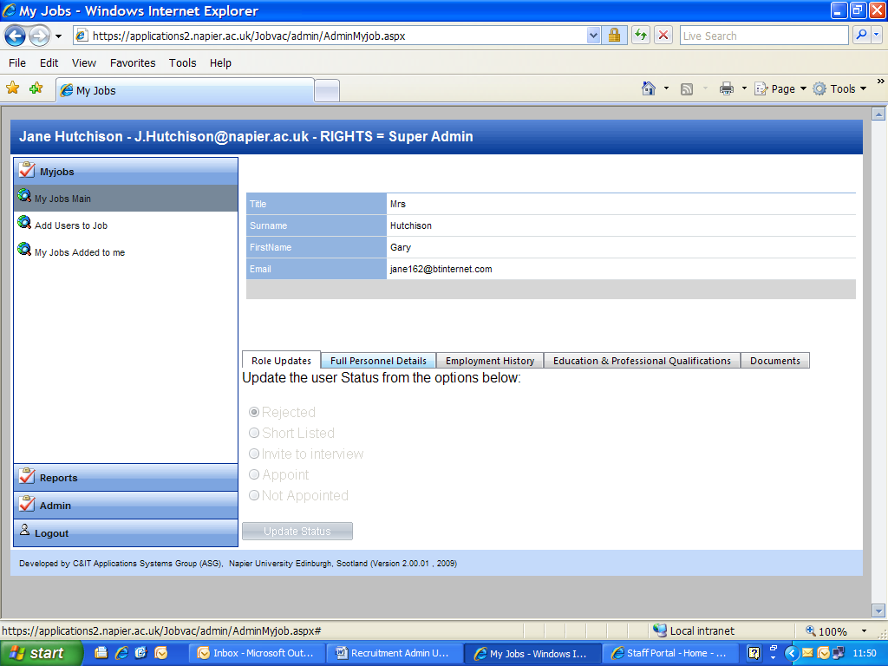
The next screen you will see is this. If you are a Panel Member then the Status options are greyed out – if you are a Recruitment Contact these will be visible. Only the Recruitment Contact can update candidate status.

You can click on each tab to view applicant details.
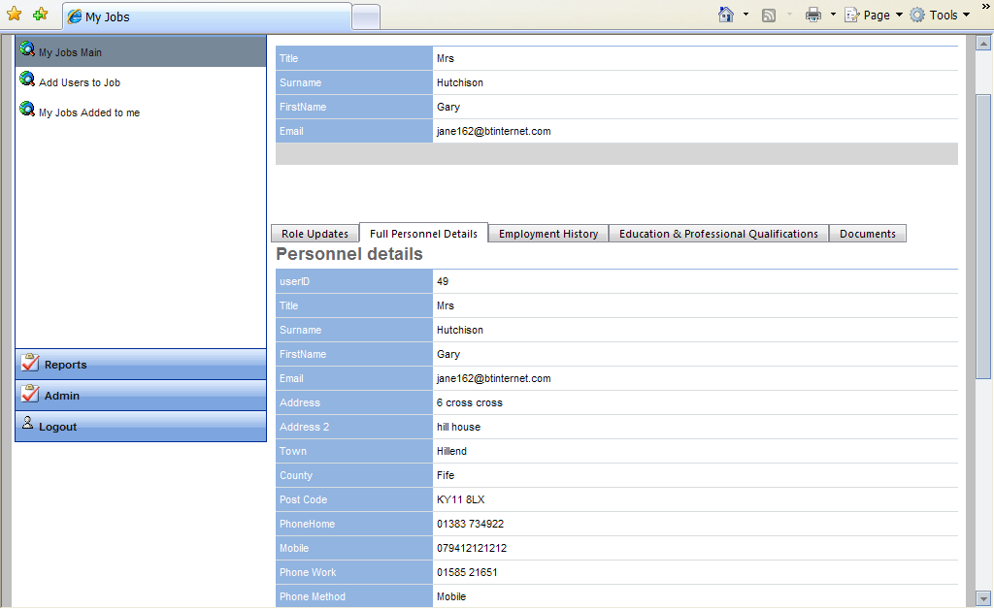
This view is not designed to be used for shortlisting purposes. An Application Details Report should be used for this purpose.

Viewing Applicant Attachments
To view an attachment click on the Documents tab. This will give you access to any attachments.
Click on the link to the attachment and Open in the normal way.
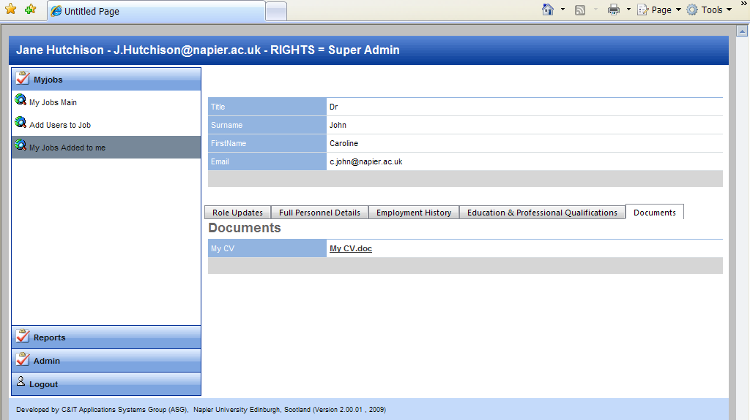
When providing applicant information for shortlisting purposes, CVs should be included for Academic roles only. CVs should not be used for shortlisting non-academic roles.
When producing applicant packs for interview you will need to check each application for an attachment and print off separately – these attachments do not print in the standard report.

Extracting Information in Excel Format
You can extract basic contact details in Excel to be used for mail merge purposes or for copy and paste into recruitment templates such as the short listing matrix.
Step 1: From my jobs main click on View Job
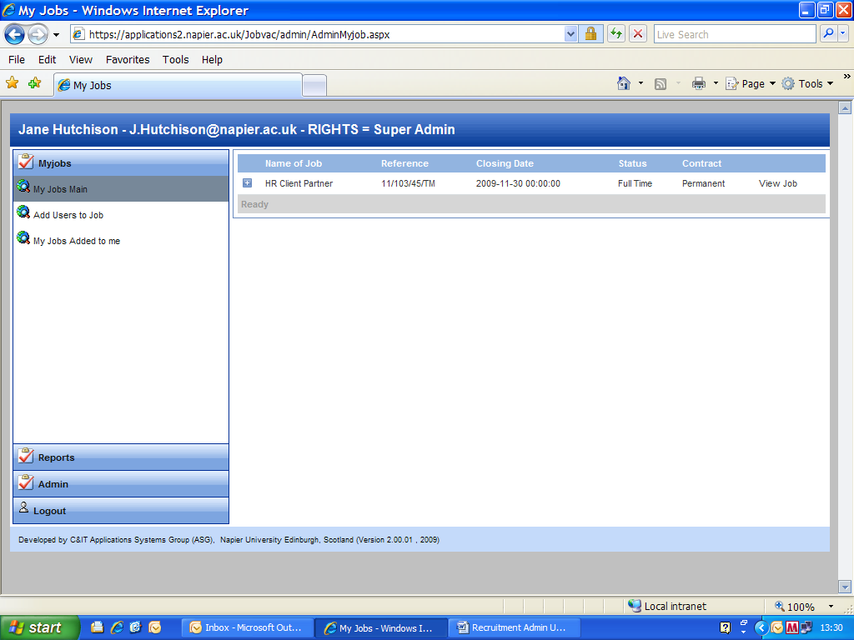
The next screen shows you a summary of the vacancy – scroll down to the bottom of that page until you see the buttons below.
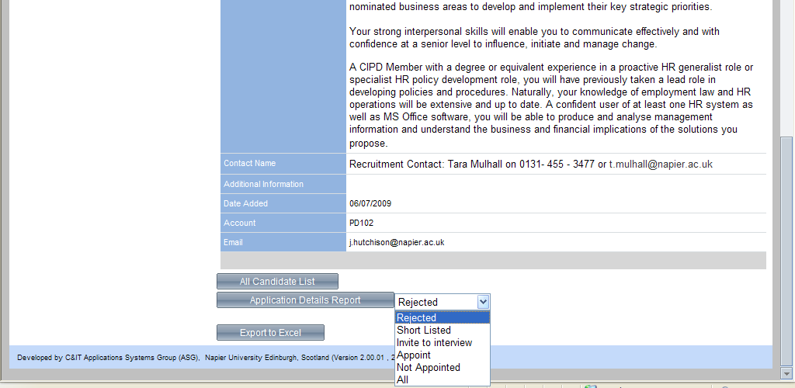
Choose Export to Excel. This will extract basic data for all candidates e.g. name, address, email and their status.

TIP: If you add additional columns to the spreadsheet headed interview date and interview time then this can be used to merge onto the invite to interview letter.
At this window choose Save use the file for mail merge or copy and paste to templates.
We suggest setting up one folder per vacancy and saving this that folder.
You will need to extract into Excel more than once e.g. to prepare short listing matrix and invite to interview letters – this is because candidate status will have changed.

This outputs the following example information:
Forename | Surname | Email | Address1 | Address2 | Town | County | Postcode | VacancyID | Status
Amy | Young | jane167@btinternet.com | 41 Straiton Mews | xxxxxxx | Edinburgh | Scotland | EH20 4NQ | 1 | Rejected
Tina | Mull | t.mull@napier.ac.uk | 23 High Street |  | Edinburgh | Uk | EH7 6TD | 1 | Rejected
Jessie | Fry | j.fry@napier.ac.uk | 1 Easter Home Drive |  | Edinburgh | Lothian | EH17 2TG | 1 | Rejected
Susan | Watts | s.muir@napier.ac.uk | Beaverbrook Cottage | Treetop Hill | West Frinton | Scotland | EH55 6RS | 1 | Rejected
Caroline | Andrews | c.andrews@napier.ac.uk | 55/4 Bire Road | Colinton | Edinburgh | Scotland | EH14 7AA | 1 | Rejected
Shirley | Smith | sh.smith@napier.ac.uk | 22 Faculty Drive |  | Edinburgh | Mid Lothian | EH11 2TG | 1 | Rejected

Using Templates
This list can be used to speed up the creation of:
- the short listing matrix – copy and paste special the first name/surname details into the matrix
- reject letters/invite to interview – use as data file for mail merges or email merges.
Please use the intranet version of templates each time you create these documents as in most cases these have been developed to make sure they can accommodate the information successfully from Excel.

Updating Applicant Status
The applicant status must be updated by the Recruitment Contact. To all other users the status options are greyed out and cannot be amended. To be as efficient as possible all applications default to “Reject” – that way the Recruitment Contact only has to update those being invited to interview etc.
The status options are:
- Rejected (default status)
- Short Listed
- Invite to Interview
- Appoint
- Not Appointed
These should be maintained as the recruitment process progresses. This is key to using the information for mail merges. It is also important for reporting purposes – for instance, we will be using the system to report on where our successful candidates are finding out about our roles, which in turn informs our advertising strategy. Also, it enables us to refine our Equal Opportunities information.
To update:
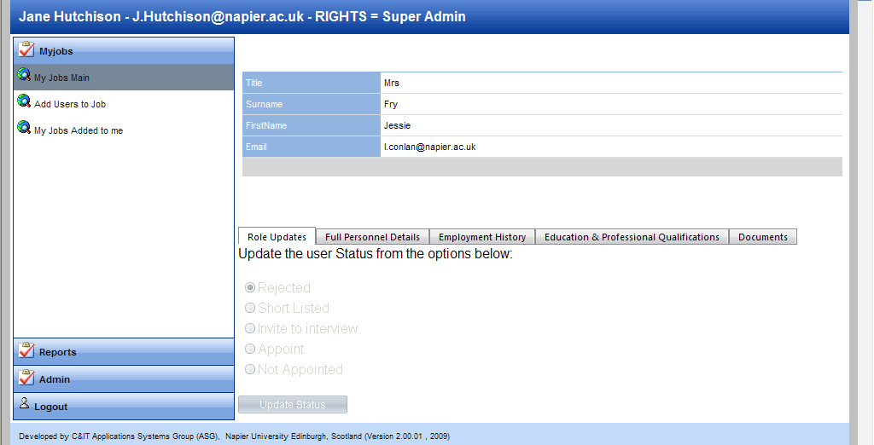
From My Jobs Main > Choose Vacancy > Choose + to expand list of candidates > Choose Full Details of candidate you want to change status > Choose appropriate status option > Click on Update Status

Producing a List of Applicants
You can create two types of list:
- All Candidate List – a basic list of applicant names
- Application Details Report – a list showing application form content (but not attachments)

These are created in PDF format by choosing the appropriate selection below. This pdf can be saved and/or emailed to the short listing panel.

To navigate to this section
From My Jobs Main > Choose Vacancy > Choose View Job to view vacancy details > Scroll to bottom of screen > Choose status type from drop down list (if using Application Details Report > Click All Candidate list or Application Details Report as appropriate.

The reports look like this

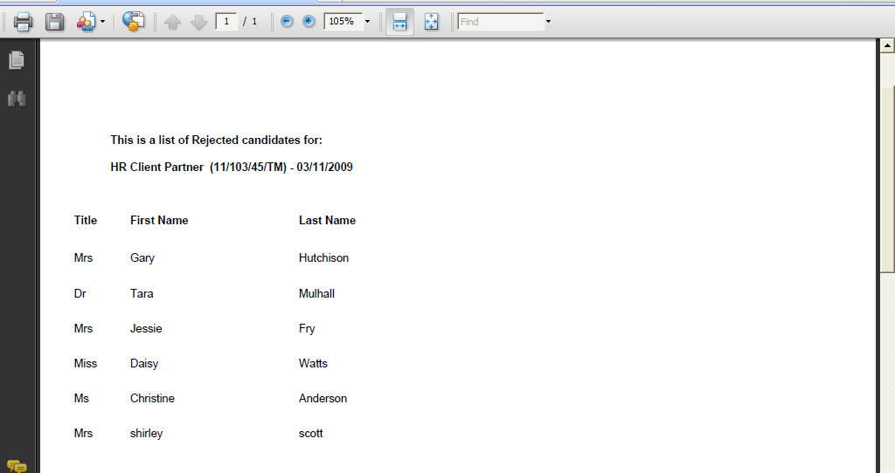
Candidate List

Candidate details report
Each section prints on a new page so we recommend using the online version and not printing/copying unless absolutely necessary e.g. for external assessors who do not have access to our Vacancy Management System.
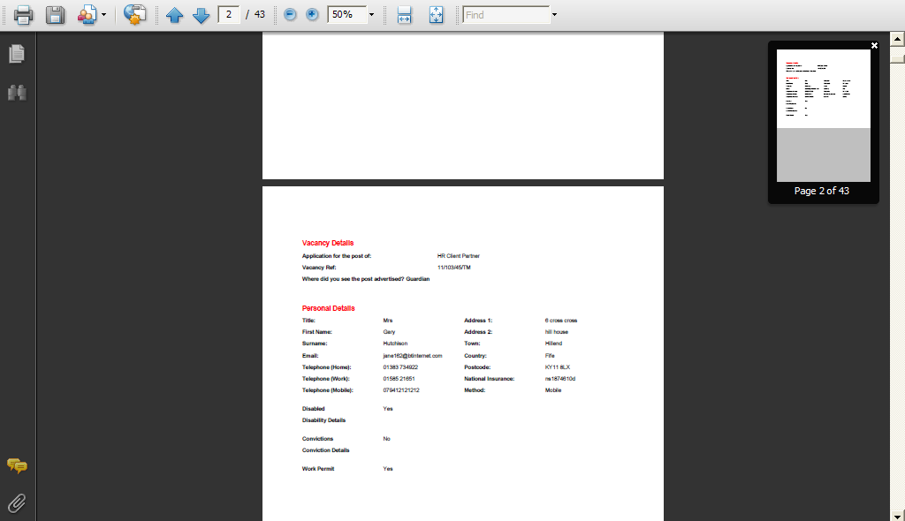

Referee Information
You will find referee information within each candidate’s application in the Education and Qualifications tab.
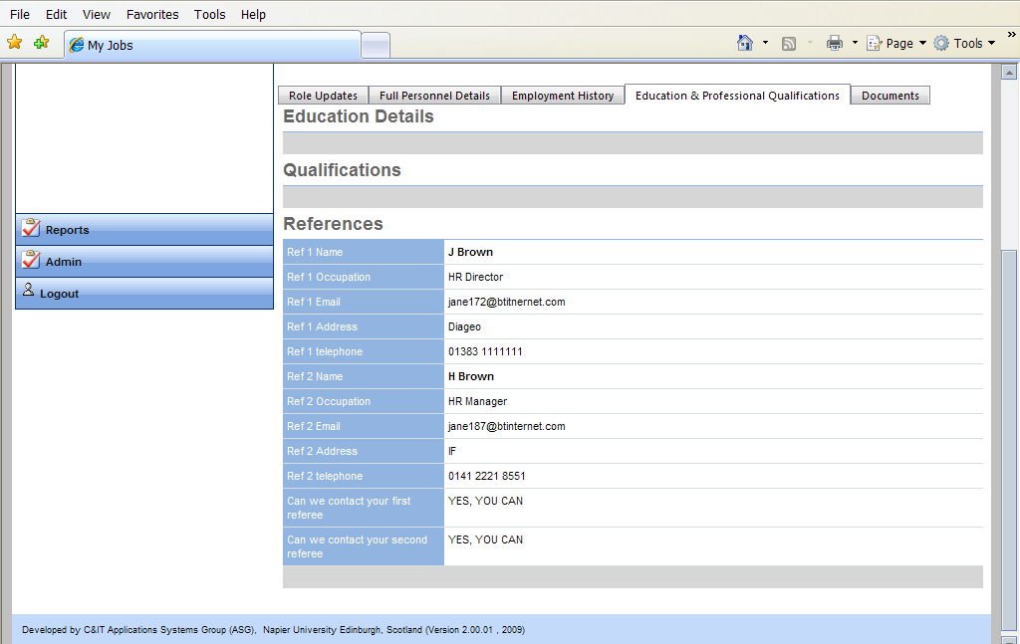

Interview Packs
At this stage you will already have updated candidate status so you can create a Candidate Details report for all those with the status of Invite to Interview.
You should check the individual applications of all invited to interview to see if they have attached CVs. These do not print off automatically in either of the report options.

Adding Offline Applicants
The majority of applications will be made online. We will continue to offer the opportunity to supply a written application to people who have a disability and therefore are unable to use the system. Internal vacancies will continue to use word forms but these are not managed in this system.
To add an application, click on Create New Application. You will see a simply styled form and should copy over the candidate details ensuring that all information is transposed just as it is on the application form. Keep the original application form and return this along with the rest of the recruitment paperwork at the end of the process.
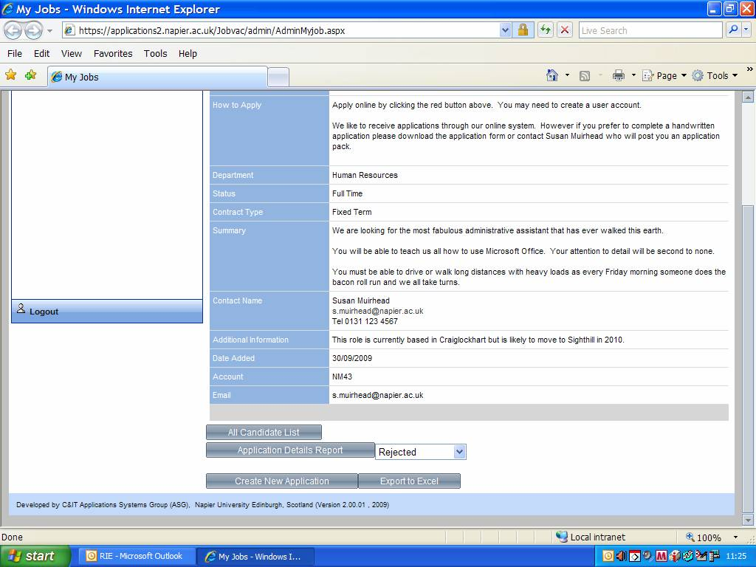

Reports
Nothing is currently available to Recruitment Contacts in this area.

Support
All users (applicants, recruitment contacts, panel members) can forward queries or suggestions to this mail box VMS@napier.ac.uk which is looked after by HR&D.
Specific vacancy queries, as opposed to system queries, should still be directed to the Recruitment Contact.

Appendix 1 – Application Form Screen Shots
We have done a significant amount of testing of the application form – and people have successfully completed it without support. As the recruitment contact you may be asked questions about form completion. It is not possible for you to view the application form online – so here for reference are some screen shots of the form.
