Research Fellow

 |  | 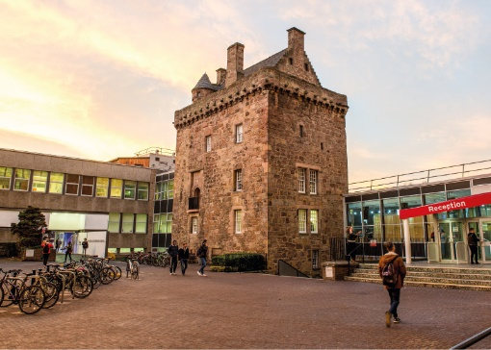

Role Description
GRADE  Grade 5  LOCATION  [Provide campus location: Sighthill, Merchiston, Craiglockhart Edinburgh]  LINE MANAGER  [Line Manager Role Title] |  | Role Summary  [1-3 paragraphs about the role]  Line Management Responsibility for:  This role does not have any line management responsibilities currently OR This role has line management responsibilities for [insert role titles / no. of line reports here].

Main Duties and Responsibilities

Teaching and Learning Support
- Could be expected to be involved in the assessment of student knowledge and supervision of undergraduate projects.
- Could be expected to assist in the development of student research skills at undergraduate or postgraduate level.

Research and Scholarship
- Define research objectives and questions
- Develop proposals for own or joint research, with the assistance of a mentor if required.
- Contribute to other’s proposals for securing funds.
- Conduct individual and collaborative research projects.
- Write up research work for peer-reviewed publication.
- Continually update knowledge and understanding in field or specialism.
- Review and synthesise the outcomes of research studies.
- Translate knowledge of advances in the subject area into research activity.
- Disseminate results to academic/research audiences

Communication
- Deal with routine communication using a range of media.
- Communicate complex information, orally, in writing and / or electronically.
- Preparing proposals and applications to external bodies, eg for funding and contractual purposes.
- Communicate material of a specialist or highly technical nature within forum specific to the subject.

Liaison and networking
- Liaise with colleagues and students.
- Build internal contacts and participate in internal networks for the exchange of information and to form relationships for future collaboration.
- Join external networks to share information and identify potential sources of funds.

Managing people
- Manage personal and own-project research and administrative activities, with guidance if required.

Teamwork
- Work with colleagues on joint projects, coordinating as required
- Collaborate with academic colleagues on areas of shared research interest.
- Attend and contribute to relevant meetings.

Pastoral care
- Show consideration to others.

Initiative, problem-solving and decision-making
- Use new research techniques and methods.
- Use initiative and creativity to identify areas for research, develop new research methods and extend the research portfolio.
- Use creativity to analyse and interpret research data and draw conclusions on the outcomes.
- Contribute to collaborative decision making with colleagues in areas of research.

Planning and managing resources
- Use research resources, laboratories and workshops as appropriate.
- Plan and manage own research activity in collaboration with others.

Sensory, physical and emotional demands
- Sensory and physical demands will vary from relatively light to a high level depending on the discipline and the type of work
- Carry out tasks that require the learning of certain skills.
- Balance with help the competing pressures of research consulting practice and administrative demands and deadlines.

Work environment
- Is required to be aware of the risks in the work environment and their potential impact on their own work and that of others.

Expertise
- Possess sufficient breadth or depth of specialist knowledge in the discipline and of research methods and techniques (for example, having obtained a PhD degree or equivalent experience) to work within established research projects or programmes or to act as lead researcher or consultant in projects.
- Engage in continuous professional development.
- Understand equal opportunity issues as they may impact on areas of research content.
- Role model the University’s values & behaviours.
- Be responsible for ensuring that the information and records processed (received, created, used, stored, destroyed) on behalf of the University are managed in compliance with ALL applicable legislation, codes and policies e.g. Data Protection, Information Security and Records Management.

PERSON SPECIFICATION
 | ESSENTIAL | DESIRABLE

Education / Qualifications
- X
- X
- X

Skills / Experience
- X
- X
- X
- X
- X
- X
- X
- X
- X
- X
- X
- X
- X

