Associate Consultant
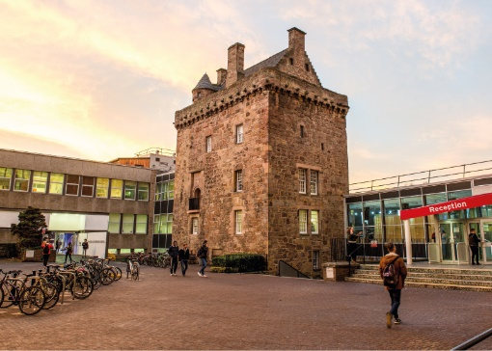

ROLE DESCRIPTION
GRADE  Grade 4  LOCATION  [Provide campus location: Sighthill, Merchiston, Craiglockhart Edinburgh]  LINE MANAGER  [Line Manager Role Title] |  | ROLE SUMMARY  [1-3 paragraphs about the role]  Line Management Responsibility for:  This role does not have any line management responsibilities currently OR This role has line management responsibilities for [insert role titles / no. of line reports here].

MAIN DUTIES AND RESPONSIBILITIES

Teaching and learning support
- Could be expected to assist in the training of students and/or temporary staff.

Research and scholarship
- Undertake basic research for example by preparing, setting up, conducting and recording the outcome of experiments and field work, the development of questionnaires and conducting surveys.
- Investigate experiment or systems failures including conducting detailed analysis or further diagnostic work, which may involve taking into account legislative requirements.
- Conduct literature and database searches.
- Write up results as project report.
- Continue to update knowledge and develop skills.

Communication
- Required to routinely provide straightforward information in a clear and accurate manner.
- Write up results of own consultancy, as part of a guided process
- Prepare written technical reports for clients.
- Communicate technical specifications to clients.
- Prepare and interpret complex technical drawings using advanced modelling and mapping software.
- Read and review technical reports for minor clients.

Liaison and networking
- Liaise with clients, colleagues and support staff on routine matters.
- Make internal and external contacts to develop knowledge and understanding and form relationships for future collaboration.
- Provide a high standard of service to external clients.

Managing people
- Provide guidance as required to support staff and any students who may be assisting with the consultancy.
- Co-ordinate work of Interns and Trainee Consultants as and when required.

Teamwork
- Actively participate as a member of a team.
- Attend and contribute to relevant meetings.
- Delegate work to Interns or Trainee Consultants, monitor its achievement and provide feedback as required.

Pastoral care
- Show consideration to others.

Initiative, problem-solving and decision-making
- Make use of standard research techniques and methods.
- Deal with problems which may affect the achievement of experiments, fieldwork, consultancy objectives and deadlines
- Contribute to decisions affecting the work of the team.
- Analyse and interpret the results of own consultancy and generate original ideas based on outcomes.

Planning and managing resources
- Plan own day-to-day consultancy activity within the framework of the agreed project.
- Co-ordinate own work with that of others to avoid conflict or duplication of effort.
- Contribute to the planning of consultancy projects and ensure own objectives and deadlines are met.

Sensory, physical and emotional demands
- Sensory and physical demands will vary from relatively light to a high level depending on the discipline and the type of work
- Carry out tasks that require the learning of certain skills.
- May be required to use specialist equipment.

Work environment
- Is required to be aware of the risks in the work environment.
- May be required to undertake work in potentially hazardous sites.

Expertise
- Possess sufficient breadth or depth of specialist knowledge in the discipline (for example with an undergraduate or Master’s degree) and be developing further skills in and knowledge of consultancy area, research methods and techniques.
- Shall be an Associate Member of relevant professional body.
- Role model the University’s values & behaviours;
- Be responsible for ensuring that the information and records processed (received, created, used, stored, destroyed) on behalf of the University are managed in compliance with ALL applicable legislation, codes and policies e.g. Data Protection, Information Security and Records Management.

PERSON SPECIFICATION
 | ESSENTIAL | DESIRABLE

Education / Qualifications
- X
- X
- X

Skills / Experience
- X
- X
- X
- X
- X
- X
- X
- X
- X
- X
- X
- X
- X
- X

