LECTURER

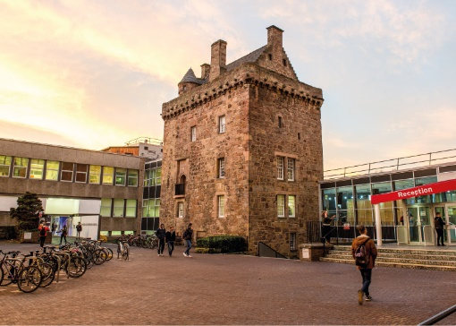

ROLE DESCRIPTION
GRADE  Grade 6  LOCATION  Sighthill, Craiglockhart or Merchiston, Edinburgh |  | ROLE SUMMARY  All new staff appointed to a Grade 6 Lecturer post will deliver high-quality, student-centred teaching, underpinned by academic scholarship (research, pedagogy, knowledge exchange or professional practice).

MAIN DUTIES AND RESPONSIBILITIES
Academic staff are expected to carry out a range of duties and responsibilities taken from the following. Whilst it is not anticipated that all activities listed below will be covered by one person, it is expected that all individuals will make a balanced contribution to teaching and learning, research and demonstrate academic leadership.

Teaching and learning support
- Design and deliver learning experiences that are engaging, challenging and informed by pedagogical scholarship and professional practice.
- Contribute to and/or lead in the development or design of the curriculum and of innovative programmes.
- Demonstrate effective teaching and professional practice as measured by student feedback, assessment outcomes and success, peer review and external validation.
- Supervise the work of students, provide advice on study skills and support learning.
- Develop methods of assessment that encourage active learning and student engagement and provide constructive feedback to students.
- Identify areas where current provisions need revision or improvement.

Research and scholarship
- Develop and design research projects and submit proposals to secure funding.
- Conduct, contribute to, or collaborate in research projects and disseminate research findings through the publication of appropriate outputs (e.g. peer reviewed articles).
- Engage with industry and society to translate knowledge advances in disciplinary, professional and pedagogical research as required to support research and teaching activities.
- Disseminate research through conference presentations, publications and public engagement activities.
- Supervise research degree students.

Communication, liaison and networking
- Liaise with national and international peers, colleagues and students, promoting the University in the identification of funding, student recruitment and securing opportunities for students (e.g. student placements, work experience etc.).
- Market the institution, facilitate out-reach activity, obtain consultancy projects and/or build relationships for future activities.
- Build academic networks for the exchange of information, collaborative research including identification of funding and form relationships for future collaboration.

Academic leadership
- Exercise academic leadership and supervision in research and teaching as a lecturer, course coordinator and/or mentor to peers, colleagues, and students.
- Develop or coordinate the work of others to ensure modules are delivered to the standards required.
- Resolve problems affecting the quality of course delivery and research progress, referring more serious matters to others, as appropriate.

Teamwork and pastoral care
- Promote, contribute, and collaborate with academic colleagues on course development, curriculum changes, group meetings, internal committees and the development of research activity and teaching.
- Collaborate and coordinate teaching, research and projects.
- Responsible for dealing with student issues in accordance with University regulations.

Initiative, problem-solving and decision-making
- Demonstrate initiative, creativity, judgement and responsibility, for applying appropriate approaches to research, accreditation of courses, teaching, learning support, assessment and/or scholarly activities.
- Develop ideas for generating income for scholarship research and knowledge exchange.
- Provide advice on strategic issues and decision-making such as subject promotion, student recruitment and marketing.

Planning and managing resources
- Responsible for managing resource, assessments, laboratories, workshops, facilities and for ensuring that student needs and expectations are met.
- Responsible for administrative duties in areas such as admissions, timetabling, examinations, progress assessment and student attendance.
- Contribute to institutional planning, staff resourcing, research, strategic development, priorities and goals.
- Be responsible for ensuring that the information and records processed (received, created, used, stored, destroyed) on behalf of the University are managed in compliance with all applicable legislation, codes and policies e.g. Data Protection, Information Security and Records Management.
- Responsible for managing research project budgets.
- Planning research degree student programmes for work.

Work environment
- Responsible for managing risk and promoting safe practices within the work environment (e.g. laboratories, workshops, studios, field trips).
- Some national and international travel to overseas may be required.

Expertise
- Possess sufficient breadth or depth of specialist knowledge in the discipline to develop teaching and research programmes.
- Engage in continuous professional development including a range of delivery techniques and the promotion of learning, professional practice and research.
- Be a nationally recognised authority, publication author and scholar in the subject discipline.

PERSON SPECIFICATION
Applicants are expected to present evidence of achievement against each of the specific criteria outlined below.

Refer to Criteria for Research, Enterprise, Learning & Teaching, Professional Practice for academic postings.

 | ESSENTIAL | DESIRABLE

Education/Qualification

- Doctoral level qualification.
- Ideally HEA membership or a strong willingness to achieve membership within 18 months of appointment.

Experience
Evidenced achievement against the criteria for Esteem, Innovation, Contribution and Academic Leadership.

- Esteem - Profile that demonstrates at least national standing
- Innovation and Impact - Record of outputs in terms of originality, significance and rigour.
- Contribution - Contribution to generation of external income. Engagement with relevant communities internally and potentially externally.
- Academic Leadership - Providing leadership and support to colleagues within the University, for example as Module Leader or Programme Leader of a small/medium programme.

Skills/Personal Requirements

- Demonstration of the University’s agreed values and behaviours – Professional, Innovative, Inclusive and Ambitious.

