Learning Spaces Technician

 | 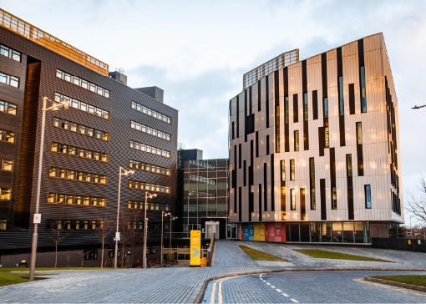 | 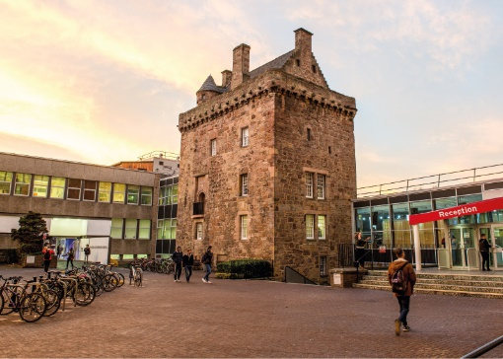

ROLE DESCRIPTION
GRADE  Grade 3  LOCATION  Edinburgh  LINE MANAGER  AV & Learning Spaces Manager |  | ROLE SUMMARY  The University is continuing to make a significant investment in its IT and digital services provision to ensure the delivery of a consistent, high quality service across the University. Information Services provide innovative and reliable IT and Library services which are continually being adapted to meet the changing needs of the staff and students in a rapidly changing technology and teaching/learning environment.  The Learning Spaces Technician role is to work as part of the Audio Visual (AV) and Learning Spaces team to support the provision, installation, and maintenance of the IT technology & AV equipment across the entire University estate. The Learning Spaces Technician will also support the use of this technology by our Professional Services and Academic staff and assist in their understanding of how this technology will work when used within the teaching and learning framework.  Line Management Responsibility for:  This role does not have any line management responsibilities currently.

MAIN DUTIES AND RESPONSIBILITIES
- Work to ensure the efficient day to day running of support for the set-up, operation, management, installation and troubleshooting all IT and AV equipment across the University
- To work with the agreed plan to schedule, install, implement & upgrade computer hardware/software and to assist in the configuration of computer equipment and associated peripherals and mobile technologies.
- Participate in the provision of front-line service at IS service points and maintain a suitable environment for study and research.
- To take responsibility for specific operational tasks under the supervision of the Manager or their nominee and to contribute to the work of the AV & Learning Spaces team in general
- To provide support on request to staff and students in relation to IT and AV services, applications and operating systems.
- Assist in the diagnosis and resolution of faults to ensure that all systems are fully functional and that equipment and system down time are kept to a minimum.
- Assist with the inventory of equipment and supplies, monitoring the repair and replacement of non-working, damaged and/or obsolete equipment.
- Provide 1st and 2nd line support for IT and AV equipment and installations
- Be responsible for ensuring that customer incidents and service requests are logged, tracked, progressed and concluded satisfactorily using the University designated Service Management System
- Assist in the operation of video production to record and stream lectures and events, and provide filming and editing services
- Adhere to SLAs and ITIL processes ensuring incidents and service requests are dealt with in an effective and timely manner
- Contribute towards the generation and maintenance of knowledge management documentation and procedures.
- Contribute to documenting working practices and processes for direct colleagues and customers.
- Identify opportunities to continually improve the work and performance of Information Services.
- To keep abreast of new IT and AV technologies and to develop such skills as are required to remain effective in this role.
- Undertake duties in line with departmental safety, health and wellbeing arrangements including any specific training and to undertake suitable and sufficient risk assessments.
- Undertake other such duties, at any location, as requested by the AV & Learning Spaces Manager or their nominee.
- Role model the University’s values & behaviours
- Be responsible for ensuring that the information and records processed (received, created, used, stored, destroyed) on behalf of the University are managed in compliance with ALL applicable legislation, codes and policies e.g. Data Protection, Information Security and Records Management.

PERSON SPECIFICATION
 | ESSENTIAL | DESIRABLE

Education / Qualifications
- A degree and/or demonstrable equivalent experience
- Evidence of Continual Professional Development
- ITIL Foundation

Skills / Experience
- Practical experience of working in a customer support environment providing technical solutions and able to demonstrate the use of equipment.
- Experience of demonstrating room technologies, video, projection and display equipment, audio systems and control environments
- Knowledge and understanding of computing devices (such as Windows desktop workstations and laptops, iOS and Android tablets and smartphones, scanner/copier/printers) and software
- Knowledge and understanding of Apple OSX desktop workstations and laptops
- Experience of delivering IT/AV Technology collaboratively in a team environment
- Experience of delivering IT/AV Technology within an educational environment
- An understanding of the traditional and emerging technology themes which underpin the provision of teaching environments
- Experience of proactively identifying and implementing improvements to services and processes
- Good verbal and written communication skills, including the ability to communicate effectively
- Strong customer focus – demonstrating good listening techniques to gain a thorough understanding of customer needs, interpreting requirements accurately, to develop technical solutions and deliver a prompt and efficient service
- Practical end user IT skills, including a good working knowledge of Operating Systems, computer applications, internet and digital information services to assist customers in the use of technology
- Ability to work calmly and systematically in a busy environment, to prioritise work and to meet service level agreements escalating issues where appropriate
- Good problem-solving and analytical skills with the ability to approach and resolve problems in a logical and practical manner.

