Research Fellow

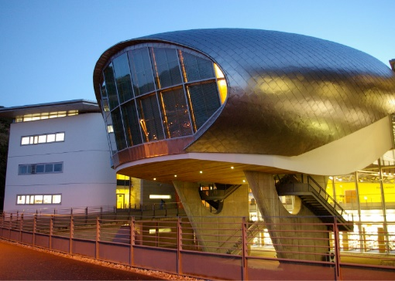 | 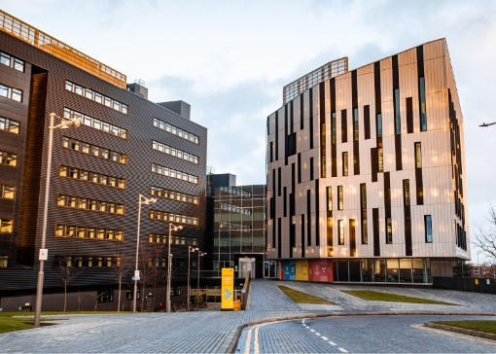 | 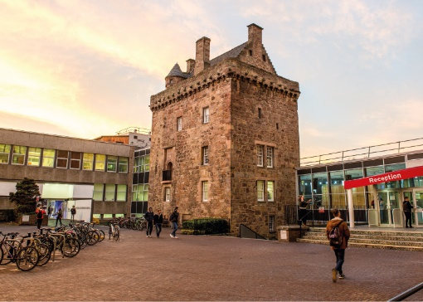

ROLE DESCRIPTION
GRADE  Grade 5  LOCATION  [Provide campus location: Sighthill, Merchiston, Craiglockhart Edinburgh]  LINE MANAGER  [Line Manager Role Title] |  | ROLE SUMMARY  [1-3 paragraphs about the role]  Line Management Responsibility for:  This role does not have any line management responsibilities currently OR This role has line management responsibilities for [insert role titles / no. of line reports here].

MAIN DUTIES AND RESPONSIBILITIES

Teaching and Learning Support
- Could be expected to be involved in the assessment of student knowledge and supervision of undergraduate projects.
- Could be expected to assist in the development of student research skills at undergraduate or postgraduate level.

Research and Scholarship
- Define research objectives and questions
- Develop proposals for own or joint research, with the assistance of a mentor if required.
- Contribute to other’s proposals for securing funds.
- Conduct individual and collaborative research projects.
- Write up research work for peer-reviewed publication.
- Continually update knowledge and understanding in field or specialism.
- Review and synthesise the outcomes of research studies.
- Translate knowledge of advances in the subject area into research activity.
- Disseminate results to academic/research audiences

Communication
- Deal with routine communication using a range of media.
- Communicate complex information, orally, in writing and / or electronically.
- Preparing proposals and applications to external bodies, eg for funding and contractual purposes.
- Communicate material of a specialist or highly technical nature within forum specific to the subject.

Liaison and networking
- Liaise with colleagues and students.
- Build internal contacts and participate in internal networks for the exchange of information and to form relationships for future collaboration.
- Join external networks to share information and identify potential sources of funds.

Managing people
- Manage personal and own-project research and administrative activities, with guidance if required.

Teamwork
- Work with colleagues on joint projects, coordinating as required
- Collaborate with academic colleagues on areas of shared research interest.
- Attend and contribute to relevant meetings.

Pastoral care
- Show consideration to others.

Initiative, problem-solving and decision-making
- Use new research techniques and methods.
- Use initiative and creativity to identify areas for research, develop new research methods and extend the research portfolio.
- Use creativity to analyse and interpret research data and draw conclusions on the outcomes.
- Contribute to collaborative decision making with colleagues in areas of research.

Planning and managing resources
- Use research resources, laboratories and workshops as appropriate.
- Plan and manage own research activity in collaboration with others.

Sensory, physical and emotional demands
- Sensory and physical demands will vary from relatively light to a high level depending on the discipline and the type of work
- Carry out tasks that require the learning of certain skills.
- Balance with help the competing pressures of research consulting practice and administrative demands and deadlines.

Work environment
- Is required to be aware of the risks in the work environment and their potential impact on their own work and that of others.

Expertise
- Possess sufficient breadth or depth of specialist knowledge in the discipline and of research methods and techniques (for example, having obtained a PhD degree or equivalent experience) to work within established research projects or programmes or to act as lead researcher or consultant in projects.
- Engage in continuous professional development.
- Understand equal opportunity issues as they may impact on areas of research content.

PERSON SPECIFICATION
 | ESSENTIAL | DESIRABLE

Education / Qualifications
- X
- X
- X

Skills / Experience
- X
- X
- X
- X
- X
- X
- X
- X
- X
- X
- X
- X
- X
- X

