[Role Title]

 | 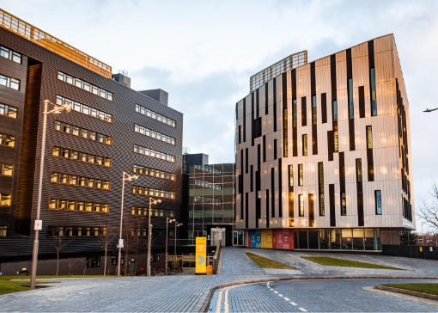 | 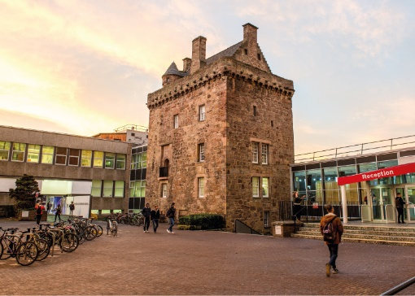

Role Description
GRADE  Grade [X]  LOCATION  [Provide campus location: Sighthill, Merchiston, Craiglockhart Edinburgh]  LINE MANAGER  [Line Manager Role Title] |  | Role Summary  [1-3 paragraphs about the role]  Line Management Responsibility for:  This role does not have any line management responsibilities currently OR This role has line management responsibilities for [insert role titles / no. of line reports here].

Main Duties and Responsibilities
- X
- X
- X
- X
- X
- X
- X
- X
- Role model the University’s values & behaviours.
- Be responsible for ensuring that the information and records processed (received, created, used, stored, destroyed) on behalf of the University are managed in compliance with ALL applicable legislation, codes and policies e.g. Data Protection, Information Security and Records Management.

PERSON SPECIFICATION
 | ESSENTIAL | DESIRABLE

Education / Qualifications
- X | a
- X | a
- X |  | a

Skills / Experience
- X | a
- X | a
- X | a
- X | a
- X | a
- X | a
- X | a
- X |  | a
- X |  | a
- X |  | a
- X |  | a
- X |  | a
- X |  | a

