Senior Research Fellow
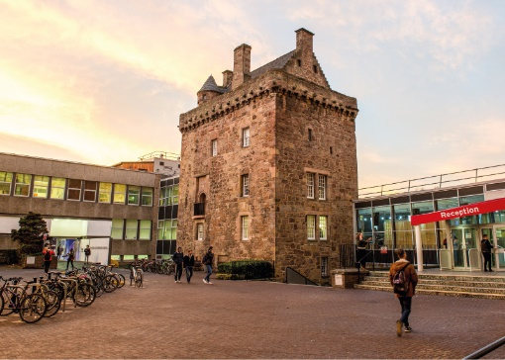

ROLE DESCRIPTION
GRADE  Grade 6  LOCATION  [Provide campus location: Sighthill, Merchiston, Craiglockhart Edinburgh]  LINE MANAGER  [Line Manager Role Title] |  | ROLE SUMMARY  [1-3 paragraphs about the role]  Line Management Responsibility for:  This role does not have any line management responsibilities currently OR This role has line management responsibilities for [insert role titles / no. of line reports here].

MAIN DUTIES AND RESPONSIBILITIES

Teaching and Learning Support
- Could be expected to contribute to teaching and learning programmes
- Could be expected to supervise postgraduate students.

Research and scholarship
- Develop research objectives, projects and proposals.
- Conduct individual or collaborative research projects,
- Identify sources of funding and secure funds as far as reasonably possible.
- Contribute to research strategy statements at research centre or departmental level.
- Extend, transform and apply knowledge acquired from scholarship to research and appropriate external activities.
- Publish in peer-reviewed journals or equivalent
- Disseminate research findings using appropriate media.
- Act as a referee and contribute peer assessment.
- Make presentations or exhibitions at national or international conferences and other similar events.

Communication
- Routinely communicate complex and conceptual ideas to those with limited knowledge and understanding as well as to peers using high level skills and a range of media.
- Routinely work with external partners liaise and communicate needs across a wide spread of partners
- Communicate with both technical and non-technical audiences, and demonstrate ability to present complex argument in a non-technical manner.

Liaison and networking
- Collaborate actively within and outwith the Institution to complete research projects and advance thinking.
- Participate in and develop external networks, for example to identify sources of funding, generate income, obtain consultancy projects, or build relationships for future activities.

Managing people
- Mentor colleagues with less experience and advise on personal development.
- Coach and support colleagues in developing their research techniques.
- Depending on the area of work, could be expected to supervise the work of others, for example in research teams or projects.

Teamwork
- Take lead responsibility for a research project or identified parts of a research project.
- Develop productive working relationships with other members of staff.
- Co-ordinate the work of colleagues to ensure equitable access to resources and facilities.

Pastoral care

• Deal with standard problems and help colleagues resolve their concerns about progress in research.

Initiative, problem-solving and decision-making

- Assess, interpret and evaluate outcomes of research.
- Develop new concepts and ideas to extend intellectual understanding.
- Resolve problems of meeting research objectives and deadlines.
- Develop ideas for generating income and promoting research area.
- Develop ideas for application of research outcomes
- Decide on research programmes and methodologies, often in collaboration with colleagues and sometimes subject to the approval of the head of the research programme on fundamental issues.

Planning and managing resources

- Plan, co-ordinate and implement research projects.
- Manage the use of research resources and ensure that effective use is made of them.
- Manage or monitor research budgets.
- Help to plan and implement commercial and consultancy activities.
- Plan and manage own consultancy assignments.

Sensory, physical and emotional demands

- Balance the pressures of research, consulting practice and administrative demands and competing deadlines.

Work environment

- Depending on area of work and level of training received, may be expected to conduct risk assessment and take responsibility for the health and safety of others.
- Role model the University’s values & behaviours;

Expertise
- Expected to have a national reputation in their field (amongst peers or clients or both).
- Possess sufficient breadth or depth of specialist knowledge in the discipline to develop research programmes and methodologies.
- Possess sufficient breadth or depth of specialist knowledge in the discipline to act as a divisional leader and to be able to project manage several major projects and the work of the lead consultants in charge.
- Ability to use a range of delivery techniques to enthuse and engage others.
- Be responsible for ensuring that the information and records processed (received, created, used, stored, destroyed) on behalf of the University are managed in compliance with ALL applicable legislation, codes and policies e.g. Data Protection, Information Security and Records Management.

PERSON SPECIFICATION
 | ESSENTIAL | DESIRABLE

Education / Qualifications
- X
- X
- X

Skills / Experience
- X
- X
- X
- X
- X
- X
- X
- X
- X
- X
- X
- X
- X
- X

