Trainee Consultant
 | 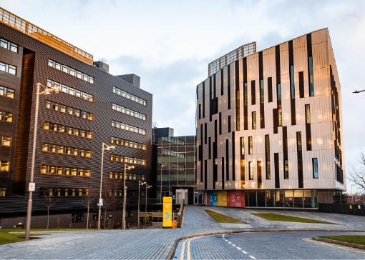 | 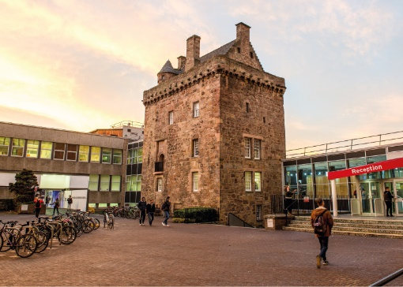

ROLE DESCRIPTION
GRADE  Grade 3  LOCATION  [Provide campus location: Sighthill, Merchiston, Craiglockhart Edinburgh]  LINE MANAGER  [Line Manager Role Title] |  | ROLE SUMMARY  [1-3 paragraphs about the role]  Line Management Responsibility for:  This role does not have any line management responsibilities currently OR This role has line management responsibilities for [insert role titles / no. of line reports here].

MAIN DUTIES AND RESPONSIBILITIES

Teaching and learning support
- Could be expected to assist in the training of students.

Research and scholarship
- Undertake basic research for example by preparing, setting up, conducting and recording the outcome of experiments and field work, the development of questionnaires and conducting surveys.
- Conduct literature and database searches.
- Write up results as project report.
- Continue to update knowledge and develop skills.

Communication
- Required to routinely provide straightforward information in a clear and accurate manner.
- Write up results of consultancy, as part of a guided process
- Assist in the preparation of written technical reports for clients.
- Assist in the communication of technical specifications to clients.
- Assist in the preparation of and interpret complex technical drawings using advanced modelling and mapping software.
- Assist in the preparation of technical reports for clients.

Liaison and networking
- Liaise with colleagues and support staff on routine matters.
- Make internal contacts to develop knowledge and understanding and form relationships for future collaboration.
- As a member of a project team provide a high standard of service to external clients.

Managing people
- Provide guidance as required to support students who may be assisting with the consultancy.

Teamwork
- Actively participate as a member of a team.
- Attend and contribute to relevant meetings.

Pastoral care
- Show consideration to others.

Initiative, problem-solving and decision-making
- Make use of standard research techniques and methods.
- Deal with problems which may affect the achievement of experiments, fieldwork, consultancy objectives and deadlines
- Contribute to decisions affecting the work of the team.
- Analyse and interpret the results of own consultancy and generate original ideas based on outcomes.

Planning and managing resources
- Contribute to the planning of consultancy projects and ensure own objectives and deadlines are met.

Sensory, physical and emotional demands
- Sensory and physical demands will vary from relatively light to a high level depending on the discipline and the type of work
- Carry out tasks that require the learning of certain skills.
- May be required to use specialist equipment.

Work environment
- Is required to be aware of the risks in the work environment.
- May be required to undertake work in potentially hazardous sites.

Expertise
- Possess sufficient breadth or depth of specialist knowledge in the discipline (for example with an undergraduate or Master’s degree) and be developing further skills in and knowledge of consultancy area, research methods and techniques.
- Role model the University’s values & behaviours;
- Be responsible for ensuring that the information and records processed (received, created, used, stored, destroyed) on behalf of the University are managed in compliance with ALL applicable legislation, codes and policies e.g. Data Protection, Information Security and Records Management.

PERSON SPECIFICATION
 | ESSENTIAL | DESIRABLE

Education / Qualifications
- X
- X
- X

Skills / Experience
- X
- X
- X
- X
- X
- X
- X
- X
- X
- X
- X
- X
- X
- X

