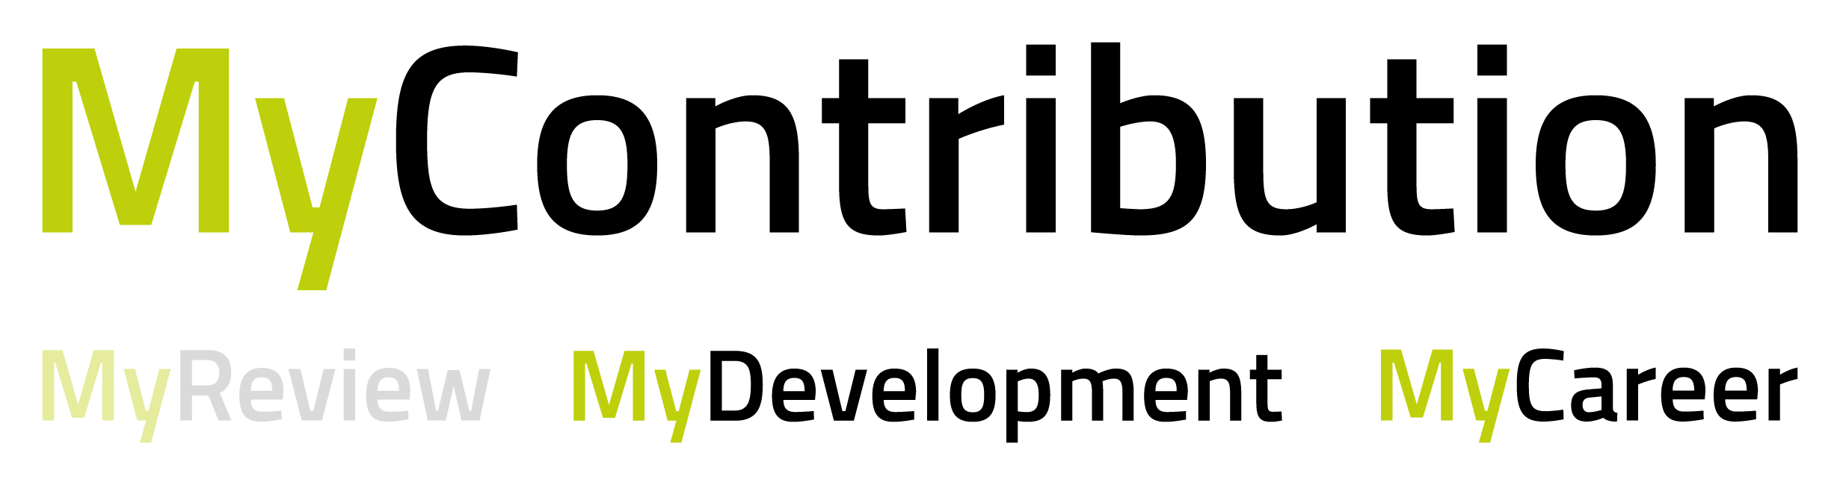
This template may be useful for you to share and agree your personal development objectives with your line manager before adding them to the My Development online form.
We recommend that you have no more than 3 personal objectives.
When agreed, you can cut and paste the relevant content into My Contribution which you will find through HR connect.
Objective Number | My Development headings | Your content
1 | Please select a competency that you wish to develop?
 | What do you want to achieve? Why?
 | How will you measure your success in this?
 | What support do you need to achieve your personal development objective e.g. training, manager support etc.
 | Set a finish date
2 | Please select a competency that you wish to develop?
 | What do you want to achieve? Why?
 | How will you measure your success in this?
 | What support do you need to achieve your personal development objective e.g. training, manager support etc.
 | Set a finish date
3 | Please select a competency that you wish to develop?
 | What do you want to achieve? Why?
 | How will you measure your success in this?
 | What support do you need to achieve your personal development objective e.g. training, manager support etc.
 | Set a finish date

