Supporting Vulnerable Staff
Manager Guidance

The purpose of this guidance is to support you to assess staff who fall within the two groups more vulnerable to the effects of Covid-19 when planning for the return to campus. These groups are those at higher risk of severe illness from Covid-19 and those at extremely high risk of severe illness from Covid-19. Further information on these groups is available from NHS Scotland. This guidance explains the steps which need to be taken to minimise, as far as reasonably practicable, their exposure to Covid-19.

It is the responsibility of staff to inform you that they do or may fall within one of the two vulnerable groups. They are not required to disclose medical information, but should indicate whether they are in a more vulnerable group, in order that appropriate consideration can be given to any suitable and reasonable adjustments that are necessary to protect their health.

If, you become aware that a member of your team falls within the vulnerable category, you should follow the steps below in the flowchart to support the assessment of risk and inform decisions about any additional measures that should be put in place. It is important to make staff aware of the overarching University Covid-19 Return to Work Risk Assessment and any department/role based risk assessments and the actions and recommendation that have been implemented as a result of this as part of your discussion. Staff should complete the Covid-19 Staff Assessment form in the appendix and discuss this with you. The situation should be kept under regular review.

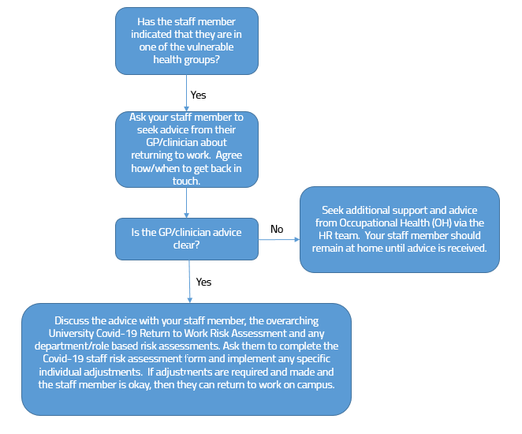

Vulnerable Staff

Staff should continue to work from home wherever possible. However when there is a requirement for staff to work on campus and who fall within the extremely high risk or higher risk group, they should be asked to contact their GP for advice on any additional specific measures which may need to be implemented to protect their health. These may include changes to work activities, practices or working patterns.

Thereafter, you should discuss with them any additional specific measures and/or adjustments, advised by their GP, which need to be implemented to protect their health and enable them to safely return to campus, where it is reasonable and appropriate to do so.

You must seek advice from Occupational Health (OH) via the HR team in the following circumstances:

- The staff member is unable to discuss their concerns with you
- You and/or the staff member require additional advice regarding their vulnerability and health

If you are unable to make the necessary adjustments to enable the staff member to work on campus and they are unable to do their work from home, you can ask them to undertake alternative duties or project work (within their skill set and grade) to complete at home.

Staff who live with someone who is in a vulnerable group

If they cannot work from home or their role is required on campus, they would be expected to attend work. However, you should discuss any concerns with them and should revisit the relevant risk assessment and working practices for their area to ascertain whether it offers sufficient reassurance for them. You should consider any additional specific measures and/or adjustments, advised by the vulnerable person’s GP, where it is reasonable and appropriate to do so.

What can be done to remove or lessen the risk?

The Health and Safety team can advise on any other local reasonable adjustments in addition to the overarching University risk assessment and local school/services risk assessment. The actual measures will be dependent upon individual circumstances and specific GP advice, however the following types of adjustments may be considered:

- Changes to tasks, duties or other ways of working
- Amended working hours or patterns
- Working from an alternative campus

Prior to making a final decision, further advice should be sought from the Health and Safety Team, your HR Partner and Occupational Health, if necessary.

COVID-19 Staff Assessment Form

The purpose of this form is to establish whether you fall within one of the vulnerable health groups, whether you can attend work on campus. If you can attend work on campus these questions will assist your manager in the consideration of any additional adjustments which may need to be discussed with you prior to your return to campus. Responses will be treated confidentially and sensitively. You do not need to provide details of any medical condition. Once completed please ensure this form is sent to the HR team at humanrsources@napier.ac.uk.

Name: | School/Service:
Job Title: | Contact number:

- Are you in the extremely high risk group and were previously asked to shield by the NHS / your GP and received a ‘shielding’ letter? Y/N
Extremely high risk group includes individuals who have:
- cancer and are receiving active chemotherapy
- lung cancer and are either receiving or previously received radical radiotherapy
- cancers of the blood or bone marrow, such as leukaemia, lymphoma or myeloma who are at any stage of treatment
- severe chest conditions such as cystic fibrosis, severe asthma, severe COPD, severe bronchiectasis and pulmonary hypertension
- rare diseases, including all forms of interstitial lung disease/sarcoidosis, and inborn errors of metabolism (such as SCID and homozygous sickle cell) that significantly increase the risk of infections
- an absent spleen or have had their spleen removed
- significant heart disease (congenital or acquired) and are pregnant

And those that have had:
- solid organ transplants
- bone marrow or stem cell transplants in the last 6 months, or who are still taking immunosuppression drugs

Or receiving:
- immunotherapy or other continuing antibody treatments for cancer
- other targeted cancer treatments which can affect the immune system, such as protein kinase inhibitors or PARP inhibitors
- immunosuppression therapies that significantly increase the risk of infection
- renal dialysis treatment

- Are you in the higher risk group but did not receive an NHS or GP ‘shielding’ letter? Y/N

Higher risk group includes individuals who are:

- aged 70 or older (regardless of medical conditions)
- under 70 and instructed to get a flu jab as an adult each year on medical grounds
- pregnant
- BAME (Black, Asian and Minority Ethnic) with underlying health conditions

And those with:
- chronic (long-term) respiratory diseases, such as asthma, chronic obstructive pulmonary disease (COPD), emphysema or bronchitis
- chronic heart disease, such as heart failure
- chronic kidney disease
- chronic liver disease, such as hepatitis
- chronic neurological conditions, such as Parkinson's disease, motor neurone disease, multiple sclerosis (MS), a learning disability or cerebral palsy
- diabetes
- problems with their spleen, for example sickle cell disease
- a weakened immune system as the result of conditions such as HIV and AIDS, or medicines such as steroid tablets or chemotherapy
- a BMI of 40 or above who are seriously overweight

- Please confirm that you have discussed your health concerns with your GP Y/N
If you answered N to this question, please contact your GP for specific advice relating to your health

- Has your GP advised you of any specific adjustments/alterations which need to be considered Y/N
to enable your return to the workplace?

If you answered Y to this question, please state these adjustments/alterations

- You consider that you are able to return to work on campus Y/N

Employee Signature ………………………………………………………………………… Date ………………………….

Manager Signature ………………………………………………………………………….. Date ………………………….

Please confirm any agreed measures and/or adjustments that will be put in place

Review date:

If you answered N to this question, a referral to Occupational Health will be made.

