Research Funding Competition – 2019/2020 – Application Information
How to Apply
All applications MUST be prepared on Worktribe.
Applications will consist of a detailed complete Worktribe bid, prepared in the same manner as that for an external funder.
This must include detailed costings, ethics, benefits as well as an attached Case for Support, and Worktribe CV (this should be downloaded from your profile and attached to the bid). Your application will then require submission for approval by your School Director of Research. Please speak to your School Research and Innovation Officer or Manager for guidance. Email applications will not be accepted.
Timescales
Intention to Submit: Tuesday 16th April 5pm
Application deadline: Monday 13th May 5pm
Awards announced: w/c 26th August
Award active: 2th September 2019 to 31 July 2020
Post award report: 8 weeks after project ends

Please follow the step by step guide below to submit your application.

- Intention to Submit
Interested applicants will need to first notify RIO of their intention to submit an application. An intention to submit a bid will have to be made by 5pm on Tuesday 13th April 2019.
An intention to submit is made by creating a project Worktribe, thereby notifying your school research and innovation manager your intention to respond to the funding call. Please see steps on how to do this below:

Step 1: Log in to Worktribe

Step 2: Create a new project in Worktribe.

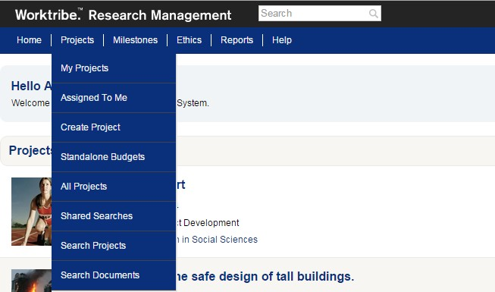

The creation of this project will constitute your intention to submit. Once you have clicked on create project you will reach the page below.
Step 3: Code your Project. The project does not need to be detailed for your intention to submit, but it should have basic information, and should be coded as outlined.

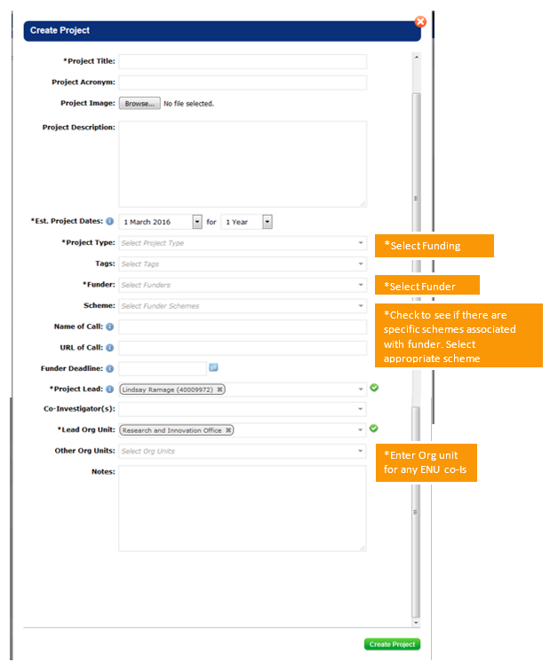

Your project will need an abstract/description.

Edinburgh Napier Funded
ZN – Napier Funded Internal Research

Create your project. This will allow RIO to register your intention to submit in response to this funding call. This must be completed by 5pm on Tuesday 16th April 2019.
Applications created after this date will NOT be accepted (these will be aborted/closed by your R&IM).

- Complete and submit your application
Once your intention to submit has been completed, you will need to complete your application on Worktribe and submit it for approval no later than 5pm on Monday 13th May 2019. Applications made after this time will not be considered.

Step 1: Complete the Case for Support form. This will be provided separately. Please review the competition guidelines for detail on completion.

Step 2: Complete your budget. Speak to your Research and Innovation Manager if you need help.

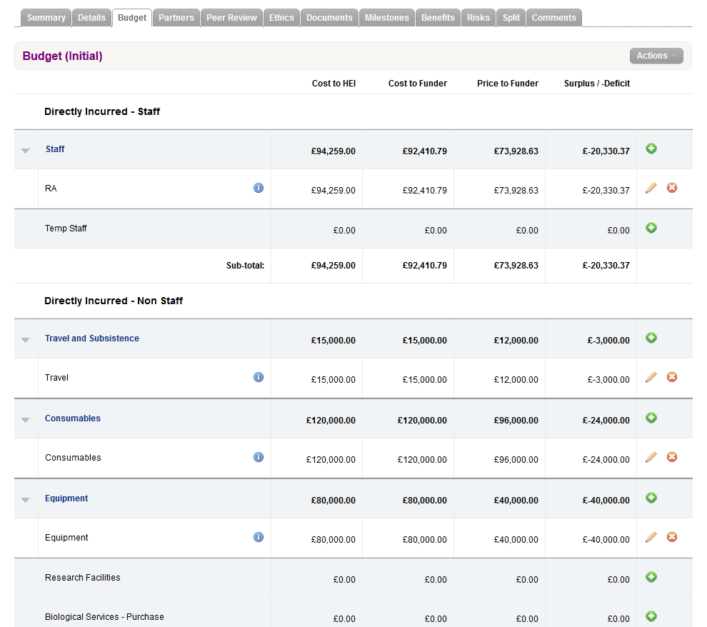
Clicking this will allow you to add a budget line. Please enter the breakdown of your costings.
Clicking this will allow you to edit items.

All Staff Costs should be added as %FTE.

How should I cost my application?
No directly allocated staff costs should be included in the price to the funder. These should be added as a cost to HEI to show the time contribution required for directly allocated staff.
Intern salary grade/point –NonAcademic AUG2018 NA-02/08
Existing staff salary information can be obtained by selecting their name from the post title search function within Worktribe
Please cost all PI/Co-I time as DA or DI as detailed on the post title info on WT. For Buyout of your time cost as normal but the cost & Price to funder should be £0. Your RI&IM will need to help with this.
For Buy Out the time contribution of the PI should be assigned to a new RA, DI post, with the same time contribution costed at NonAcademic AUG2018 NA-04/22.

Step 3: Add Ethics and Benefits information to your project.

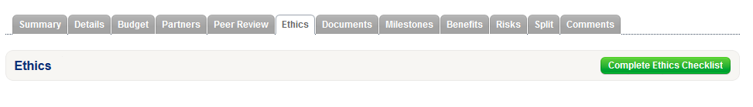

To enter ethics information please click ‘complete ethics checklist’ and answer the questions. If you answer yes to any of the ethical questions you should send the project for review by your school ethics gatekeeper for review.

To enter benefits, again click on the green ‘add benefit’ button. You should add all benefits for your project, one at a time.

Step 4: Submitting your project for approval.

Upload a copy of your completed Case for Support form, as well as a downloaded copy of your Worktribe CV.

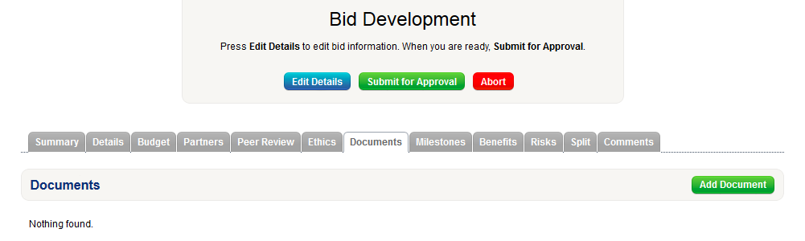

Once this has all been completed, click ‘Submit for Approval’. This will send the application to your Research and Innovation Manager, and will confirm your submission. This needs to be submitted no later than 5pm on Monday 13th May to be considered.

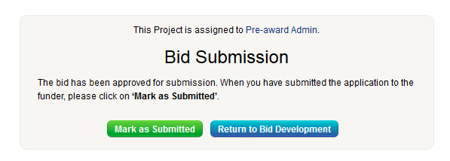

Your Research and Innovation Manager will review your proposal and may seek more information or changes to the project. Once this is done it will sent to your School DoR. They will review the information for a final time and if approved the status of the project will change to ‘Bid Submission’ as above.
How can I have the best chance of success?
For the best chance of success you should seek some external feedback on your application. Ask someone to read your case for support, and give you feedback in relation to the assessment criteria. This competition is created to mirror external funding bids, so the panel would expect the same quality of application to be submitted.
When searching for feedback:
- Choose non-specialists
- Choose people with grant committee experience
- Don’t choose people who will be too nice
- Don’t choose people who never win research grants
External funders will expect bids to be written with their criteria in mind. This competition is no different, and you should review information on the assessment criteria to understand what assessors will be looking for in successful applications. Assessment criteria should guide the writing of your proposal.
When writing your proposal try to avoid:
- Not being clear on what you plan to do or how you will do it
- Expecting the reviewers to have lots of time to read your proposal (be concise).
- Not showing why the project is important.
- Not showing that you have the skills and experience to successfully carry out the work.

Where can I find more information?
You should read the competition guidelines, assessor criteria, and review the review form before writing and submitting your application.
If you have any queries please contact the competition administrator:
Alisdair Stapley
Email: a.stapley@napier.ac.uk
Ext 2269
H18 Merchiston

