Staff Christmas 2015 Competitions and events!

Enjoy catering
We will provide red and green themed food for all staff and students at the University. However especially for staff we will provide a £20 voucher for anyone who comes up with a great sales pitch before November 15th 2015.
[EN]GAGE sport fitness facilities
We understand how stressful this season can be, so we will bring the gym to you! Every week during the month of November, we will hold 20 minute ‘keep fit at your desk’ sessions at each campus in staff leisure rooms which will focus on stretching and engaging your body while sitting at a desk in office clothes.
You don’t need to change your clothes because you won’t be sweating!

Environmental Sustainability Team
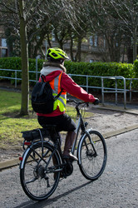
As Christmas is a time of hard work and over-spending, we will be providing a free clothing and accessories swap event November 20th from 12-2pm in room 6.B.16a. If you wish to participate please bring your donations at any time before the event to room 6.B.18 Sighthill campus. For each item you bring you’ll be given a voucher to take the same number of items away during the event!

