ABI Wildlife Consultancy



Biodiversity Audit on behalf of Edinburgh Napier University

Report for July 2011

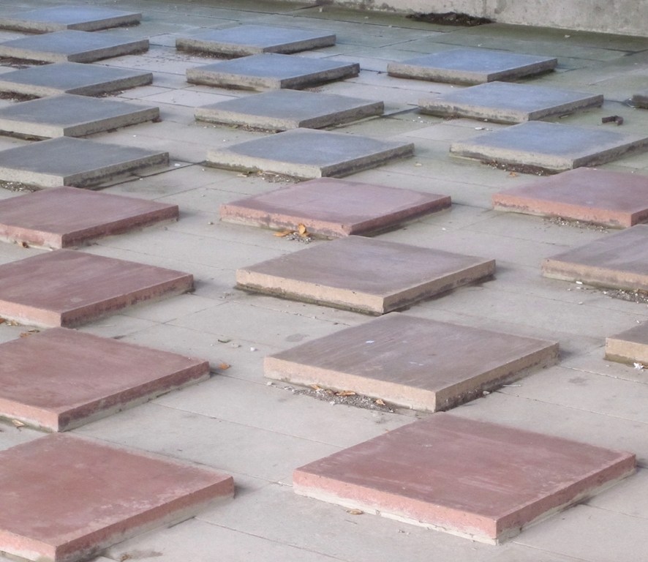

Merchiston – how diverse is concrete?

Survey Work

Field work has now come to an end and the job now begins of pulling all the data together, analysing the data and writing it up. It has been an interesting time for me, as in the past I worked for fourteen years in very remote areas, mainly the Highlands and islands dealing with rare and endangered species. Once upon a time we were all led to believe that all the rare species in the world are in Africa: how wrong this is. Scotland has many rare species and habitats found only in a few places on the globe. I did not think a year ago when I took on the twelve month contract that I would find anything rare in Edinburgh but it has surprised me what one can find within a city!

Of course, all Taxa are important and not just the rare. What is interesting having done this survey is that it has opened my eyes to the pressures put on species by people and development yet species survive. What is also interesting about this is that these biomes are shaped and tied into these pressures and as a result, remain mainly in a constant flux of post-disturbance succession – the plant list alone supports this. However, it has been a very enjoyable contract where I have met staff who have all been so helpful and kind, students and local people who have all shown interest in the project.

The main focus this month has been night work looking for and detecting bats (amongst other things that are in the woods at night)! Seven Pipistrel (55’s) were recorded in Craighouse in the north wood, three in the parkland and two in the south wood along with tawny owls. None were recorded in Craiglockhart, though there has been one in the past, and none in Merchiston. There has also been Pipistrel (45’s) recorded in past surveys.

The numbers within the tables show the total amount of species recorded over the twelve month period of the survey. It is surprising that there are protected species: two Edinburgh Biodiversity Action Plan species and one Red Listed species found within Merchiston. Comparing all buildings across all campuses, Merchiston has the lowest amount of species. However, its situation being more built-up and surrounded by concrete offers less habitat within the campus compared to the other campuses. All data will require analyses to determine biodiversity levels within each campus and I look forward with interest to the outcome.

Craighouse

Numbers refer to the total amount of species over a twelve month period

Habitat Type birds mammal plants fungi invertebrates lichen grasses ferns

N Wood 28 8 53 16 55 10 8 3

S Wood 25 10 35 22 58 10 5 1

Parkland 28 7 41 33 \* 3 7 0

Buildings 8 8 42 0 \* 7 6 5

Craiglockhart

Habitat Type birds mammal plants fungi invertebrates lichen grasses ferns

SI Grassland 19 4 47 5 67 0 10 2

Buildings 7 2 24 0 \* 4 1 1

Parkland 31 7 75 57 32 13 10 4

Merchiston

Habitat Type birds mammal plants fungi invertebrates lichen grasses ferns

Buildings 8 0 19 0 \* 5 0 2

Intro Shrub 4 4 39 2 25 1 1 1

*\* not recorded due to not meeting survey requirements*

Abbie Patterson

Ecological Consultant