**ESAG/12/04**



**Edinburgh Napier University**

**2009/10 ESR Feedback Report:**

Universities that Count assesses the extent to which key **environmental** and **social** issues are integrated into your university’s strategy, practice and performance.

You have achieved:

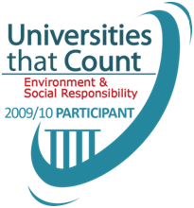

|  |
| --- |
| Community Management |
| Environment Management |
| Marketplace Management |
| Workplace Management |
| Climate Change |
| Waste Reduction  & Recycling  **ESR Index**  Anglia Ruskin University  Arts University College at Bournemouth  Aston University  Birmingham City University  Bournemouth University  City College Norwich  Coventry University  De Montfort University  Edinburgh Napier University  HEFCE  Kingston University London  Leeds Metropolitan University  Liverpool Hope University  London Business School  Loughborough University  Nottingham Trent University  Oxford Brookes University  Queen's University Belfast  Staffordshire University  The London School of Economics and Political Science  The University of Northampton  The University of Nottingham  The University of Sheffield  University College Falmouth  University of Aberdeen  University of Bath  University of Bedfordshire  University of Birmingham  University of Bradford  University of Bristol  University of Cambridge  University of Derby  University of Dundee  University of East Anglia  University of Edinburgh  University of Exeter  University of Glamorgan  University of Gloucestershire  University of Hertfordshire  University of Leicester  University of Lincoln  University of Liverpool  University of Manchester  University of Plymouth  University of Southampton  University of St Andrews  University of Strathclyde  University of Sunderland  University of Warwick  University of West of England  University of Westminster  University of Winchester  University of Worcester  University of York  **Environment Index**  Anglia Ruskin University  Arts University College at Bournemouth  Birmingham City University  City College Norwich  Coventry University  Kingston University London  Liverpool Hope University  London Business School  Queen's University Belfast  Staffordshire University  The University of Northampton  University of Bath  University of Bedfordshire  University of Birmingham  University of Cambridge  University of Derby  University of Dundee  University of East Anglia  University of Hertfordshire  University of Leicester  University of Liverpool  University of Manchester  University of Southampton  University of Strathclyde  University of York |
| Staff & Student Travel |
| Design & Build |
| Water  Consumption |
| Biodiversity |
| Health, Safety & Wellbeing |
| Staff Development |
| Equality, Diversity & Inclusion |
| Public & Community Engagement |
| Teaching, Learning & Research |



**Introduction**

We are delighted to present this Feedback Report reflecting your performance in Universities that Count 2009/10. Benchmarking your achievements in Environmental and Social Responsibility (ESR), the Report summarises your scores in an Executive Summary and then gives more insight in the Detailed Results Analysis which follows.

Your Index Score was 68.0% and the sector average was 75% - you are ranked 26 out of 29 ESR participants and have been awarded a Participant UTC Standard. The HE sector overall has improved its performance significantly over last year’s sector average of 67% and is much closer to the business average of 86% indicating excellent progress for Higher Education in just two years.

Sector-led, voluntary and self-assessed, the Universities that Count Index for Environmental and Social Responsibility (ESR) has established itself as a leading UK benchmark for the Higher Education Sector. Participants say that the Index has helped them to gain a deeper understanding of the ESR issues they face, and has brought the importance of Education for Sustainable Development into clearer focus. Congratulations on your participation this year.

For universities, the way you influence your students is key to a more sustainable future and perhaps the greatest impact you can have on sustainability is through producing sustainability-literate graduates who will lead more responsible lives and careers. Research and knowledge exchange examining sustainability issues is also a vital contribution that universities make to our sustainable future, and the way you manage sustainability issues on campus will also shape graduate values and behaviour. The Index encompasses both the academic and operational activities; with the former benchmarked in Universities that Count through a specially-written survey section on Teaching, Learning, Research and Knowledge Exchange.

Benchmarking is the starting point for ‘bench-learning’ - a conduit for communicating learning, knowledge and sharing of ‘best practice’ - and for the leaders to pass their success on to others. As part of the survey UTC asks participants to list the most challenging aspects of incorporating sustainability into their teaching and learning, and the three best things learnt along the way. Through the sharing of experiences and the capture of this sort of information the UTC partners are committed to finding ways to improve understanding for all.

The UTC Team:



**Executive Summary**

The Universities that Count ESR Index model has been specially developed for use in Higher Education, and is based on the respected Business in the Community Corporate Responsibility Index, published in the Financial Times. Universities can compare their ESR performance with their peers in the sector, and against businesses completing the BITC Index. The other important benefit is an increased understanding of how the interlocking areas of ESR balance within your university – as shown in the Radar Diagram below.

The online survey starts with Corporate Strategy – your strategic intentions. It then focuses on Integration – how those intentions are turned into actions – and then how each of the ‘four pillars’ of ESR are managed – Environment, Community, Workplace and Marketplace (students and suppliers). Impacts on social and environmental issues are reported in the fourth section of the survey. A range of impact choices is offered, including the crucial academic areas of Teaching, Learning, Research and Knowledge Exchange. Finally, the survey examines Assurance – which ensures that ESR successes are sustained – and Disclosure, the degree of sharing that you engage in. The table below shows your overall score and the Impact Areas where you achieved an Excellent or Outstanding score. The key to the icons is on page 2. Your Environment score is also listed, and your Teaching, Learning and Research score (if applicable).

|  |  |  |  |  |  |  |  |  |  |  |  |  |
| --- | --- | --- | --- | --- | --- | --- | --- | --- | --- | --- | --- | --- |
| **ESR Index Performance** | | | | | | | | | | | | |
| **09/10 Score** | | **Band[1]** | | **08/09 Score** | | | | **HE Sector Average** | | **BITC Business Average** | | |
| **68.0%** | | **Participant** | | **n/a** | | | | **75.3%** | | **86.1%** | | |
| **Impact Area of Outstanding Achievement (≥90%):** | | | | | | |  | | | | | | |
| **Impact Area of Excellence (≥75%):** | | | | | | |  | | | | | | |
| **Environment Index Performance** | | | | |  | **Teaching, Learning & Research Performance** | | | | | |
| **Score** | **Sector Average Average** | | **BITC Average** | |  | **Score** | | | **Sector Average** | |  |
| **77.1%** | **70.2%** | | **83.5%** | | NB: If you did not complete the TLR ‘.0%’ will display above. | **24.0%** | | | **60.5%** | |  |

.

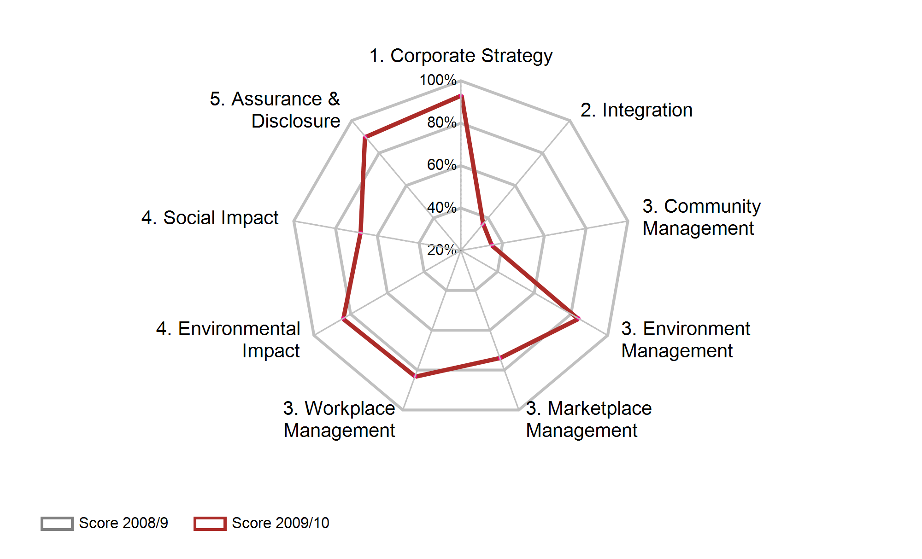



**Summary of Section Results**

**The ESR Model**

Universities that Count is based on the Business in the Community Corporate Responsibility (CR) Index, an online self-completion questionnaire which rates an organisation’s strategic approach to Environmental and Social Responsibility, its success in integrating its strategy into its operations, and the depth of its commitment to these issues. Having examined the overall CR framework for the organisation, the questions then concentrate on the management of corporate responsibility and the performance achieved in four key social and environmental areas – the “four pillars” - Community, Environment, Marketplace (students and suppliers) and Workplace (employee) issues. Twenty-nine Institutions completed the ESR Index out of 54 participants. The Index can be represented visually, with each section’s scores weighted as shown:



UTC also offers participants the opportunity to complete the Environment Index, which follows a similar model but concentrates on the environmental aspects of strategy, integration, management and performance. This is often the entry point for a university that is just starting off on its ESR journey. Twenty-five HEIs responded this year. The shaded areas of the diagram show the areas covered by the Environment Index.

**Top Level Summary**

Presented in the sections defined in the Index Model on page 5, your university’s performance is as follows: the bars show your performance, the average for the HE sector as a whole, and the average score achieved by businesses in the BITC CR Index.

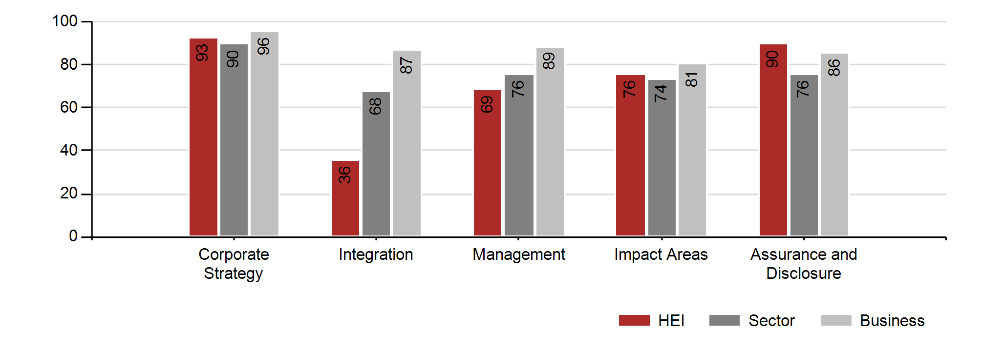

**Management Areas**

As described above, the Index Model is centred on “four pillars” of ESR Management covering Community, Environment, Marketplace (students and suppliers) and Workplace (employees) issues. The next section of the survey concentrates on the effectiveness of your university’s management of these areas – inquiring into key issues, objectives and targets and examples of performance improvement. These results help you to understand the balance of resources your university is devoting to these issues, and how this compares with your peers.

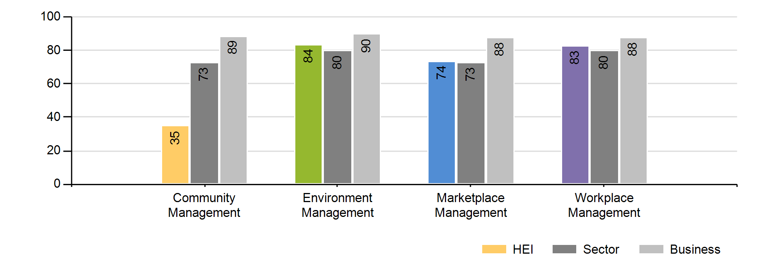

**Environmental and Social Impact Areas**

Having looked at Strategy, Integration, and Management, the Survey now examines the impact that is achieved in a range of environmental and social areas. Your university completed mandatory questions on Climate Change, and Waste Reduction and Recycling, and then chose a third area of environmental impact (see below). For Social impacts, your university chose three from a range which included Health, Safety and Wellbeing, Staff Development, Equality, Diversity and Inclusion, Public and Community Engagement and Teaching, Learning, Research and Knowledge Exchange. The charts in the Detailed Results Analysis indicate which impact areas you selected.

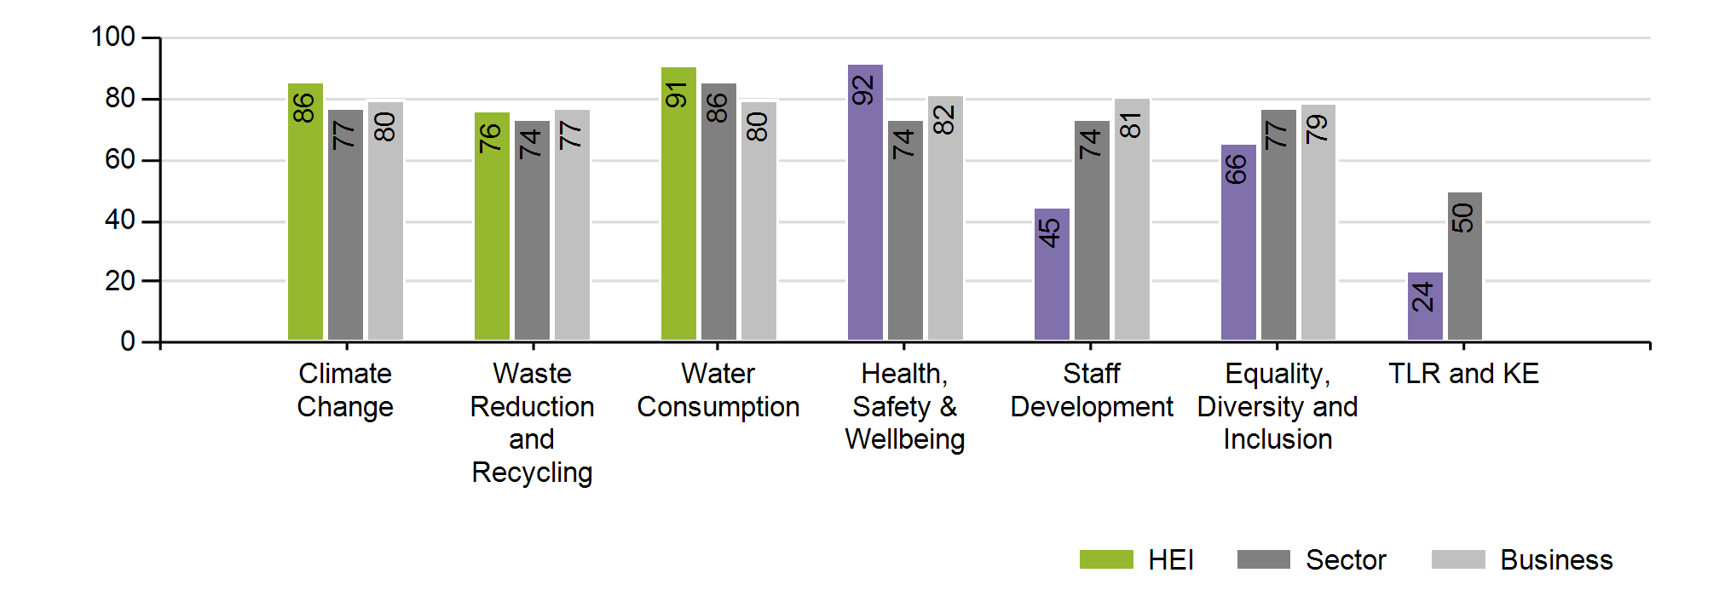

The Detailed Results Analysis which follows examines how your university answered the individual questions which contributed to the scores outlined above.



**Detailed Results Analysis**

**Section 1: Strategy**

The first section of the survey examines the strategic intentions of your university, asking how ESR issues are included in your vision and values, where the responsibility for these issues lies in the senior management team, how your risk evaluation includes ESR, and how your university demonstrates public advocacy of its values.

|  |  |
| --- | --- |
|  | **Risk Management** |
| In this second year of UTC, many more universities are including environmental and social responsibility risks in their Risk Management Process. By placing ESR risks alongside more ‘traditional’ issues, universities are moving ESR considerations closer to the heart of their governance processes. |

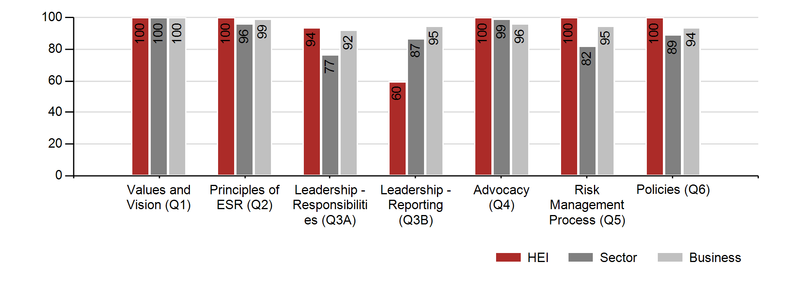

**Section 2: Integration**

This section looks at how your strategic intentions are converted into action by embedding them in the “DNA” of your university – its strategic decision making processes, performance management and reward and recognition systems, training and stakeholder engagement.

|  |  |
| --- | --- |
|  | **Public Reporting** |
| We are seeing an emerging trend to more public reporting, with a number of universities publishing Sustainability or CSR Reports, and many more devoting specific sections of their websites to these issues. Whilst universities have always been relatively open in their disclosure of these areas, drawing all the threads together into a cohesive set of reports or web pages that can be accessed easily is becoming accepted best practice. |

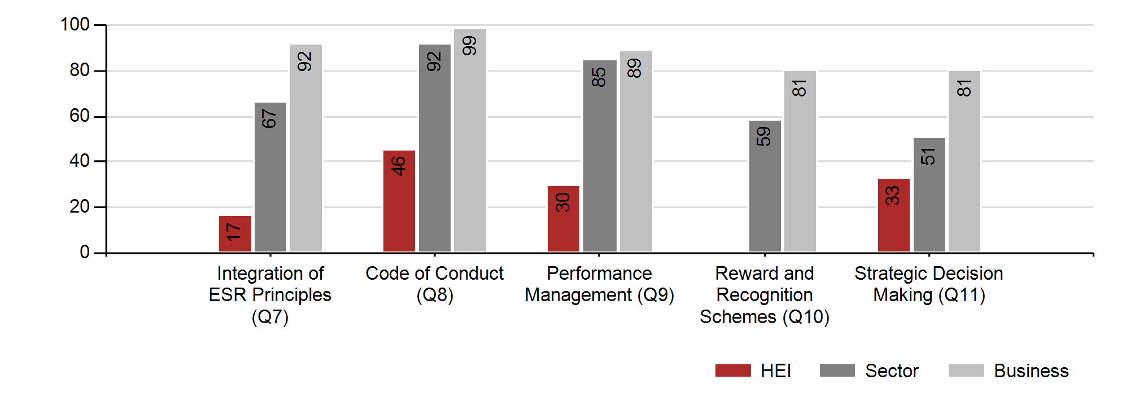

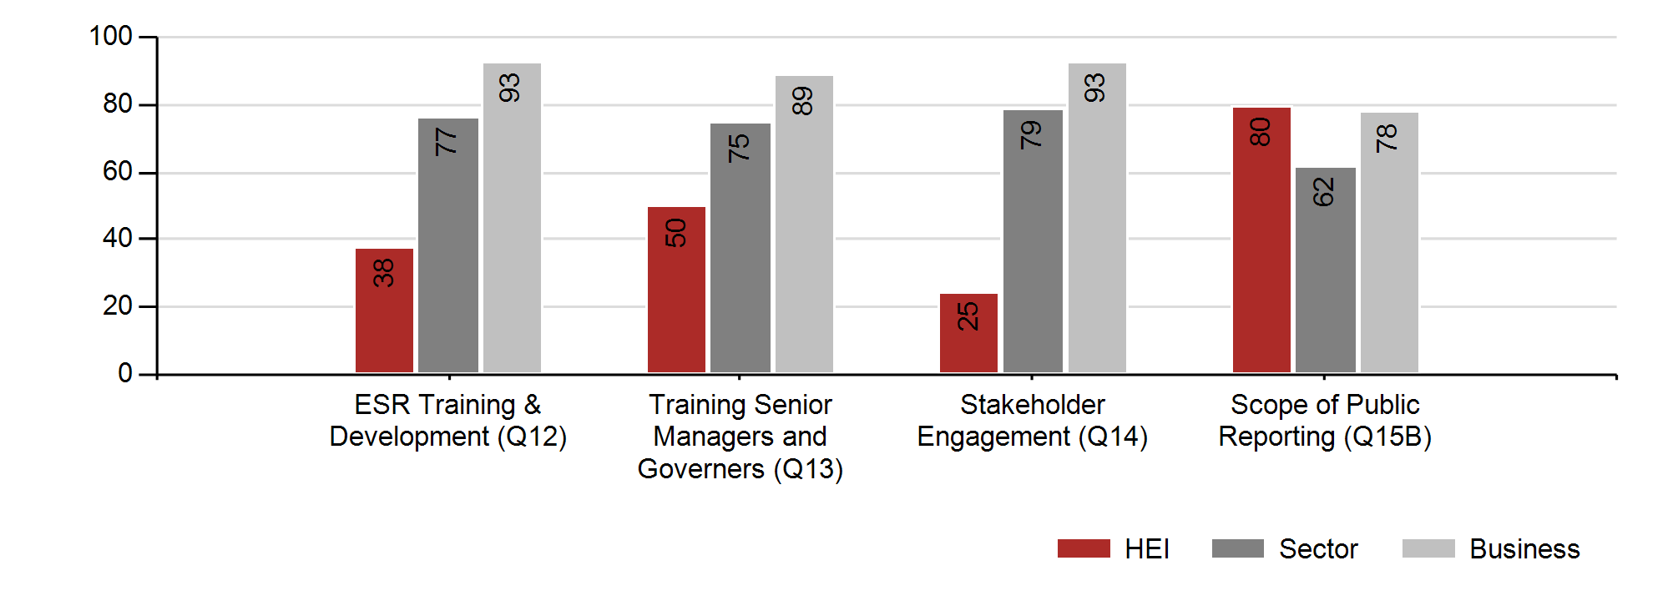

**Section 3: Management Practice**

The ‘four pillars’ are the focus here, with questions examining how your university manages its approach to Community, Environment, Marketplace (suppliers and students) and Workplace (employees). In each case, the questions probe the strategy and key issues for the area, how targets for improvement are set and monitored, and how your university works with its stakeholders to achieve success.

|  |  |
| --- | --- |
|  | **Community Management** |

In year 2 of UTC we have seen more universities grouping their community activities into an overarching Community Strategy: also the contribution of universities to local and national economic success is a growing area of interest.

|  |  |
| --- | --- |
|  | **Community Partnerships** |
| Universities are increasingly linking with communities in partnership, and formalising these relationships with written agreements on what each party can expect, integrating projects into strategies to serve the needs of the region, engaging in better dialogue to improve the understanding of key issues, and so on. |

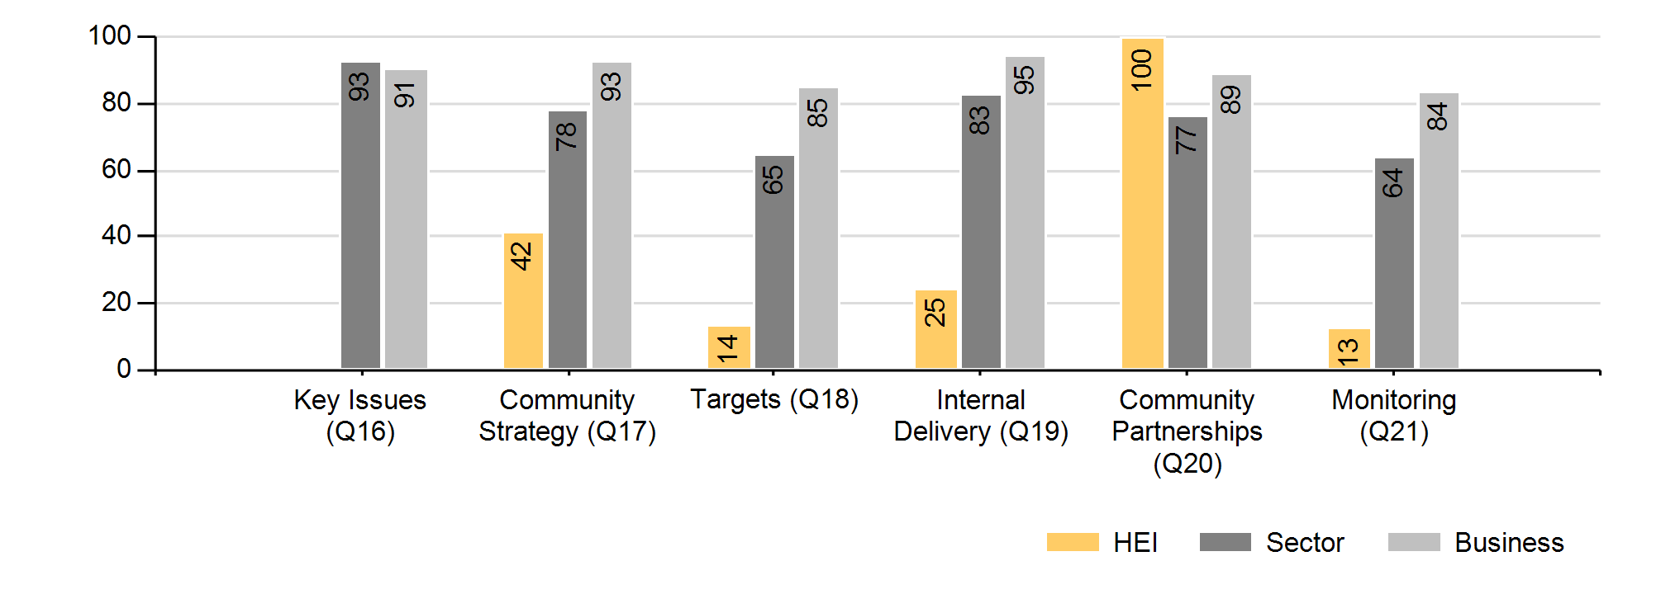

|  |  |
| --- | --- |
|  | **Environment Management** |

Much development work has been undertaken to link Universities that Count to the Estates Management Statistics: the UTC questions now state the specific sections of the Statistics that are relevant, greatly simplifying the task of completing the survey. The Sector has responded well to the increased focus on environment generally, and carbon specifically, and this is evident in the higher scores this year.

|  |  |
| --- | --- |
|  | **Environmental Management Systems** |
| This year’s UTC submissions have seen an increase in uptake of formal Environmental Management Systems (EMS). Eco Campus remains a popular approach but this year an increase in the use of BS8555 across the sector is clearly evident. |

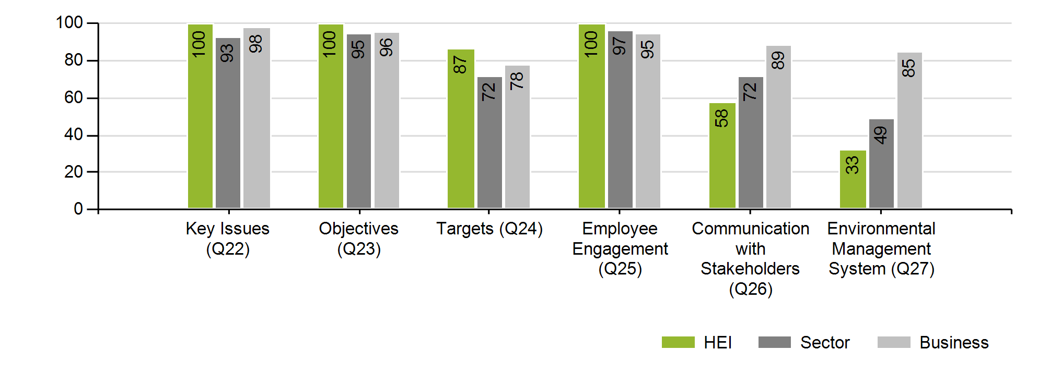

|  |  |
| --- | --- |
|  | **Marketplace Management** |

Although treated as one ‘pillar’ in the model, this covers two distinct areas – students (in terms of marketing, recruitment and other student focussed activities that may influence them), and the growth of sustainability standards in the supply chain.

|  |  |
| --- | --- |
|  | **Student Stewardship** |
| In addition to direct interventions through the curriculum and research, leading universities are also developing their stewardship of students to encourage better environmental and social responsibility from them. Using the campus or halls of residence as learning environments can be particularly effective in reaching the un-engaged student who would never volunteer to go to a sustainability lecture. |
|  |  |
|  | **Sustainable Procurement** |
|  | Universities are just starting to recognise their power as purchasers, where subtle changes in procurement policies can reap rewards in both economic efficiency and sustainability. The Procurement Centres of Excellence serve as excellent focus points, and many university suppliers will be strengthening their own sustainability credentials in order to win business. |

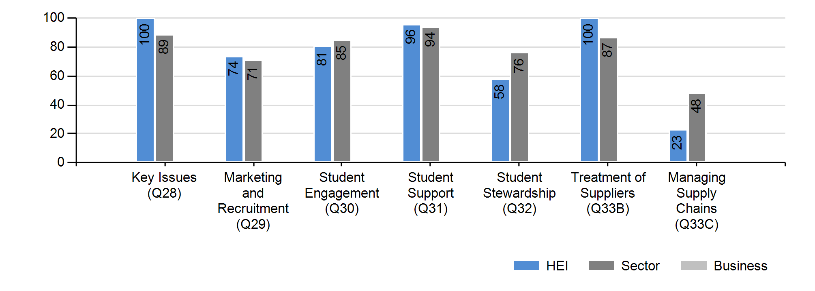

|  |  |
| --- | --- |
|  | **Workplace Management** |

Your university’s approach to its people is examined in this section, an area where universities have an excellent track record, often outscoring the much larger organisations which complete the business version of the Index. The different needs and attitudes of academic and operational staff must be taken into account, and the best universities are creating a “one institution” ethos.

|  |  |
| --- | --- |
|  | **Employee Programmes** |
| Schemes which create a fulfilling work experience and involve staff in all areas of the university’s development are increasingly effective areas of engagement with staff. Some universities find that a focus on sustainability and wider issues of social responsibility provides an excellent rallying point for their people to engage with the institution and each other. |

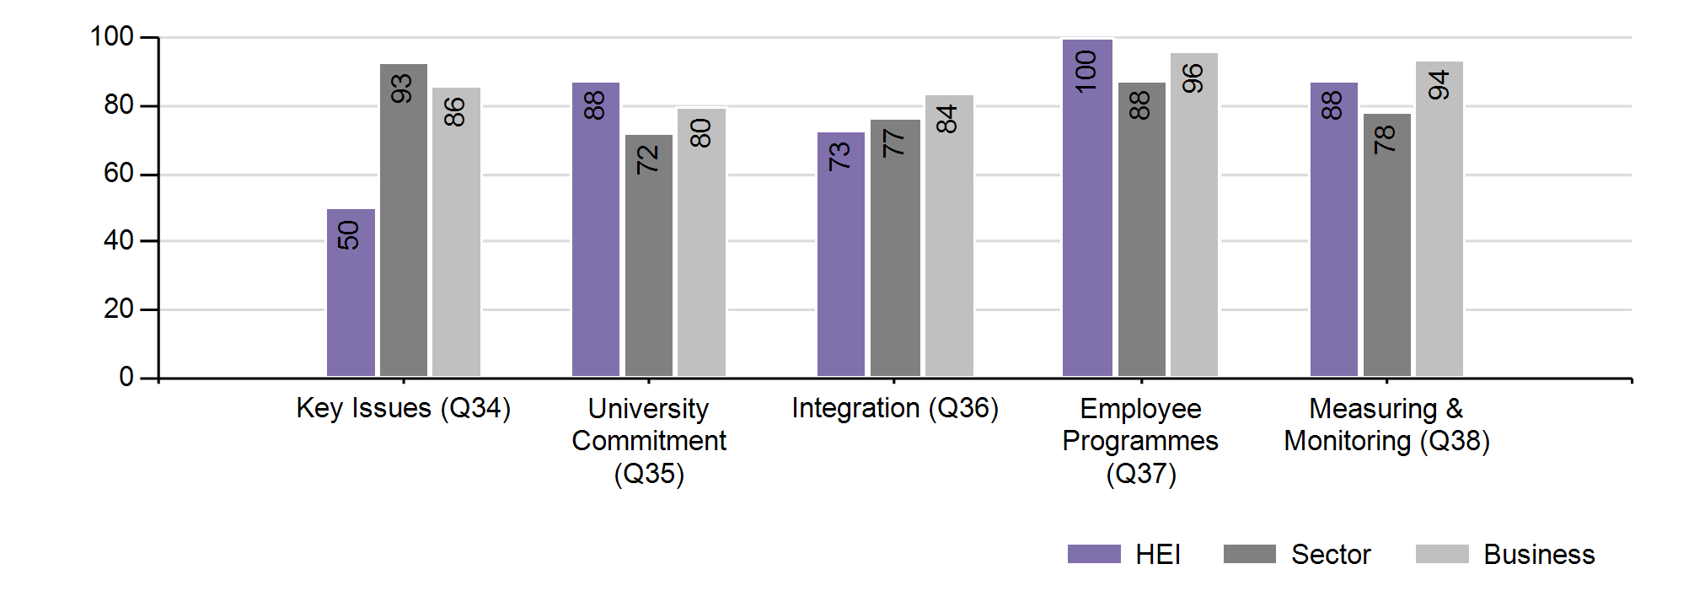

**Section 4i: Environmental Impact Areas**

This section of the survey looks at the improved environmental impacts resulting from your university’s approach to these issues. The questions ask how the area is monitored, the scope and quality of the data, and what performance improvement has been achieved. Your university completed two impact areas – Climate Change and Waste Reduction and Recycling – common to all participants and selected a third area from a range of choices, detailed below. This year, to broaden understanding of the status of these Impact Areas, your Feedback Report contains the HE sector and business average charts for all of the Impact Areas, whether you selected them or not. The charts for your selected areas will also contain your own university's scores.

|  |  |
| --- | --- |
|  | **Climate Change** |

An area of crucial importance to all universities, in year 2 of UTC we have seen institutions become more progressive in the scope of emissions captured, moving from those which are most easily measured to those which require sophisticated surveys or data analysis. Universities are gaining strength from sector-wide carbon reduction initiatives: 85% of UTC participants are in the Carbon Trust's Higher Education Carbon Management Plan scheme, and 25% have achieved one of the Carbon Trust Standards. On a wider stage, 24% of UTC universities are in the EU Emissions Trading Scheme and almost all - 87% - will participate in the Carbon reduction Commitment.

|  |  |
| --- | --- |
|  | **Greenhouse Gas Scope** |
| Most universities are familiar with reporting on GHG Scope 1 and 2 emissions, but a number are moving on to Scope 3. Carbon from commuter travel and waste are the most commonly reported Scope 3 emissions in UTC. In one case, researching the CO2 content of students’ journeys to and from the university at the beginning and end of each term uncovered a figure which almost equalled the emissions from the university’s campus electricity consumption. Broadening scope in this way requires courage, and the institutional commitment to do something about the results that emerge. |

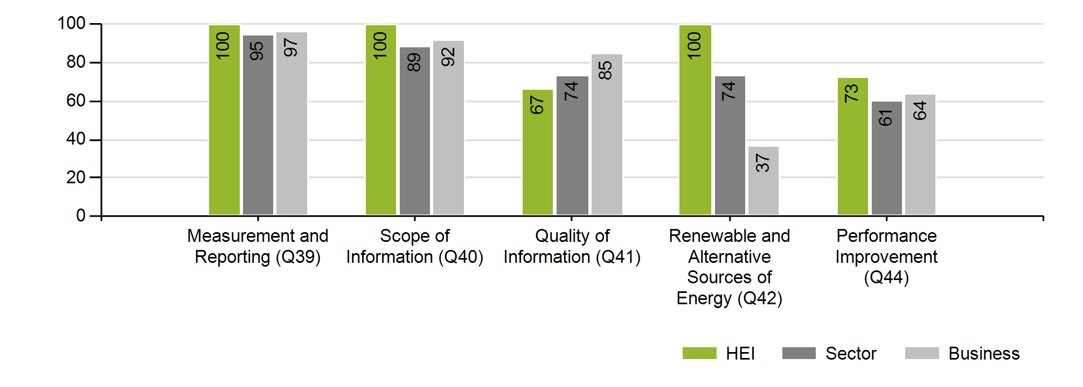

|  |  |
| --- | --- |
|  | **Waste Reduction & Recycling** |

|  |  |
| --- | --- |
|  | **Measurement** |
| After a number of years when waste collections were recorded by simple bin lifts (with no way of recording whether the bins were full or not) many universities are now asking their contractors to move to onboard weighing. In this way each waste site can be analysed in detail, and the effect of local reduction initiatives can be monitored. |

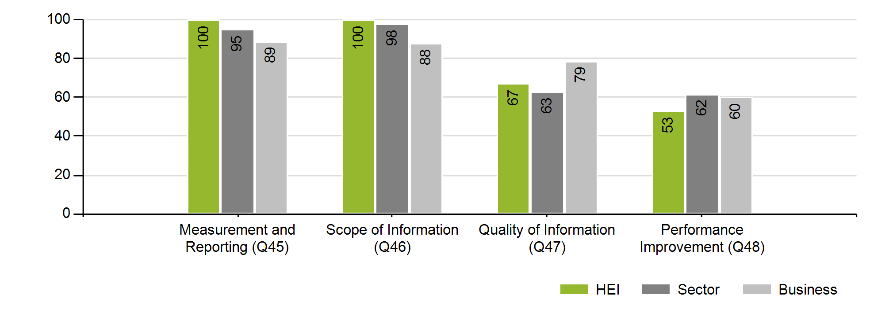

The impact areas which follow are optional: For completeness, all four are included whether or not they were selected. Your university’s selected impact area contains your university’s score.

|  |  |
| --- | --- |
|  | **Staff & Student Travel** |

|  |  |
| --- | --- |
|  | **Travel Plans** |
| Most UTC universities now have a Travel Plan, and many have a Travel Manager to take responsibility for it. A range of innovative approaches came through in UTC survey responses, including offering free car parking to drivers of low-emission cars and car sharers, encouragement for cycling and walking, and investment in more effective public transport. In addition agendas such as reducing car use and increasing wellbeing (health and exercise) are merging. |

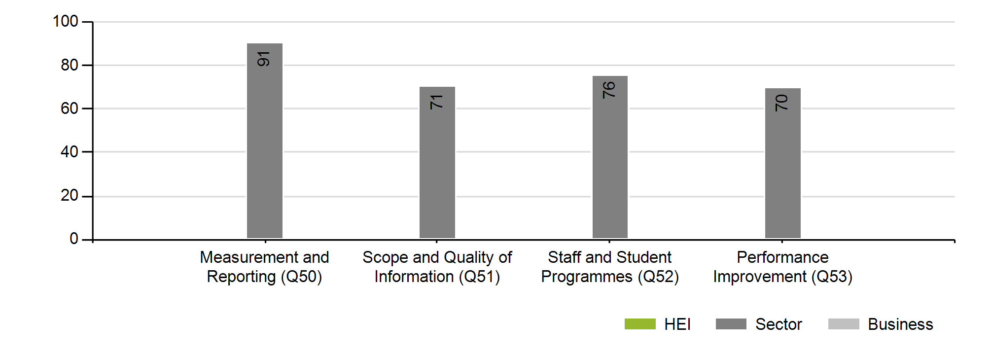

|  |  |
| --- | --- |
|  | **Design & Build of new and refurbished buildings** |

|  |  |
| --- | --- |
|  | **Refurbishment** |
| Alongside BREEAM ‘Excellent’ aspirations featuring in most new building plans, some universities are now applying a similar level of sustainability rigour to their refurbishment works. With funding sources tightening, refurbishment rather than new build is a more likely route to follow, so the sustainable approach to refurbishment will become more important in coming years. |

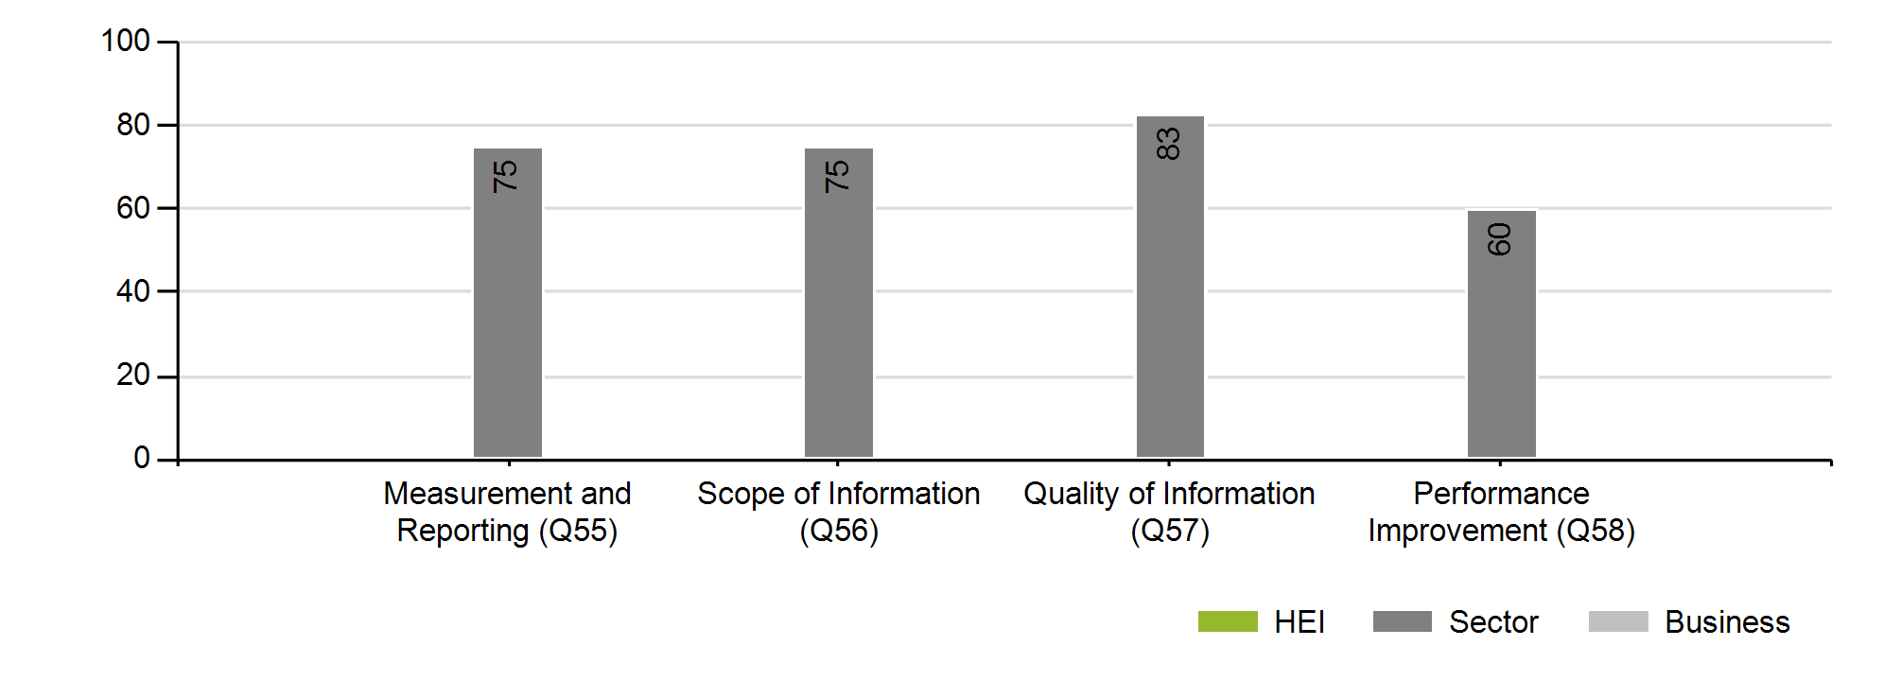

|  |  |
| --- | --- |
|  | **Water Consumption** |

|  |  |
| --- | --- |
|  | **Grey Water** |
| New to this question is a section on ‘grey’ water use. Many new buildings feature grey water systems for toilet flushing, etc, and these are now being retro-fitted to existing buildings too. Intelligent water meters have an effect on the psychology of water consumption, and a number of universities collaborated to produce an online Water Diary to encourage students and staff to think more carefully about their use of water. |

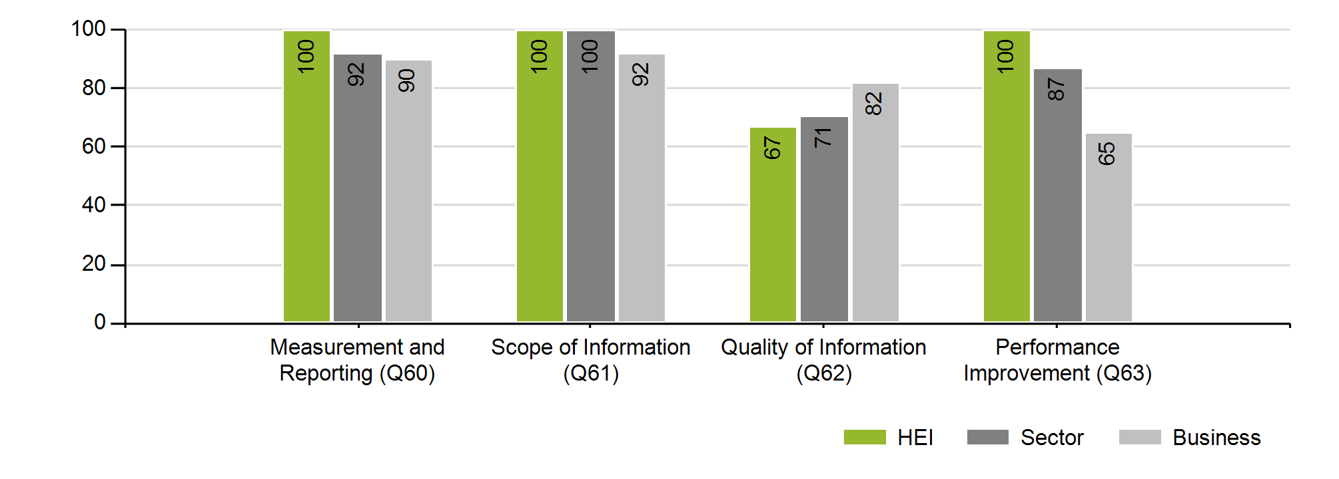

|  |  |
| --- | --- |
|  | **Biodiversity** |

|  |  |
| --- | --- |
|  | **Student Involvement** |
| Tree surveys and species counts are an excellent way of tracking biodiversity, but they are labour-intensive: a number of universities involve their students in this aspect of managing their estate, exchanging valuable work experience for skilled pairs of eyes to record species improvements. |

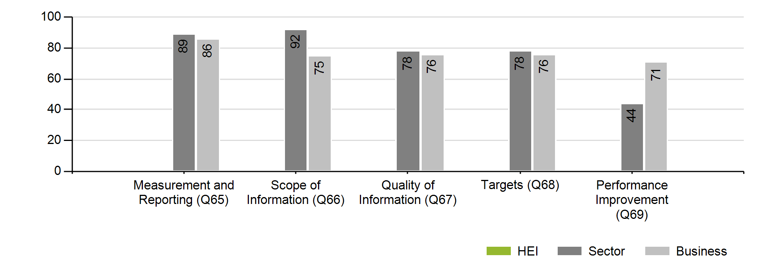

**Section 4ii: Social Impact Areas**

In a number of university towns and cities, the university is both the largest single employer and hosts the largest cohesive community - its students. Therefore a strategic approach to the social impacts of your university’s activities is essential. Universities that Count asks participants to complete 3 sets of social impact questions, choosing from a range of 5 areas: your institution’s choices are detailed below. As with the Environmental Impact Areas, this year your Feedback Report contains the HE sector and business average charts for all of the Social Impact Areas, whether you selected them or not. The charts for your selected areas will also contain your own university's scores. This is to broaden understanding of the status of all of these Social Impact Areas.

|  |  |
| --- | --- |
|  | **Health, Safety and Wellbeing** |

|  |  |
| --- | --- |
|  | **Wellbeing programmes** |
| This year the UTC questions on Health, Safety and Wellbeing were extended to cover students as well as staff. This revealed a wealth of effective student wellbeing interventions, ranging from healthy eating to fitness and exercise to responsible approaches to alcohol. Our results indicate that whilst programmes are on the increase, evaluating and reporting on impact is in its early days. |

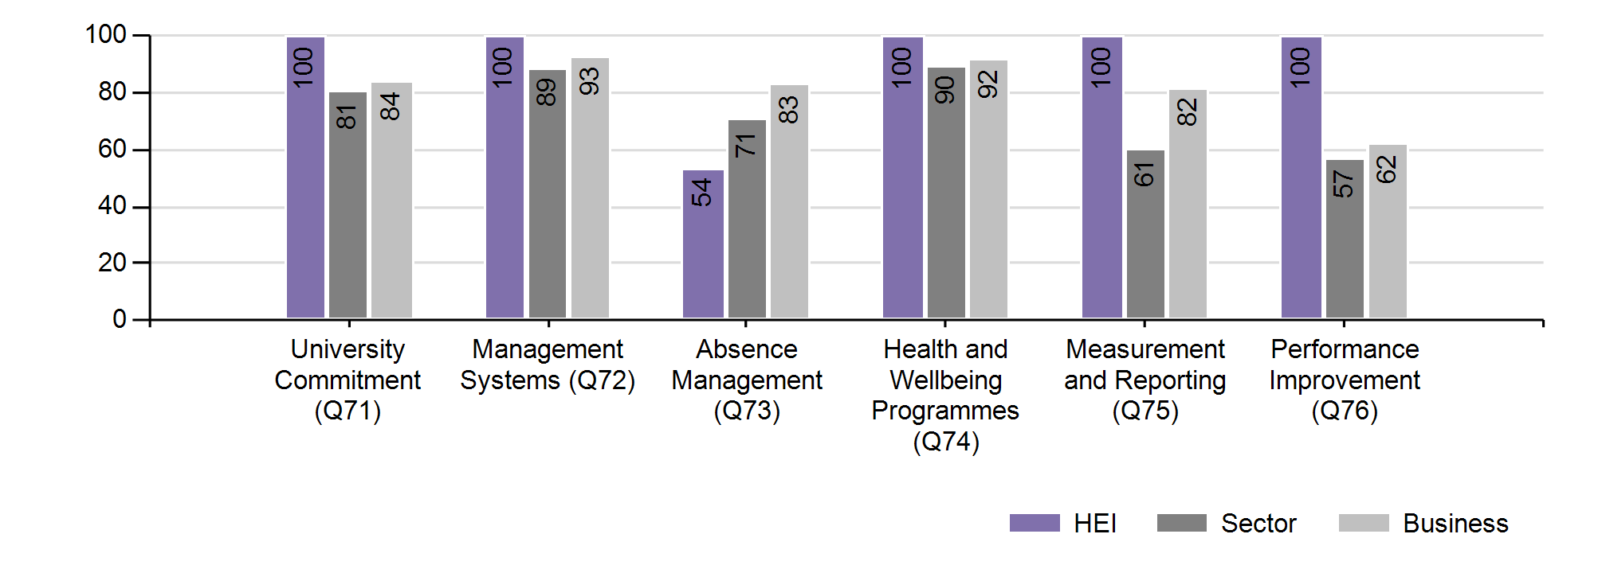

|  |  |
| --- | --- |
|  | **Staff Development** |

|  |  |
| --- | --- |
|  | **Linking staff development to university strategy** |
| Universities have always – as learning institutions – been supportive of staff development, but the leading institutions are now planning their people development in line with their strategic priorities for the future, and linking closer with appraisal outcomes. Areas of likely skills shortage are identified and addressed early, leading to greater opportunities for promotion from within as the long-term priorities move into the near term. Measuring impact is not easy but the high scorers have found ways to connect staff development to other objectives such as succession of female staff and secondment opportunities. |

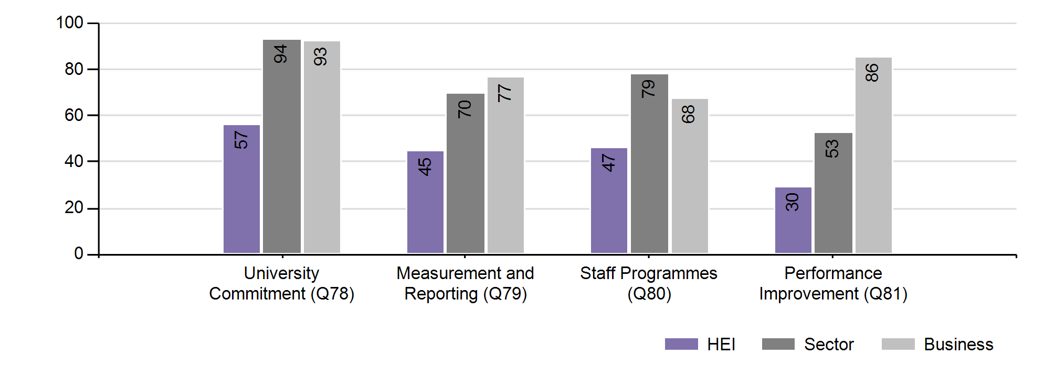

|  |  |
| --- | --- |
|  | **Equality, Diversity and Inclusion** |

|  |  |
| --- | --- |
|  | **Broadening diversity factors** |
| For this year’s UTC, the Equality Challenge Unit provided guidance on the development of the questions. Universities are completing their Single Equality plans, and the answers show a broadening of the equality and diversity factors that universities consider – new categories include those with childcare and other caring responsibilities, and the particular needs of the increasing number of international students. Innovative ways of engaging staff on sensitive issues were being undertaken by the leaders, including designing physical space to be more inclusive. |

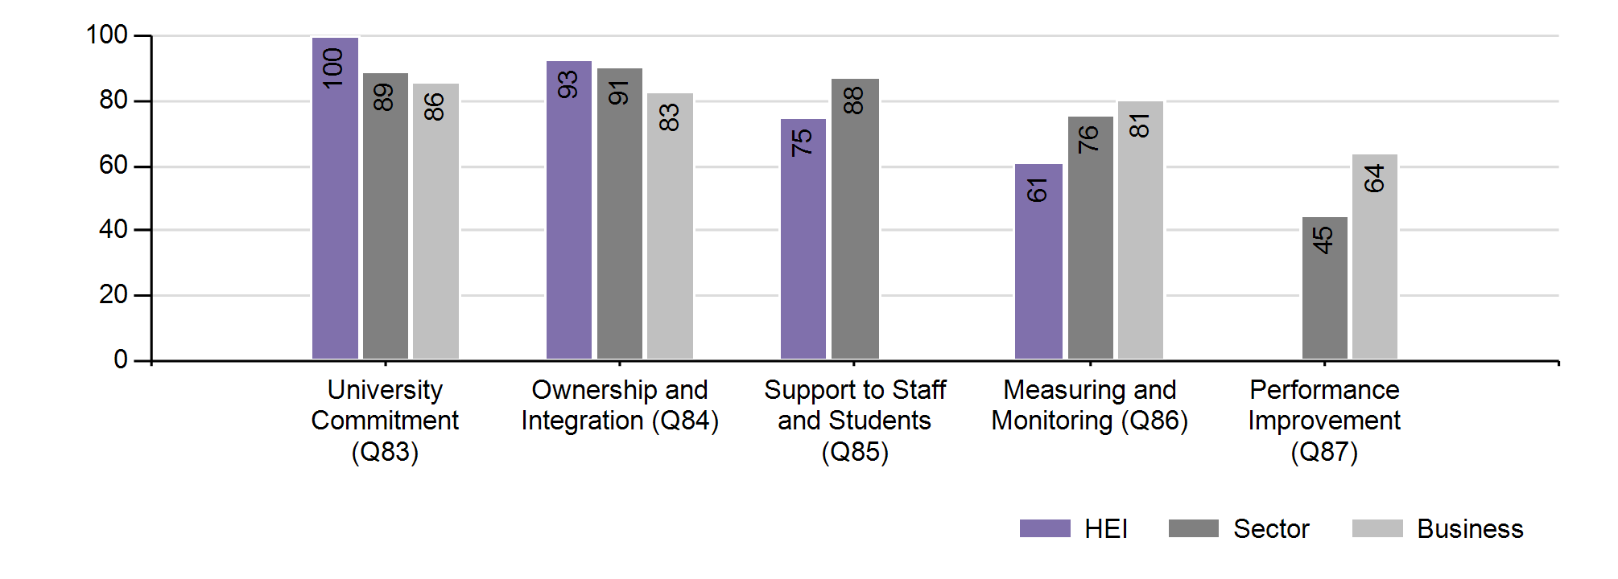

|  |  |
| --- | --- |
|  | **Public and Community Engagement** |

|  |  |
| --- | --- |
|  | **Beacons and Co-Ordination** |
| This is a new section especially developed for Higher Education by Universities that Count, and a subject which is gaining in importance for the sector. Based on advice from the National Coordinating Centre for Public Engagement, UTC framed new questions concentrating on how Engagement generates mutual benefit - with all parties learning from each other through sharing knowledge, expertise and skills. As the NCCPE says, “done well, it builds trust, understanding and collaboration, and increases the institution's relevance to, and impact on, civil society." |

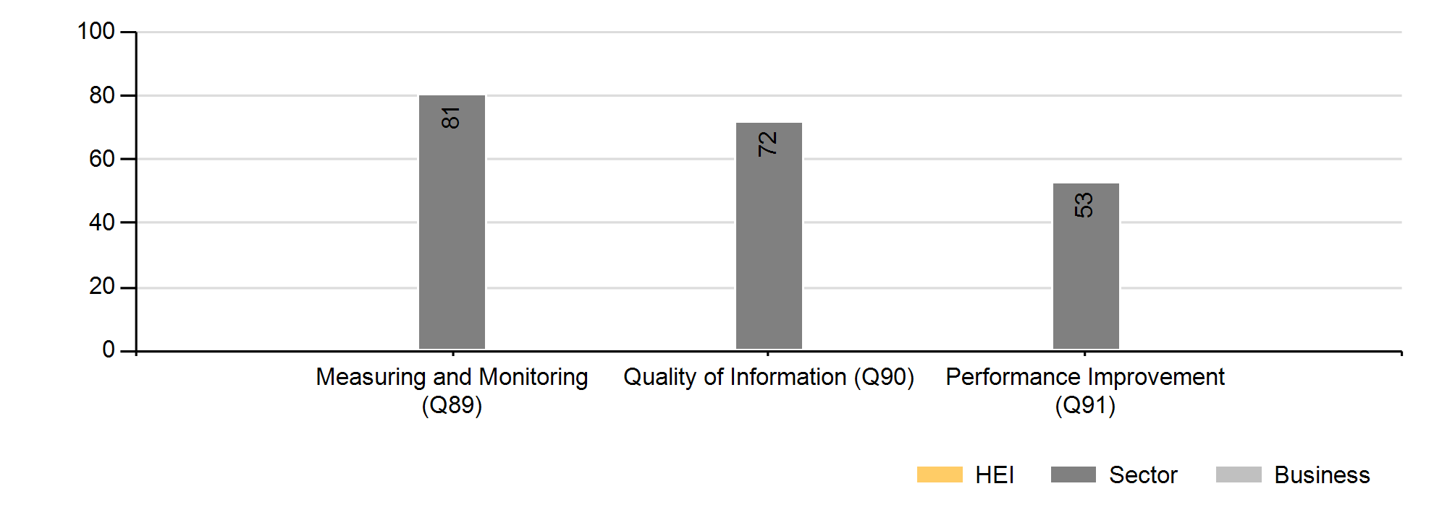

|  |  |
| --- | --- |
|  | **Teaching, Learning, Research and Knowledge Exchange** |

The latest Teaching, Learning, Research and Knowledge Exchange questions have been developed with the assistance of leading academics in education for sustainable development.

There are two strands: the first is concerned with the curriculum (teaching and learning). The second is about academic activities focussing on sustainability outside the curriculum such as research, knowledge exchange and extracurricular sustainability-focussed activities.

|  |  |
| --- | --- |
|  | **The TLR questions** |
| The questions ask about:  • A University’s commitment – does the university formally recognise the importance of including sustainability in the curriculum? Does it tell ‘the world’ about its ambitions?  • The current state of play – does the university know what’s going on right now? I.e. has the university assessed or scoped out its existing teaching and learning for sustainability in the curriculum?  • Action planning – Has the university started planning – and implementing plans - to increase or improve the level of sustainability learning opportunities?  • Sharing success with colleagues and seeing the full picture – does the university have a process in place to help communicate where and how progress is being made?  • Quality of information – as with any academic activity; assuring a certain standard of quality is important. Has the university found ways to make sure the work it is doing in this area is of a high standard – and the information it is are collecting around ‘progress’ is reliable?  • Improvement cycle - An important ‘measure’ of success is the ability to demonstrate a positive impact. Has the university found an ‘indicator’ to measure success? And gauge performance over time? |

In the current UK Universities that Count survey, these Teaching Learning and Research questions were completed by 27 of 54 participants, giving a solid foundation for effective bench-learning. As a way to encourage completion of this impact area, for a second year the opportunity to complete and receive feedback as an additional, non-scored impact area was provided. The opportunity was also extended to Environment Index participants for the first time this year. Additional feedback and guidance will be made available to support development in this area.

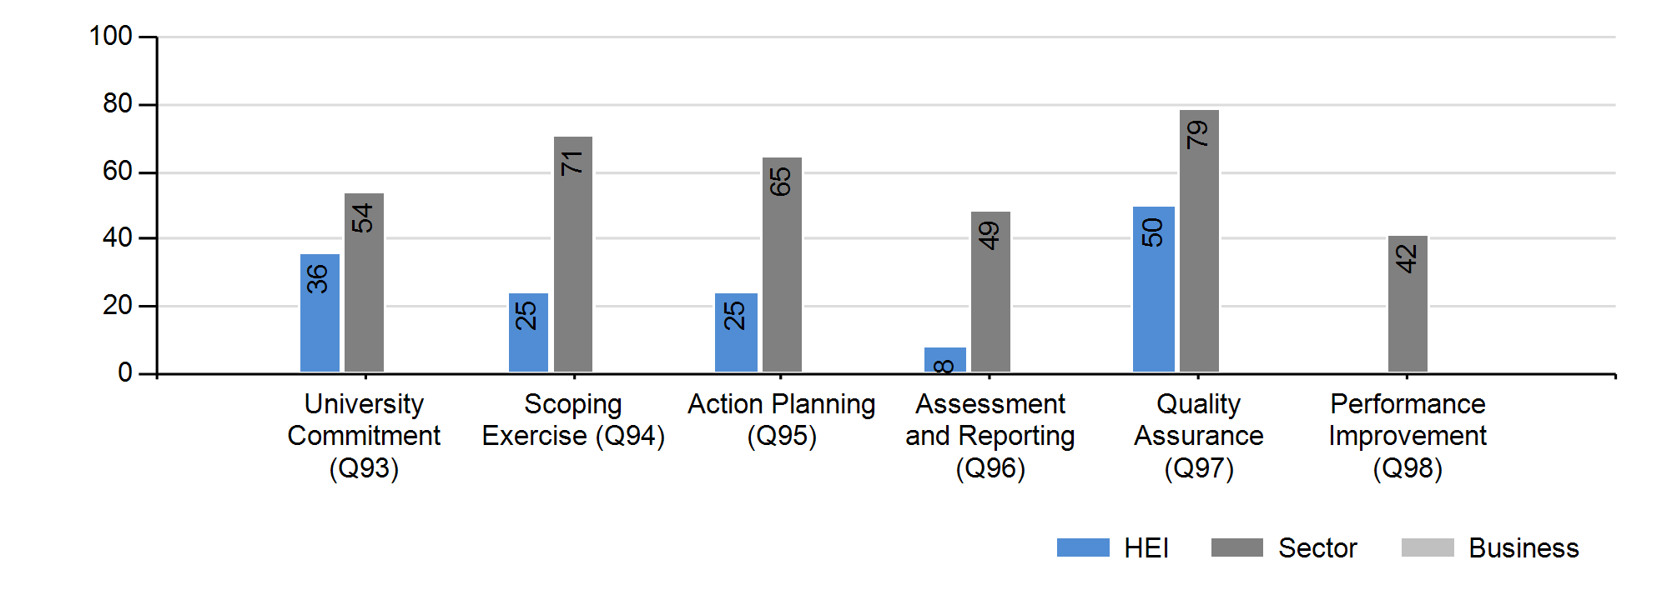

**Section 5: Assurance & Disclosure**

The question on Assurance probes the systems and procedures which ensure that the ESR improvements measured by the survey are sustainable over time – an effective governance framework builds stability and increases the opportunities for strategic, rather than ad hoc, development.

For the first time, your university is scored on its attitude to disclosing its results. The question asks how participants wish to share their results, and their survey submission, with other participants and the public. An increasing number of universities are publishing their UTC Feedback Reports on their websites: this year the Feedback Report has been redesigned with an Executive Summary to meet the needs of website readers.

|  |  |
| --- | --- |
|  | **Disclosure** |
| One of the key principles of responsible organisational practice is a commitment to transparency - encouraging stakeholders to understand how your university performs and how its decision processes work. The UTC Disclosure question asks whether your university will put its UTC results in the public domain, share its UTC submission with other individual UTC participants on a mutual basis, and share with a wider range of participants to assist bench-learning.  The answers were encouraging. Your university selected full disclosure. For the UTC participants as a whole, 69% of universities selected full disclosure, with only 9% wishing not to disclose this year. |



**Conclusion**

Thank you for your participation in the second year of Universities that Count. We hope that the improvements we have made to this Feedback Report have helped your understanding of your university’s results and the opportunities you have to improve your performance. The UTC team offers a range of additional services to aid interpretation and action planning, from detailed results analysis to performance improvement workshops – please contact us (simon@csrconsultancy.com) for more details.

Next year, Universities that Count will offer a streamlined survey and will move to public disclosure of the results in bands – bronze, silver, gold and platinum. As environmental and social responsibility factors continue to move to centre stage, your university’s reputation and standing will be influenced by student and staff perceptions of its commitment to these issues. Independent benchmarking is the best way to provide a sound basis for those perceptions, and we look forward to more and more institutions joining UTC as the programme develops.



Thank you to our funders:

1. Standard Threshold: Platinum ≥ 94%; Gold ≥ 89%; Silver ≥79%; Bronze ≥ 69%