ABI Wildlife Consultancy



Biodiversity Audit on behalf of Edinburgh Napier University

Report for January 2011

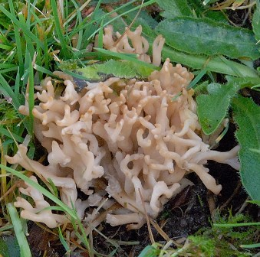

*Clavulinopsis umbrinella* – Red Data Book *sp*

Survey work.

Grey squirrel survey was carried out and the invertebrate analysis has now been completed. Grey squirrel dreys were counted in all wooded areas within Craiglockhart and Craighouse to give rough densities; none were recorded at Merchiston though grey squirrels do use the trees there. Invertebrate species list have been where possible taken to species level, though some remain at family level due to difficulty in identification of this group. A few species of minute parasitic wasps have still to be identified with help from the Museums of Scotland collection. Bird and mammal recording continues.

Interesting information was received from Professor R. Watling, and communication with the fungi recorder for south-east Scotland, regarding the species of fungi found at Craiglockhart last November. Though this species will be recorded as *Clavulinopsis umbrinella* for the moment, this may change in light of new research about to be published and perhaps be recorded as *Clavulinopsis cinereoides* which could be a first for Scotland? Both species are rare and listed as vulnerable species in the Red Data book. Interestingly these species highlight old grassland habitat.

Craighouse

Numbers refer to the amount of different species

Habitat Type Birds Mammals

N Wood 13 2

S Wood 12 1

Amenity Grass 12 0

Buildings 2 0

To-date we have recorded 5 species of bird that are Red Listed, (JNCC *et al.,* 2009), and 9 species that are on the Notable Species List for Edinburgh (Edinburgh Biodiversity Action Plan 2010-2015) within Craighouse. Birds on the Red list are birds of conservation concern due to their long term decline in numbers and include species such as starling, house sparrow and herring gull – all once very common! Ninety nine species of invertebrate were found in which some are listed as rare (old text) and these will have to be clarified and up-dated.

Craiglockhart

Numbers refer to the amount of different species

Habitat Type Birds Mammals

Grassland 2 1

Amenity Grass 5 0

Buildings 2 0

Woodland 6 1

Seven bird species are on the Red list and 6 on the Notable Species List for Edinburgh. Eighty six invertebrate species were found. A short-tailed field vole was found after watching a kestrel catch the small mammal before dropping it.

Merchiston

Numbers refer to the amount of different species

Habitat Type Birds Mammals

Buildings 3 2

There were 26 species of invertebrates found. However, all invertebrates caught by sweep-netting are only those within vegetation and the numbers would be much higher for all sites if other methods of catching were used in parallel e.g., pitfall traps and water traps.

A. Patterson

Ecological Consultant