Principal Consultant
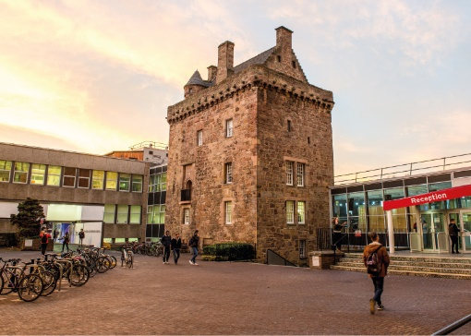

ROLE DESCRIPTION
GRADE  Grade 7  LOCATION  [Provide campus location: Sighthill, Merchiston, Craiglockhart Edinburgh]  LINE MANAGER  [Line Manager Role Title] |  | ROLE SUMMARY  [1-3 paragraphs about the role]  Line Management Responsibility for:  This role does not have any line management responsibilities currently OR This role has line management responsibilities for [insert role titles / no. of line reports here].

MAIN DUTIES AND RESPONSIBILITIES

Teaching and learning support
- Could be expected to supervise MRes, MPhil or PhD students.

Research and scholarship
- Contribute to the development of strategies in the Centre.
- Develop proposals for consultancy projects which will make a significant impact by leading to an increase in knowledge and understanding and the discovery or development of new explanations, insights, concepts or processes.
- Actively seek and secure funding.
- Act as principal investigator on major research projects.

Communication
- Negotiation of consultancy projects and needs across all audiences and at all levels of delivery, funding and negotiation.
- Present at conferences and events.
- As a specialist, give newspaper, radio and television interviews.
- Prepare and review intellectual property including patents and registered designs.
- Prepare, review and comment on industry regulations and standards.
- Could be required to provide give evidence/information to courts and government agencies.

Liaison and networking
- Lead and develop internal networks for example by chairing and participating in Institutional committees.
- Lead and develop external networks for example with other leading thinkers in the field.
- Develop links with external contacts such as other educational and research bodies, employers, professional bodies and other providers of funding and research initiatives to foster collaboration and generate income.

Managing people
- Provide leadership to those working within research areas
- Direct the co-ordination of the work of others, to ensure for example that consultancy projects are delivered effectively and to time or that a team has agreed objectives and work plans.
- Contributing to the development of teams and individuals through the professional development review system and providing advice on personal development.
- Supervise and mentor other staff to develop their research and/or research management skills.
- Could act as line manager of research teams
- Act as a personal mentor to peers and colleagues.

Teamwork
- Lead teams within areas of responsibility.
- Ensure that teams within the department work together.
- Act to resolve conflicts within and between teams.

Pastoral care
- Responsible for dealing with referred issues for consultancy staff.
- Provide first line support for colleagues, referring them to sources of further help if required.

Initiative, problem-solving and decision-making
- Resolve problems affecting the delivery of consultancy projects within own area and in accordance with regulations.
- Make decisions regarding the operational aspects of own consultancy programmes.
- Contribute to decisions which have an impact on other related programmes.
- Provide advice on issues such as ensuring the adequate balance of consultancy projects, appointment of consultants and other performance matters.
- Spotting opportunities for strategic development of new projects or appropriate areas of activity and contributing to the development of such ideas.

Planning and managing resources
- Responsible for the delivery of own consultancy programmes.
- Contribute to the overall management of the department in areas such as budget management and business planning.
- Be involved in departmental level strategic planning and contribute to wider strategic planning processes in the institution.
- Plan and deliver research, consultancy or similar programmes, ensuring that resources are available and required income levels are achieved.
- Contribute to the management of quality, audit and other external assessments.

Work environment
- Depending on area of work (e.g. laboratories, workshops, studios) may be expected to take responsibility for conducting risk assessments and reducing hazards.
- Overall responsibility for the health and safety of others within consultancy group.
- May be required to undertake work in potentially hazardous sites.

Expertise
- Required to have an international reputation (amongst peers or clients or both) in their field, or both a national reputation in their field and outstanding performance in the discharge of their independent managerial responsibilities in relation to large or complex projects.
- To have the ability to manage the work of several consulting divisions across a wide spectrum of the core discipline.
- In-depth understanding of own specialism to enable the development of new knowledge and understanding within the field.
- Role model the University’s values & behaviours;
- Be responsible for ensuring that the information and records processed (received, created, used, stored, destroyed) on behalf of the University are managed in compliance with ALL applicable legislation, codes and policies e.g. Data Protection, Information Security and Records Management.

PERSON SPECIFICATION
 | ESSENTIAL | DESIRABLE

Education / Qualifications
- X
- X
- X

Skills / Experience
- X
- X
- X
- X
- X
- X
- X
- X
- X
- X
- X
- X
- X
- X

